SUBCOURSE EDITION
IS1143 7

RADIO WAVE PROPAGATION
AND ANTENNAS

US ARMY SINGLE CHANNEL RADIO OPERATOR
MOS 31C SKILL LEVELS 1, 2 and 3 COURSE

AND

U.S. ARMY SPECIAL OPERATIONS COMMUNICATIONS SERGEANT
MOS 18E SKILL LEVELS 3 AND 4 COURSE

RADIO WAVE PROPAGATION AND ANTENNAS

SUBCOURSE NO. IS1143-7
(Developmental Date: 31 December 1986)

US Army Signal Center and Fort Gordon
Fort Gordon, Georgia

Nine Credit Hours

GENERAL

The Wave Propagation and Antennas Subcourse is designed to teach the knowledge necessary to identify characteristics of wave propagation and calculating antenna lengths. Additional information is contained concerning types of antennas, and frequency selection procedures for short and long distance radio circuits.

Lesson 1: Identify Characteristics of Wave Propagation.

TASK: Identify the characteristics of wave propagation.

CONDITIONS: Given this lesson material, pencil, paper and without supervision.

STANDARDS: Demonstrate competency of the task skills and knowledge by correctly responding to 70 percent of the multiple choice test covering identification of the characteristics of wave propagation.

(This objective supports SM task number and title 113-596-7056, Direct Installation of a Doublet Antenna.)

i

Lesson 2: Calculate Antenna Length.

TASK: Calculate antenna length, and identify antenna properties.

CONDITIONS: Given this lesson material, pencil, paper and without supervision.

STANDARDS: Demonstrate competency of the task skills and knowledge by correctly responding to 70 percent of the multiple-choice test covering calculating antenna length and identifying antenna properties.

(This objective supports the following SM task numbers/titles.)

113-596-1051 Construct Inverted-L (Military Type) Antenna

113-596-1070 Construct a Doublet Antenna

331-916-0007 Construct a 14 Percent Off-Center-Fed Antenna

331-916-0008 Construct a Counterpoise

331-916-0009 Construct a Long Wire Antenna

331-916-0010 Construct Slant Wire Antenna

331-916-0017 Construct Vertical Half-Rhombic Antenna

ii

TABLE OF CONTENTS

Page
Section

TITLE PAGE i

TABLE OF CONTENTS iii

GRADING AND CERTIFICATION INSTRUCTIONS vi

INTRODUCTION vii

Lesson 1 - IDENTIFY CHARACTERISTICS OF WAVE PROPAGATION 1

Learning Event 1 - Ground Waves 1

Practice Exercise: Learning Event 1. 13

Learning Event 2 - Skywaves 15

Practice Exercise: Learning Event 2 41

COMPREHENSIVE PRACTICE EXERCISE LESSON 1 43

Lesson 2 - CALCULATE ANTENNA LENGTH 46

Learning Event 1 - Characteristics of Antennas 46

Practice Exercise: Learning Event 1 65

Learning Event 2 - Common Antennas 66

Practice Exercise: Learning Event 2 98

Learning Event 3 - Siting 100

Practice Exercise: Learning Event 3 116

Learning Event 4 - Frequency Selection 118

Practice Exercise: Learning Event 4 163

COMPREHENSIVE PRACTICE EXERCISE LESSON 2 165

iii

Whenever pronouns or other references denoting gender appear in this document, they are written to refer to either male or female unless otherwise indicated.

Page
Section

ANSWERS TO PRACTICE EXERCISES 168-170

iv

THIS PAGE INTENTIONALLY LEFT BLANK

v

GRADING AND CERTIFICATION INSTRUCTIONS

INSTRUCTIONS TO THE STUDENT

This subcourse has a post test which is a performance oriented multiple-choice test covering two lessons. You must score a minimum of 75 percent on this test to meet the objective of the subcourse. Answer all questions on the enclosed ACCP examination response sheet. After completing the post test, place the answer sheet in the self-addressed envelope provided and mail it to the Institute for Professional Development (IPD) for scoring. IPD will send you a copy of your results. Nine credit hours will be awarded for successful completion of the subcourse.

***IMPORTANT NOTICE***
THE PASSING SCORE FOR ALL ACCP MATERIAL IS NOW 70%
PLEASE DISREGARD ALL REFERENCES TO THE 75% REQUIREMENT.

vi

INTRODUCTION

The most important element in a radio circuit is the antenna. You may have a powerful transmitter and a frequency, but without the correct antenna, communication will be less than desirable, if not impossible.

This subcourse provides information necessary to make the right choice for an antenna and how to select the correct frequency depending upon the environmental conditions.

Without an understanding of wave propagation, decisions on frequency selection and antennas could result in no communications.

Even though a frequency selection is made for you, without a thorough understanding of how the frequency was selected, you will not understand why you couldn't communicate or what frequency you should have used for a given radio circuit.

vii

Lesson 1/Learning Event 1

LESSON 1
IDENTIFY CHARACTERISTICS OF WAVE PROPAGATION

TASK: Identify the characteristics of wave propagation.

CONDITIONS: Given this lesson material, pencil, paper and without supervision.

STANDARDS: Demonstrate competency of the task skills and knowledge by correctly responding to 70 percent of the multiple choice test covering identification of the characteristics of wave propagation. (This objective supports SM task number and title 113-596-7056, Direct Installation of a Doublet Antenna.)

Learning Event 1: GROUND WAVES.

1. In 1887, Henrich Hertz demonstrated that electromagnetic energy could be sent out into space in the form of radio waves. Radio waves travel at the speed of light in free space, 186,000 miles per second, or 300,000,000 meters per second. Free space implies that radio waves travel through empty space or a vacuum. In actual practice, radio energy travels slightly slower because of the presence of trees, hills, lakes, and the air it travels through. If we have a radio frequency of 1,000,000 cycles (1 MHz) per second, its full wave length is 984 feet. We will use the Greek letter lambda λ to represent wave length. V (velocity) will represent the speed of radio waves. F (frequency) represents the assigned frequency.

λ= V/F

Since: λ = V/F = 300,000,000 meters per second/1,000,000 HZ (1MHz)

λ = 300 meters = one wave length

one meter equals 3.2808 feet

converting into feet = 300 X 3.2808 = 984 feet = one wave length = λ

then one half wave length λ /2 = 984/2 = 492 feet

1

Figure 1. Simple radio communication system.

2. The Atmosphere. How do radio waves travel from the transmitter to the receiver? What effect does the atmosphere have on our radio energy? The answers to these and other questions will be answered as we discuss each facet of wave propagation. The atmosphere around us changes seasonally, yearly, daily, and hourly. The atmosphere is comprised of the troposphere, stratosphere, and the ionosphere.

2

Figure 2. Layers of the earth's atmosphere.

3

a. The Troposphere. The troposphere lies from the earth's surface to a height of approximately 6.8 miles.

b. The Stratosphere. The stratosphere lies between the troposphere and the ionosphere. It is also called the isothermal region. Its height is from 6.8 miles to 30 miles above the earth.

c. The Ionosphere. Because it is the furthest layer away, it is ionized the most by the sun. It extends from approximately 30 to 250 miles above the earth. The ionosphere has several layers which have varying levels of ionization.

3. Frequency Classifications. Not only does each atmospheric layer vary in ionization levels, but certain bands of frequencies have unique propagation characteristics. The lower frequencies have different characteristics from the upper frequencies. It is important to understand how each band of frequencies travels from the transmitter to the receiver.

Table 1. Frequency band coverage.

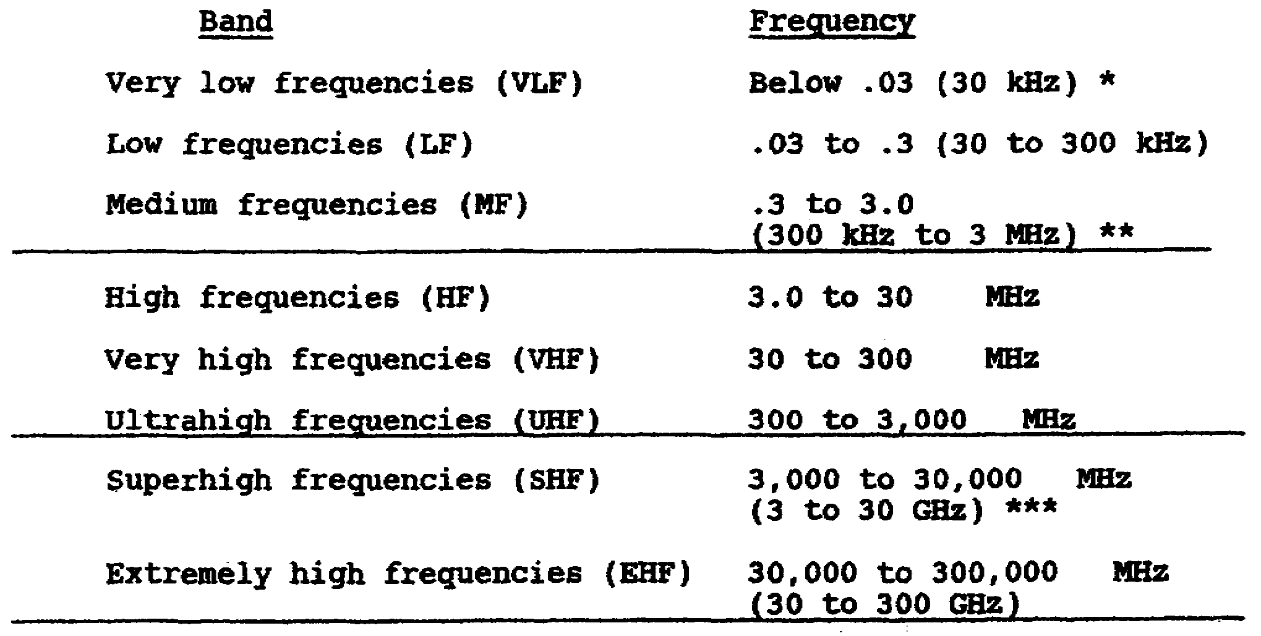

*1kHz = 1 kilohertz = 1,000 hertz or 1 kHz

**1MHz = 1 megahertz = 1,000,000 hertz or 1 MHz or 1,000 kHz

***1GHz = 1 gegahertz = 1,000,000,000 hertz or 1 GHz or 1,000 MHz

4

Table 2. Frequency band characteristics.

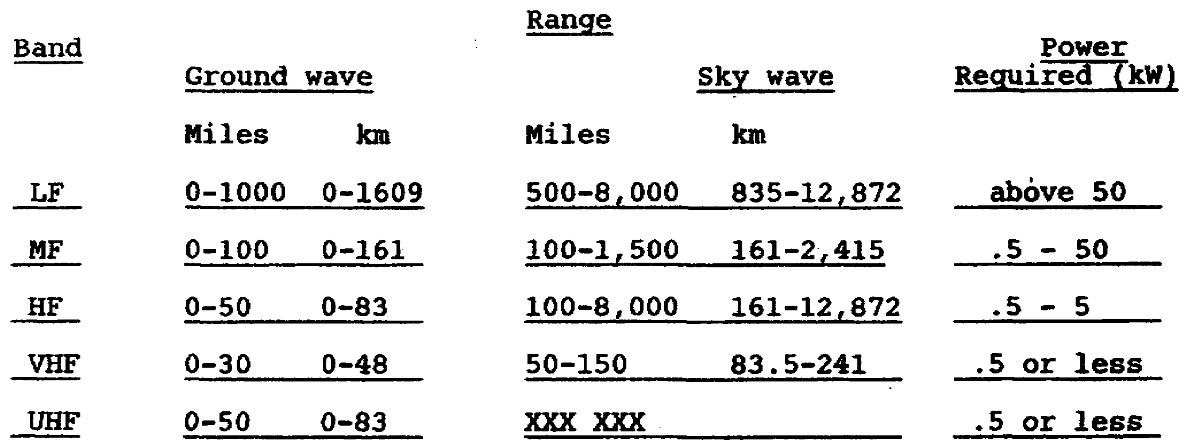

4. Propagation in the atmosphere. There are two ways radio energy travels from the transmitter to the receiver: by means of ground waves or by sky waves. The ground waves travel along the surface of the earth. The sky wave travels from the transmitter to one of the ionospheric layers and is returned to earth. Long distance radio communication, depending on the frequency, can be by either ground or sky wave. The advantage of sky wave communication is that very little power is needed to travel long distances, say around 8,000 miles. In order to communicate by ground waves, a powerful transmitter is needed in order for the radio waves to travel the same distances. A combination of both ground and sky wave communication usually occurs. The earth's surface affects the radio energy coming in contact with it. Terrain features (jungle, desert, and large bodies of water) either aid or lessen the radio signal. Diffraction is the bending of the radio wave with the curvature of the earth. The only variable in a ground wave signal is the terrain over which it travels. There are many variables in a sky wave signal: the frequency, the ionospheric layers, the time of day, the season, and the sunspot cycle.

5

Figure 3. Principal paths of radio waves.

a. Reflection. A radio wave may be reflected. An example of reflection is shown in figure 4. A beam of light is shown into a mirror, almost all of the light energy is reflected. A radio signal is the same. Depending on the type of surface it contacts, the Signal will be either absorbed or reflected. Metal surfaces and bodies of water are good reflectors. Dense vegetation like that found in a jungle will absorb the majority of the radio energy. Notice in figure 4 that the beam of light is reflected at the same angle it entered the mirror. This is also true with a radio wave reflecting off the earth's surface.

6

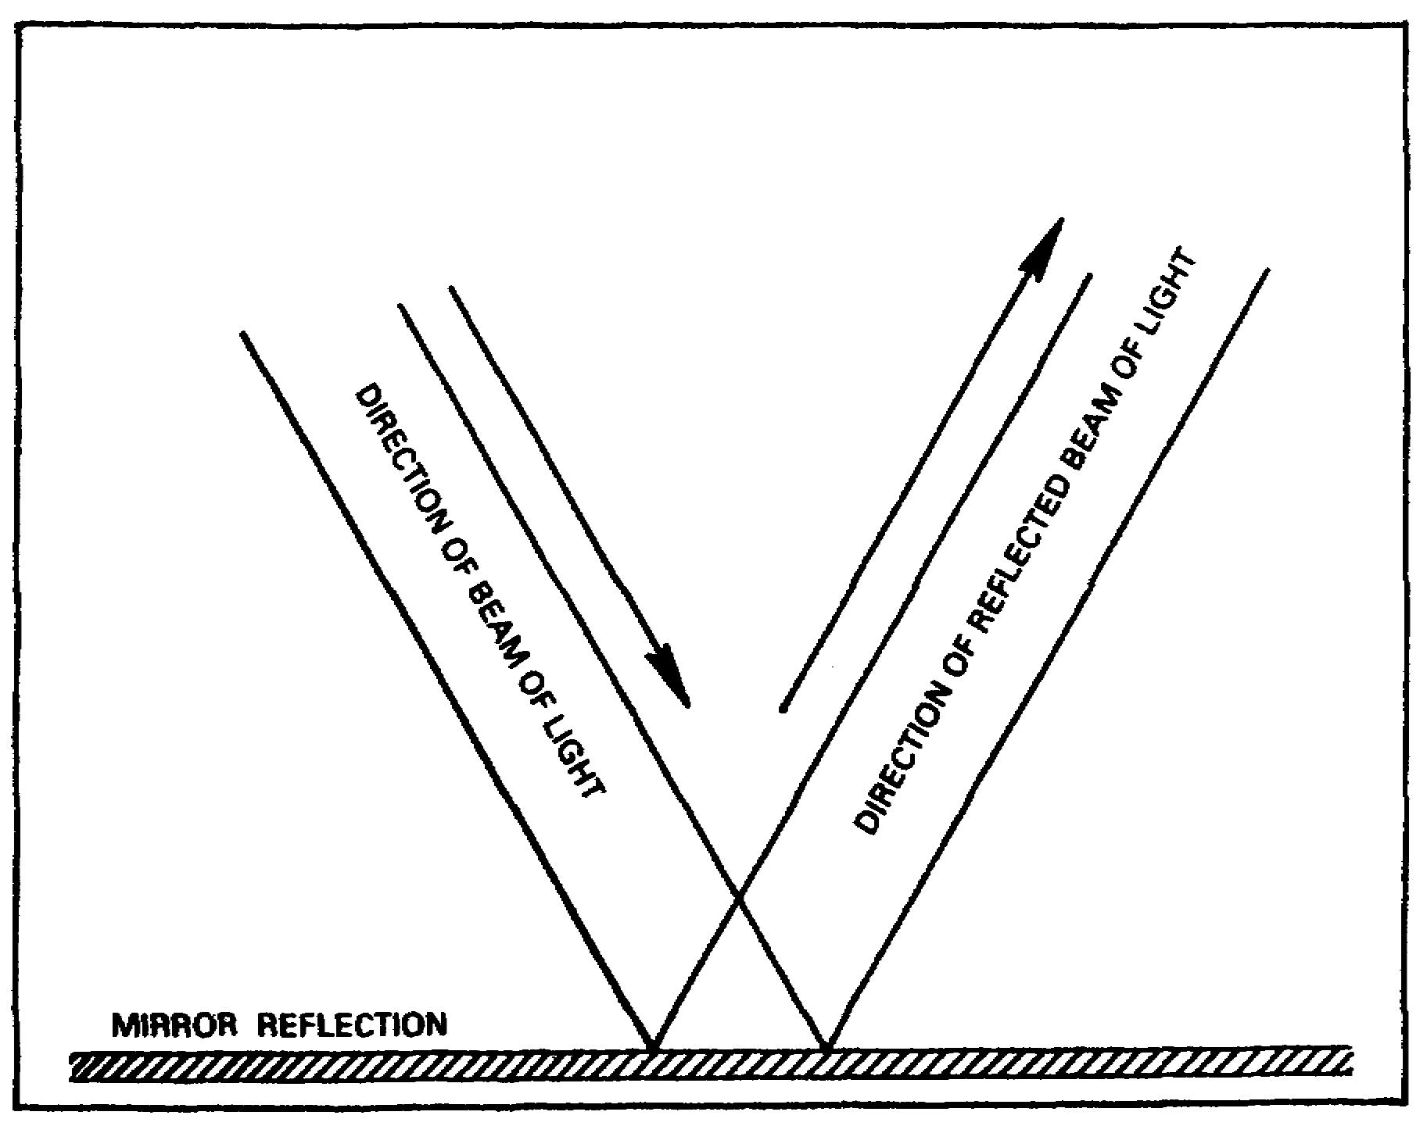
Figure 4. Mirror Reflection.

b. Refraction. A radio signal that strikes an ionospheric layer is similar to the wave in figure 5. When a beam of light strikes a pool of water, the beam is bent slightly. This is what happens to a radio wave when it strikes an ionospheric layer. The signal is bent and is returned to earth. The terms reflection and refraction are used interchangeably.

7

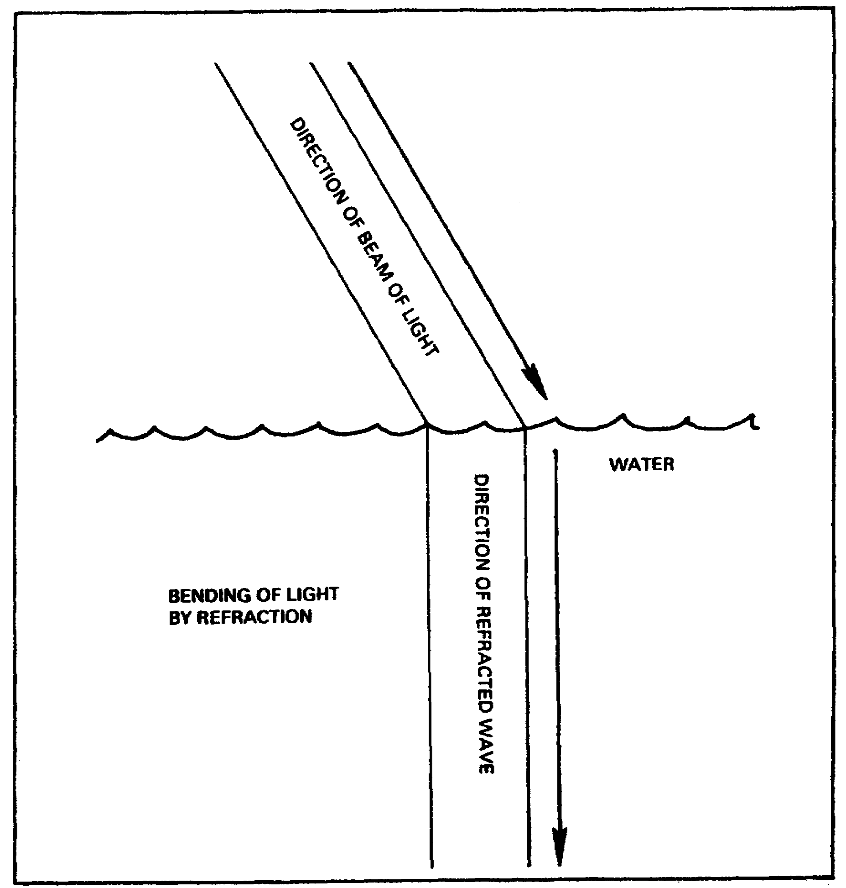
Figure 5. Bending of light by refraction.

c. Diffraction. If that same beam of light is shown on an object, it will not cast a perfect shadow. The light rays tend to bend around the object and decrease the size of the shadow. This also happens to a radio wave that strikes an object such as a mountain. The radio wave tends to bend around the object. This is shown in figure 6.

8

Figure 6. Diffraction of wave around solid object.

5. Types of Ground Waves.

a. Radio waves that do not make use of the ionosphere are called ground waves. The received signal strength depends on how powerful the transmitter is. Terrain features the wave must travel over affects the received signal strength. The Earth's surface reduces the range of a ground wave signal. Mountains and jungles are bad terrain features. Sea water is the best terrain feature to transmit a radio signal over. Other bodies of water are also good, but not as good as sea water.

b. Figure 7 shows the various types of ground waves that a radio signal may take from the transmitter to the receiver. The signal may also be refracted by the troposphere. The ground wave is composed of a direct wave, a ground reflected wave, a surface wave, and a tropospheric wave.

9

Figure 7. Possible routes for ground waves.

6. Direct Wave Component. The direct wave is that part of the ground wave that travels directly from the transmitting antenna to the receiving antenna. The direct wave is limited to line of sight distances. To increase the range, increase the height of either the transmitting or receiving antenna.

7. Ground Reflecting Component. The ground reflected component is that part of the radio wave that is reflected before it reaches the receiving antenna. It may be reflected from the ground or from a body of water. When the radio wave is reflected, the phase is reversed. This could affect the reliability of communication. It could cancel out the radio waves that travel directly to the receiving antenna. To minimize the canceling effect, the antenna should be raised at either end.

8. Surface Wave Component.

a. The surface wave travels along the Earth's surface. It follows the curvature of the earth. When both the receiving and transmitting antennas are located close to the earth, the direct and reflected wave may cancel each other out.

10

Table 3. Propagation Characteristics of Local Terrain

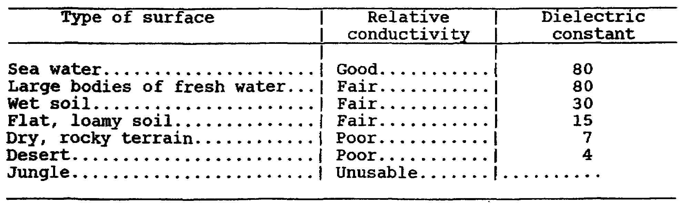

b. The surface wave is transmitted as a vertically polarized wave. When using the surface wave, use a vertical antenna. A horizontal antenna transmits a horizontal wave which is short circuited by the earth. The better the type of local terrain, the further the signal will travel and not be absorbed. The range of the surface wave is determined by how powerful the transmitter is. An increase in power will increase the surface wave range. The range of the surface wave is also affected by the terrain features it must travel over.

9. Frequency Characteristics of Ground Waves.

a. The frequency used will determine which component of the ground wave will be used. If the frequency is below 30 MHz the surface wave will be used primarily. Between 10 and 30 MHz the local terrain features will determine which component of the ground wave will be used. At frequencies greater than 30 MHz the direct wave is primarily used because the local terrain features absorb the surface and ground reflected waves. Above 30 MHz, vertical or horizontal polarization may be used.

b. Frequency bands use certain components of the ground wave:

(1) The low frequency band (30 to 300 kHz) is used for moderate distance ground wave communication. A vertical antenna should be used in the low frequency band. The radio wave follows the curvature of the earth for several hundred miles.

(2) The medium frequency band (300 kHz to 3 MHz) is used for moderate distance communication over land and for long distance communication over sea water up to 1,000 miles.

11

(3) The high frequency band (3 to 30 MHz) is used for short distance communication. At these frequencies, the local terrain absorbs more and more of the signal as the frequency increases, decreasing the ground wave range. Long distance communications is possible using sky wave.

(4) The very high frequency band and higher bands (30 MHz and over) are used for line of sight communication. Only the direct wave component of the ground wave is usable. The range can be increased by raising the height of the antenna. Sky wave communication is not possible because the frequencies pass through the ionosphere and are not reflected.

12

LESSON 1/LEARNING EVENT 1

PRACTICE EXERCISE

Instructions: Select the BEST response, and circle the correct answer.

1. What is the speed of radio waves?

a. 186,000 miles per second.

b. 186,000,000 miles per second.

c. 300,000 miles per second.

d. 302,808 miles per second.

2. The frequency range of the VLF band is--

a. .03 to 3 MHz.

b. below .03 MHz or below 30 kHz.

c. 30 to 300 MHz.

d. above 3 MHz.

3. Which of the following will not reflect radio energy?

a. Sea water.

b. Fresh water.

c. Jungle.

d. Metal buildings.

4. Refraction is--

a. radio energy entering and leaving a layer at the same angle.

b. similar to radio energy striking a mirror.

c. similar to disfraction.

d. radio energy bending upon entering a ionospheric layer and returning to earth.

13
5. Which is the worst terrain feature to locate an antenna?

a. Sea water.

b. Wet soil.

c. Desert.

d. Jungle.

Turn to page 168 to check your answers.

14

Lesson 1/Learning Event 2

Learning Event 2: SKYWAVES.

1. Early radio communication was thought to be impossible over long distances. The reasoning, local terrain would absorb the radio signal. When trans-atlantic communication was accomplished, this opened up new questions. If the surface wave was limited, then how did communication take place? The conclusion made was that the earth was surrounded by something other than air. Two men, one an Englishman the other an American, suggested that a electrified layer above the earth reflected radio signals. Later experiments showed that more than one layer existed.

2. Formation of the Ionosphere: As shown in figure 2 the earth's atmosphere extends up to a distance of 250 miles. The level of ionization increases with height. The sun's rays combined with cosmic rays ionize these layers.

a. Ionization. The bombardment by the sun and ultraviolet rays charge the atoms in these layers. This action is called ionization.

b. Recombination. As the sun goes down and the intensity of the ultraviolet rays decreases, the ionization of the layers decreases. Just before sunrise, ionization is at its lowest point.

c. Source of ionization - the sun. The earth and the sun are composed of the same basic elements. The violent state of these elements on the sun keeps it in a constant of state of molten or gaseous condition.

15

There is only one principal ionized layer at night.

Figure 8.

IONOSPHERE STORMS

Definition: Any marked or sudden deviation from normal conditions of height or frequency.

Effect: Normally reliable frequency may become useless. Signal may weaken or "blackout".

Duration: Several minutes to several weeks. Tendency to repeat every 27 days as the sun rotates.

Ionosphere storms usually originate in North and South Polar Regions.

16

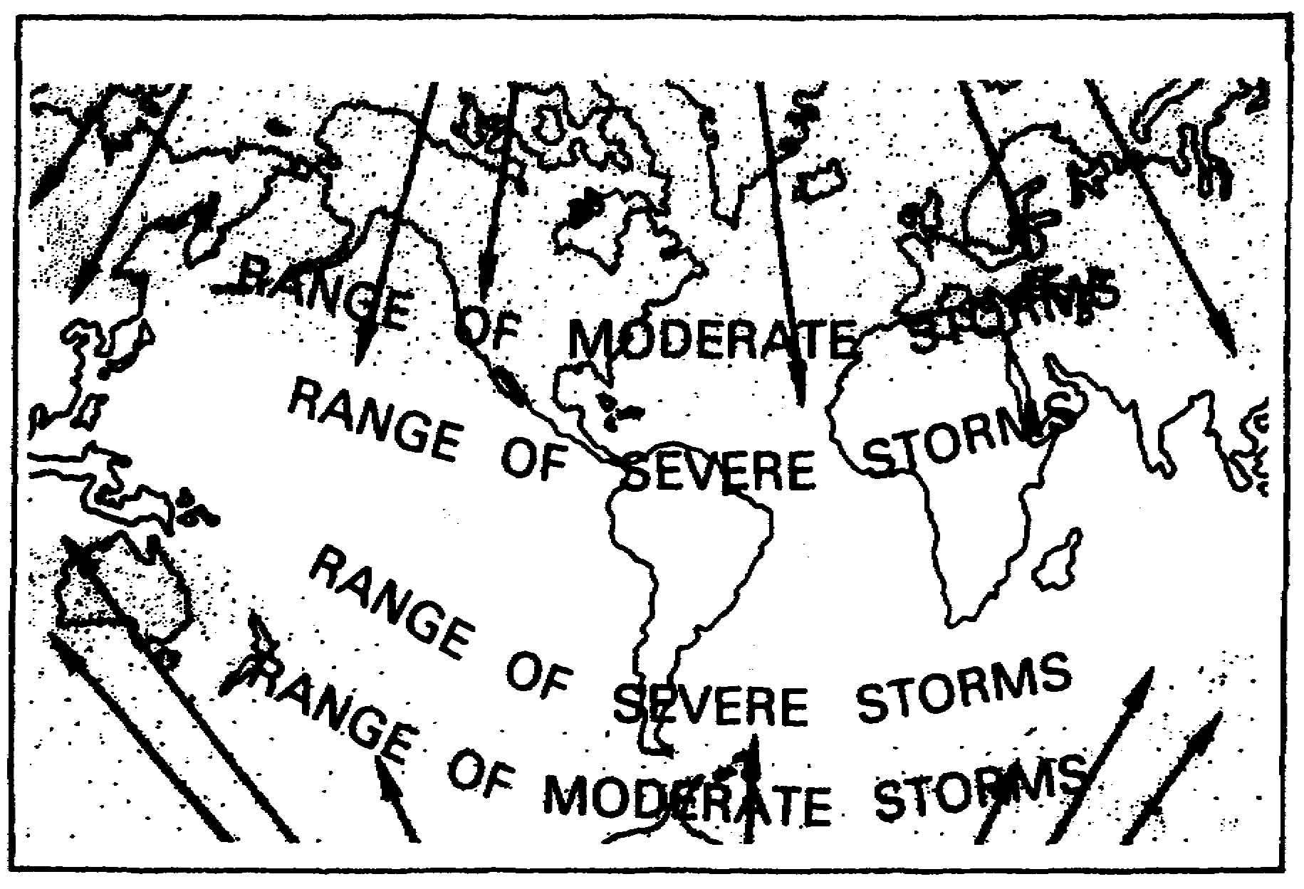
Figure 9.

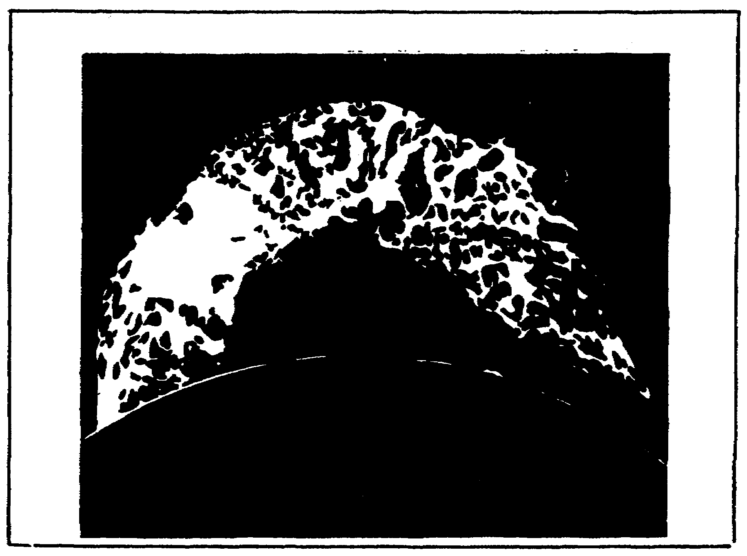

Figure 10. Solar eruption.

17
(1) Eruptions on the surface of the sun shoot hot gases from its surface up to a half million miles away. Spots of intense ultraviolet radiation are another disturbance noted. These spots are referred to as sunspots.

(2) The number of sunspots vary from year to year. The minimum to maximum sunspot cycle takes about 11.1 years. During periods of high sunspot activity, higher frequencies are usable. During low sunspot activity, lower frequencies must be used.

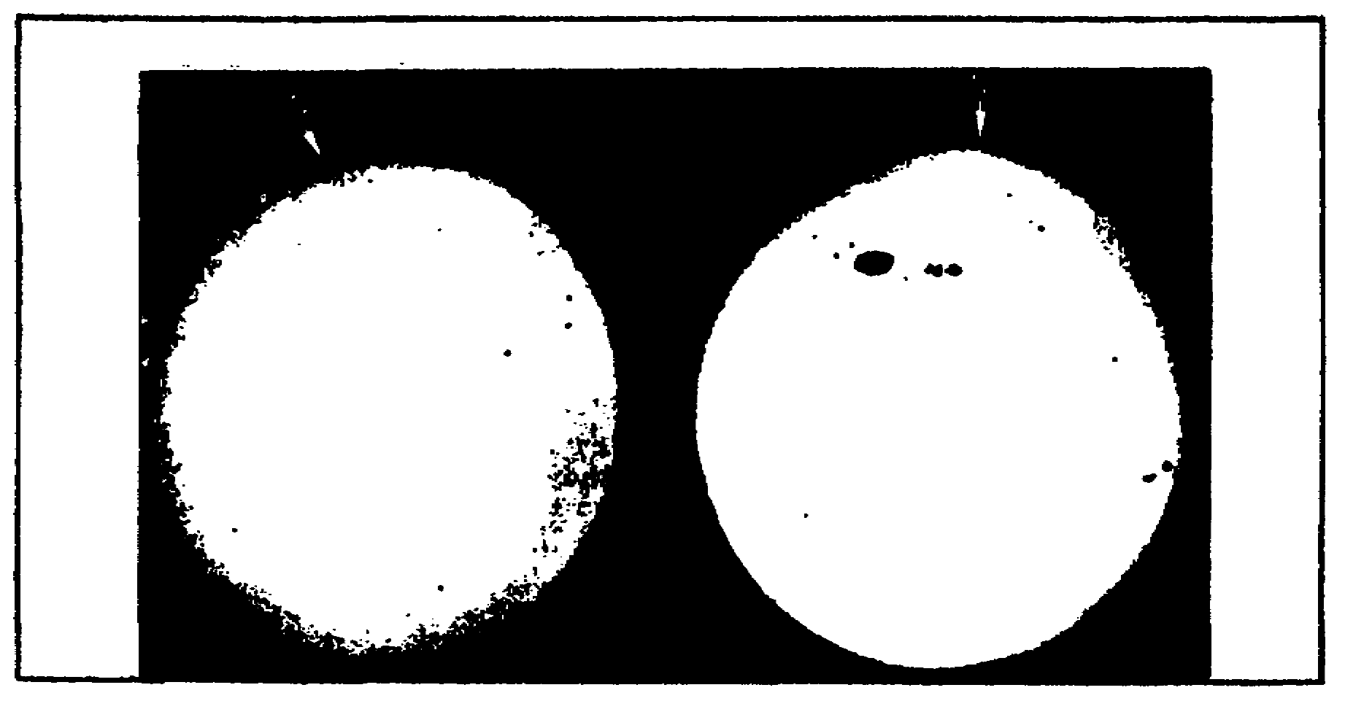
Figure 11. Sunspots.

(3) Dellinger fade. When the sun produces bright visible flares, the effect is felt immediately in the various ionospheric layers. Absorption of most radio frequencies is noted during this period. It is called the Dellinger fade. The lower frequencies are affected to a lesser degree.

3. Ionosphere Layers or Regions. There are four layers in the ionosphere. They called the D, E, F1, and F2 layers. All four layers are present during the daytime. At night, the F1 and F2 layers thin out and tend to merge into one layer - the F layer. The D and E layers disappear at night. These layers have less ionization. After the sun sets, recombination occurs and the layers disappear. The number of layers, their height, and level of ionization fluctuates. The ionization changes hour by hour, day by day, month by month, season by season, and year by year.

18

Figure 12. Layers of the ionosphere.

a. D Layer. The D layer is approximately 30 to 55 miles above the earth. This layer has the least ionization and therefore has the lease effect on radio frequencies. It is present during the day only. The height varies over the eleven year sunspot cycle. The D layer is approximately 6 miles thick.

b. E Layer. The E layer is approximately 55 to 90 miles above the earth. The E layer reflects radio frequencies up to about 20 MHz. The maximum one hop range of the E layer is 1,500 miles. This layer is present only during the day. The height of the layer varies during the eleven year sunspot cycle. The E layer is approximately 15 miles thick.

c. F Layer. The F layer is from 90 to 240 miles above the earth. The F layer is present only at night. This layer is created when the F1 and F2 merge. Because it is the most ionized, recombination takes place more slowly. The height varies over the course of the eleven year sunspot cycle.

d. F1 and F2 Layers. During the daylight hours, the F1 layer has a height of approximately 90 miles and is approximately 12 miles thick. The F2 layer has a height of approximately 160 to 220 miles and is approximately 15 miles thick. The F2 layer, being the closest to the sun, has the most ionization. The height of both layers varies over the eleven year cycle of sunspot activity.

19
e. Other layers. Other layers or clouds appear from time to time over the eleven year sunspot cycle. These layers appear near the E layer. Together, they are called the Sporadic E layer.

Figure 13. Effect of frequency on the critical angle.

Figure 14. Relationship between skip zone, skip
distance, and ground wave.

20

4. Characteristics of the Ionosphere.

Critical frequency. Layer height will determine how far a radio transmission travels. In addition, the higher the frequency the greater the density of ionization that is required to reflect the signal back to the earth. The F2 layer will reflect higher frequencies than the F1 layer. The same will hold true for the F1 layer as compared to the E layer. The D layer will reflect frequencies below approximately 500 kHz. For each layer there is a maximum frequency which is refracted, but higher frequencies are not. This is called the critical frequency. Frequencies higher than the critical frequency will pass through the layer and will not be refracted. As a radio wave passes through a layer, it is partially absorbed. Figure 15 shows different frequencies striking different layers. Some will be returned, others will pass through. All frequencies below the critical frequency are refracted. Frequencies above the critical frequency pass through the layers.

Figure 15. Critical frequencies.

21

5. Regular Variations of Ionosphere.

a. General. The ionospheric layers exist because of the sun's activity. The sun's state of activity will determine, among other things, the critical frequency for each ionospheric layer.

22

Figure 16.

23

Table 4. Regular Variations of Ionosphere.

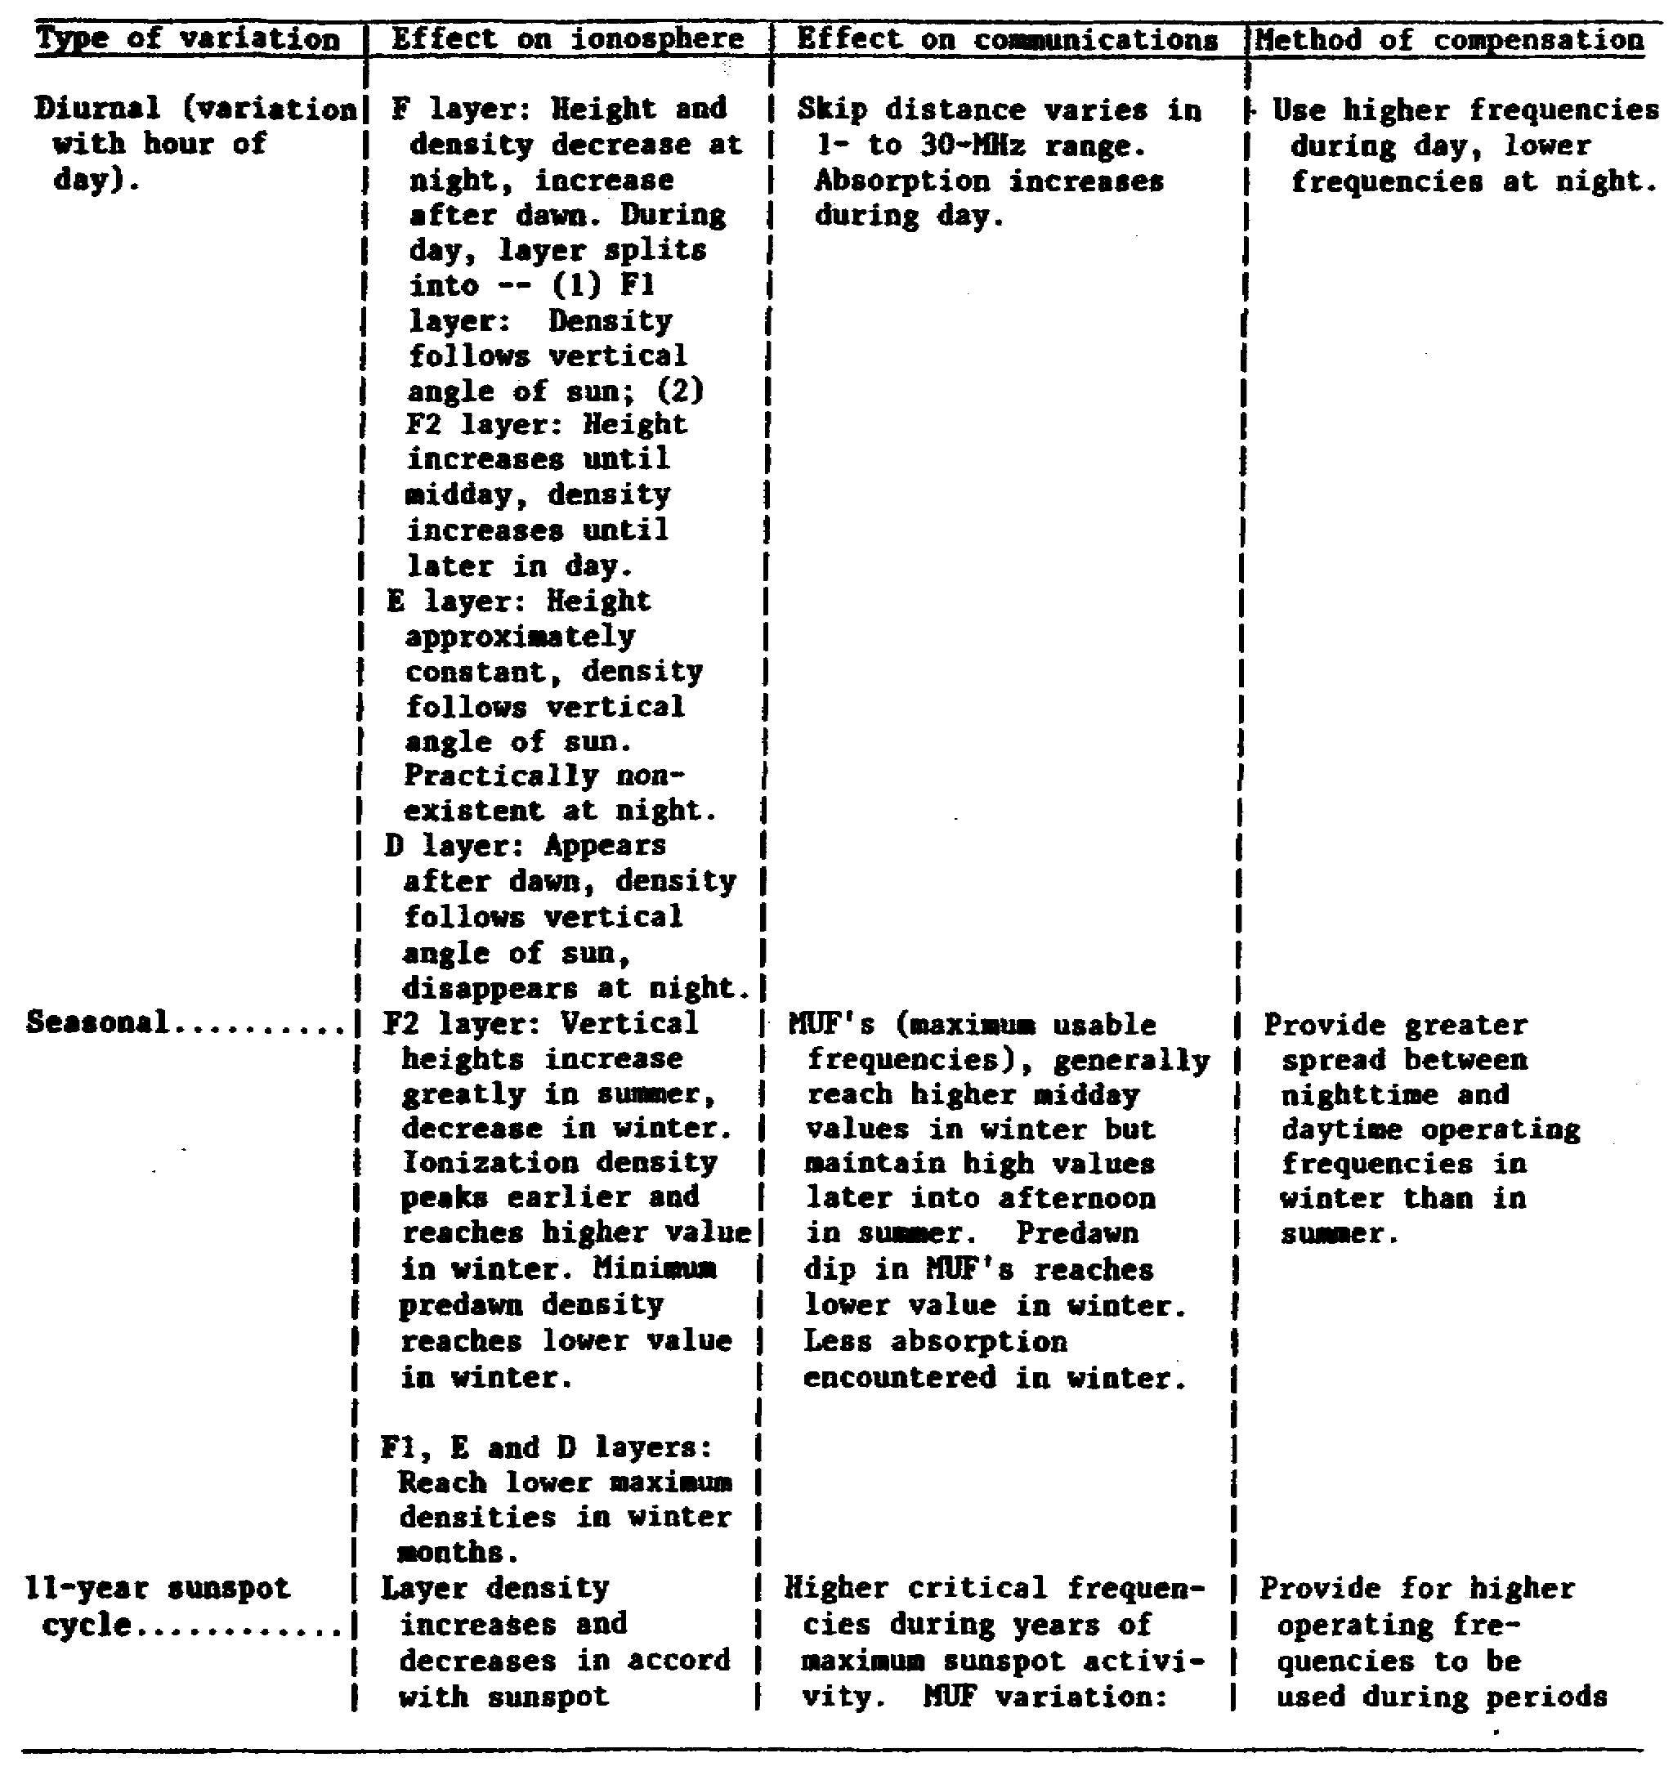

24

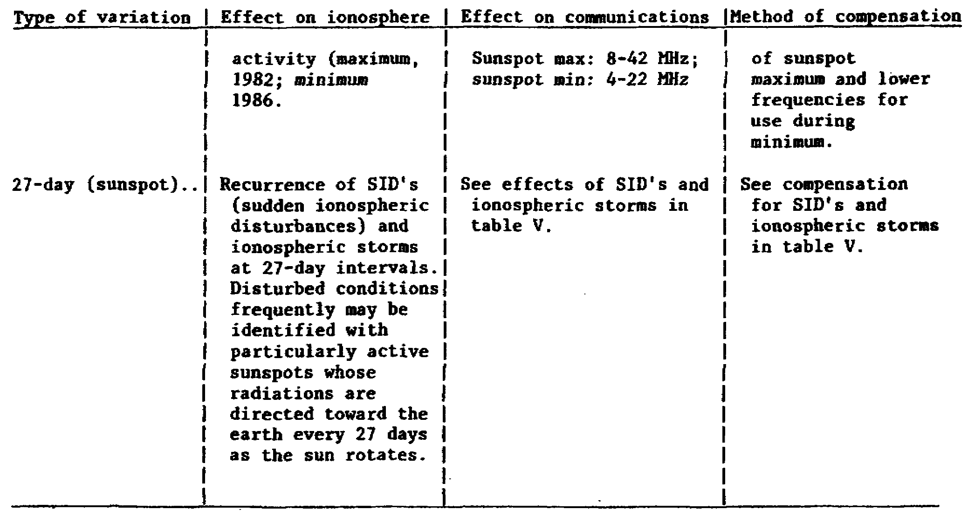

b. In general, because of the variations of ionization during the daytime, higher frequencies can be used. During the night, lower frequencies are used. The critical frequency for the F2 layer, which exists only during the day, is higher than that of the F layer. At night, the F layer is actually a combination of the Fl and F2 layers. It is common for stations in a net not to receive each other with the same signal strength. Layer density varies over the circuit path. It is common for one station to hear well and the rest don't. There are times when there is only one-way communication because of layer density variation. The layers vary in thickness from 6 to 75 miles.

25

Figure 17. Daily and seasonal variations in ion density.

c. Seasonal Cycle. As the earth tilts on its axis, the sun rays strike the layers obliquely. This will cause the northern half of all layers to be more ionized than the southern half because the northern hemisphere is tilted away from the sun. We can also see that there is a difference in layer height during the winter and summer.

d. Eleven Year Cycle. As stated earlier, the sunspot activity varies over an eleven year period. During a high sunspot activity, higher frequencies may be used. Longer distance communication may be also possible because of the use of higher frequencies. During low sunspot activity, lower frequencies must be used and shorter distance radio circuits can be expected.

e. Twenty-seven Day Cycle. The sun requires 27 days to rotate around its axis. While rotating, sun exposes different sunspot concentrations. This variation affects the layers, sometimes making F2 predictions difficult.

26

SINGLE HOP TRANSMISSION
Distance AB less than 2500 miles (4000 KM).

Figure 18a.

27

MULTIPLE HOP TRANSMISSION
Distance AB more than 2500 miles (4000 KM).

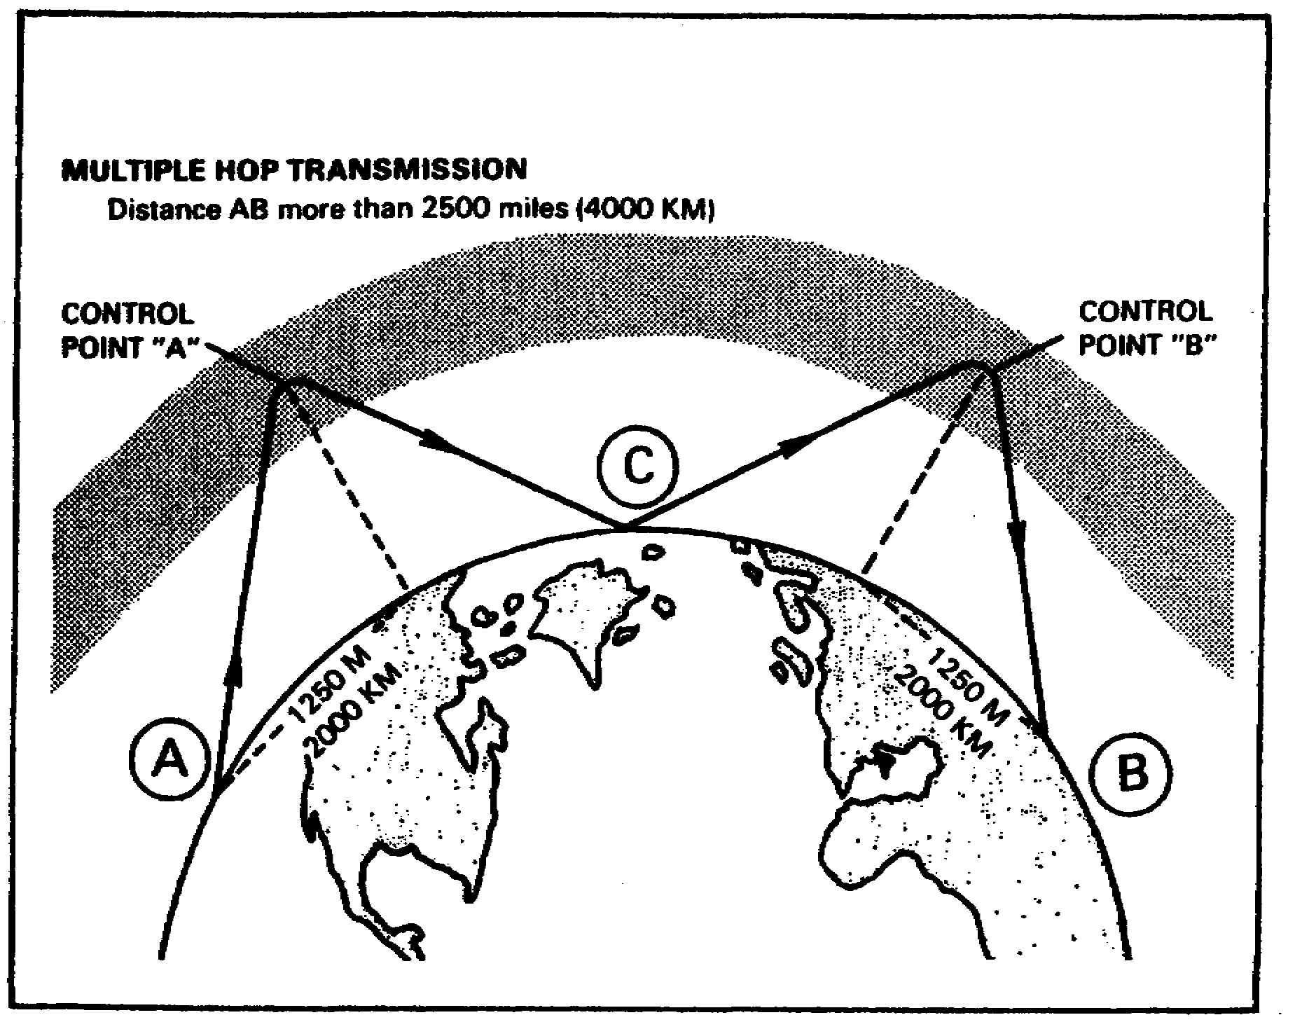
Figure 18b.

28

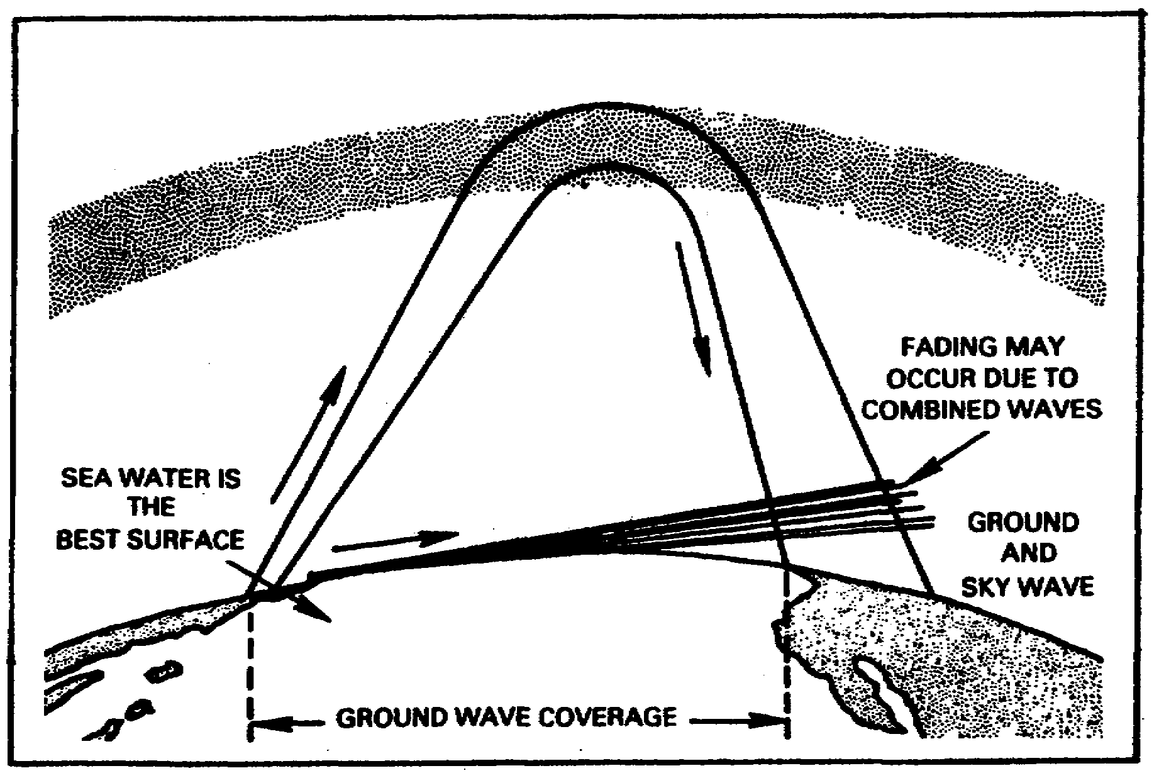
Figure 19.

IN THE HF BAND - Higher frequencies are bent less, that is, higher frequencies have more penetrating power.

29

Figure 20.

6. Irregular Variation of Ionosphere.

a. In addition to the regular variation of the ionosphere, there are temporary effects. Some of these are Sporadic E, sudden ionospheric disturbance (Dellinger fade), ionosphere storms and scattered reflections.

b. Sporadic E. The Sporadic E is a temporary phenomenon. It consists of an ionized cloud at a slightly higher height than the normal E layer. Why it appears and what causes it to move is unknown. It will reflect frequencies from 1.5 to 15 MHz. Its s appearance is frequent, especially in the middle latitudes. Not all stations in a net may experience the Sporadic E reflection.

30

c. Sudden Ionospheric Disturbance or Dellinger Fade. Ionization from a violent solar eruption travels down to the D layer. This causes an almost total absorption of all frequencies, above 1 MHz. This disturbance is called SID or Dellinger fade. This blackout of radio communication may last from a few minutes to several hours.

d. Ionospheric Storms. An ionospheric storm is caused by a severe disturbance of the ionospheric layers. The levels of ionization of the layers thin out, making reflections frequencies above 1.5 MHz difficult. Lower working frequencies are in order. These storms may last several hours to several days. These storms are caused by particle radiation from the sun. The storms will start normally after a sunspot group crosses the center of the sun.

Table 5. Irregular Variations of Ionosphere.

31

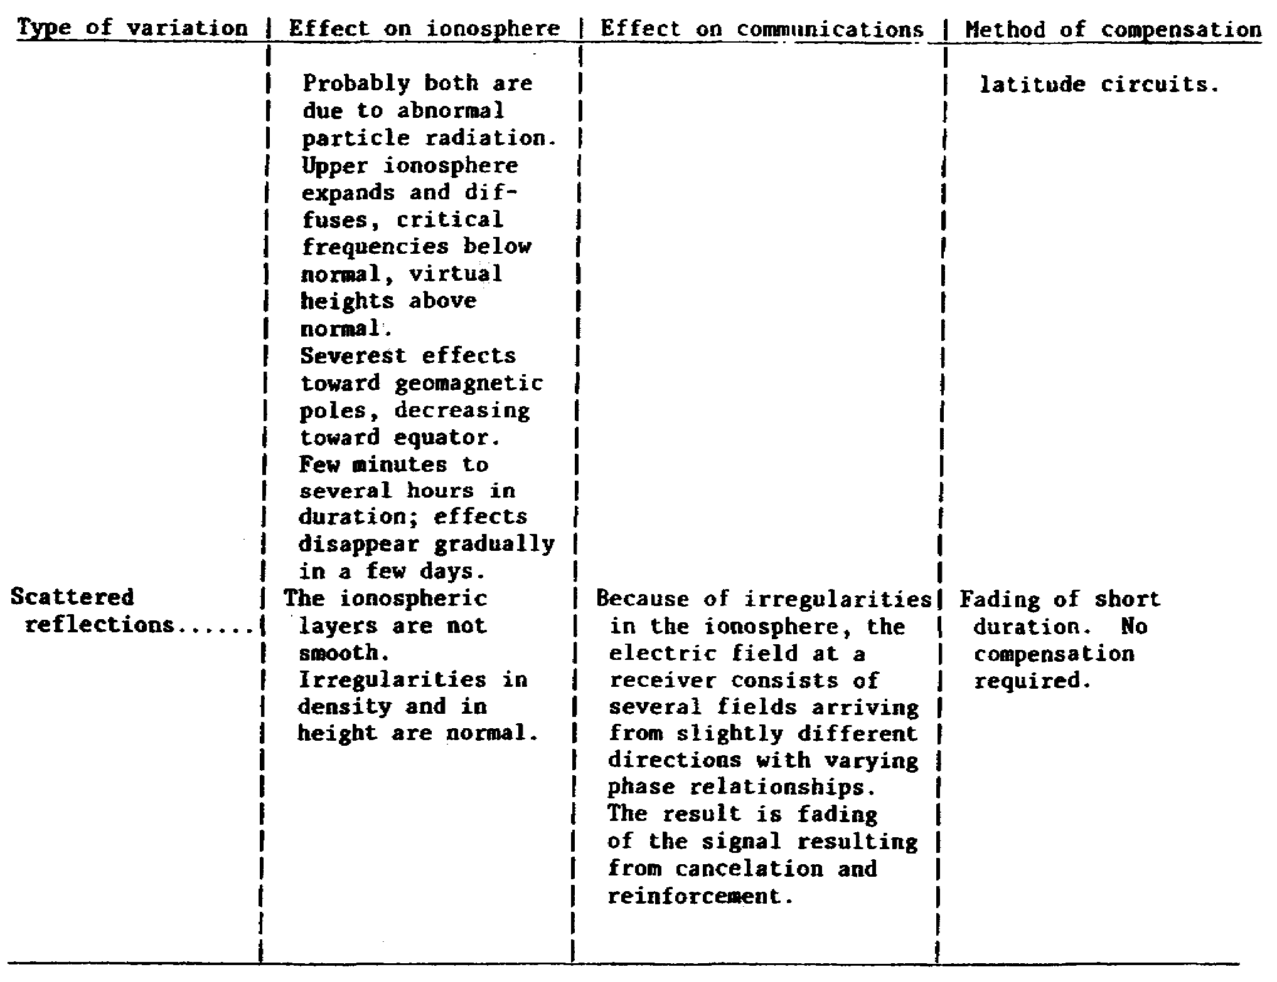

e. Scattered Reflections. Another irregular variation is the rapid change of ionization with height. A radio signal may be reflected by more than one layer. The received signal may arrive from several directions which will cause flutter fading.

7. Ionospheric Predictions. By the sounding of the ionosphere, predictions are possible. Long range forecasting can predict the optimum working frequency, maximum useful frequency, and lowest useful frequency.

32

Figure 21. Bright solar eruption.

Figure 22. Scattering of signal components of radio wave.

8. Sky Wave Propagation. Sky wave propagation is the reflection of radio waves from the various ionospheric layers.

33

Sky wave Propagation offers long range communication with very little power required. The most difficult question regarding sky wave propagation is what frequency to use. The HF (3-30 MHz) band uses ionospheric reflection most effectively.

a. Sky Wave Transmission Path. Figure 23 indicates the many varied paths a radio signal may take from the transmitter to the receiver. Notice that a receiving station located in the skip zone would receive no signal. Through proper frequency selection, antenna and antenna height determination, there will never be a skip zone. Notice also that from the point the radio signal leaves the transmitter to the point it contacts the earth is called the skip distance.

(1) Sky wave modes. The distance the sky wave signal travels before it returns to earth depends upon the ionospheric layer used. When the signal strikes the earth, part of the signal is absorbed. The rest is reflected back to the ionosphere. This is repeated until the signal is too weak to be reflected either by the ionosphere or the earth. This is called a multi-hop transmission.

(2) Frequency. The problem as to what frequency to use is not an easy one to solve. As mentioned earlier, the higher the frequency, the higher the ionospheric density required to return the frequency to earth. Figure 28 shows radio signals of several frequencies. Some are returned while others are not. The 5 and 20 MHz signals are returned, while the 100 MHz signal is not. Notice that the 20 MHz signal travels further. While this may hold true for day time communication, it might not be true at night.

b. Maximum Usable Frequency (MUF).

(1) See Figure 23. For a given distance, there is a frequency in which any further increase in frequency will result in no communication. In other words, the station located in the skip zone does not receive a signal. The highest frequency that can be used between two points is the maximum usable frequency. As the distance increases the MUF increases.

(2) Care must be taken in selecting the frequency. Too high - it passes through the ionosphere or overshoots the receiver. Too low and it will be absorbed by either an ionospheric layer or the earth.

34

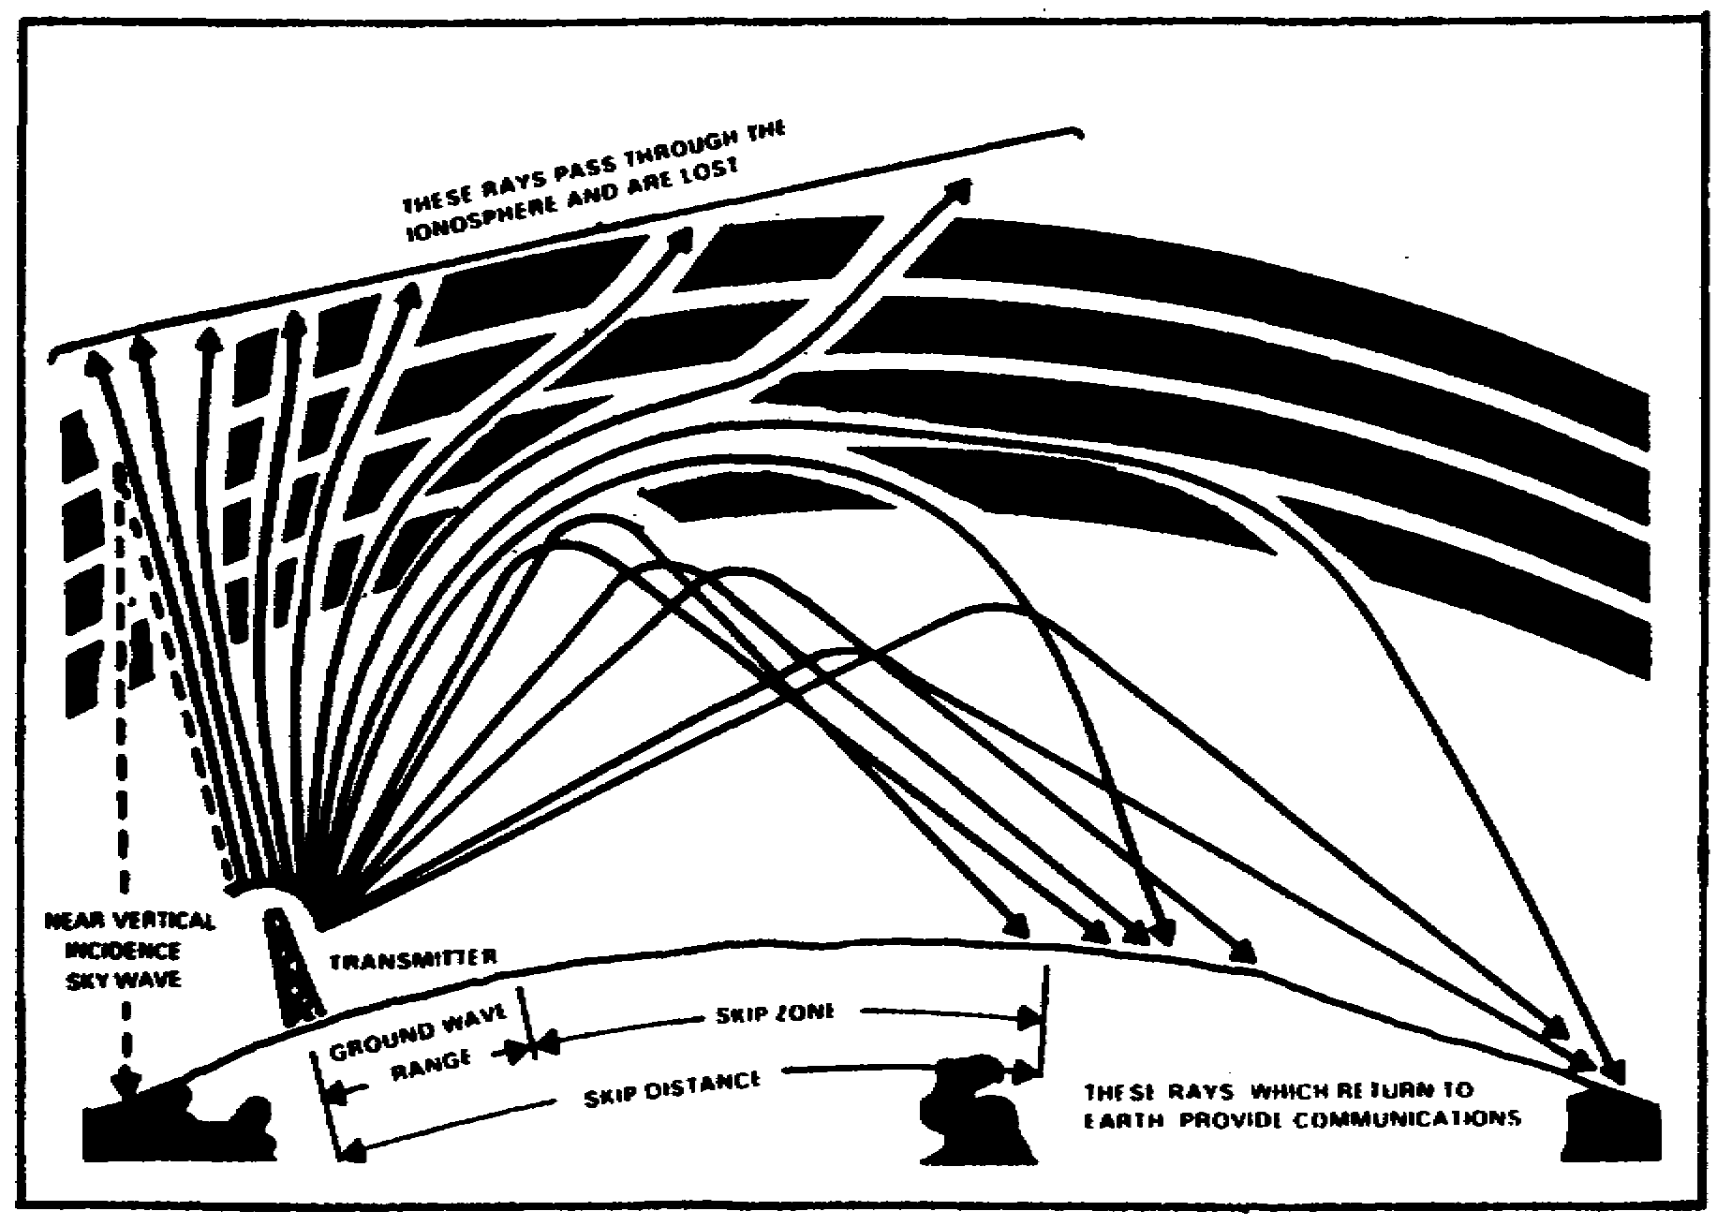
Figure 23.

35

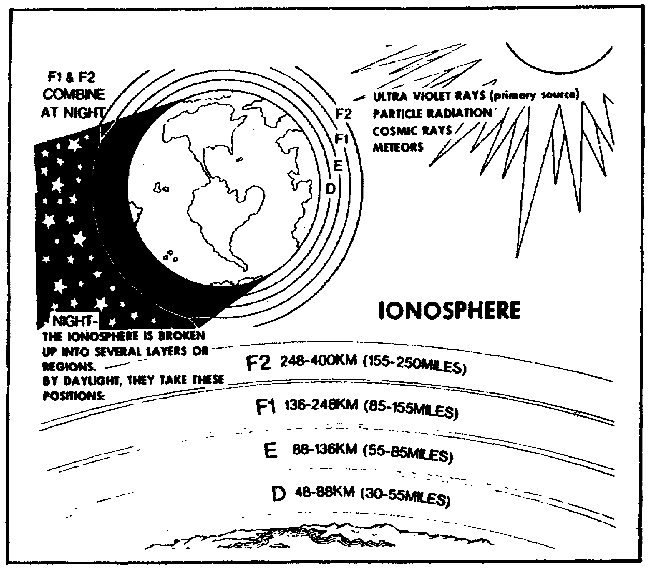
Figure 24. Average layer distribution of the ionosphere.

36

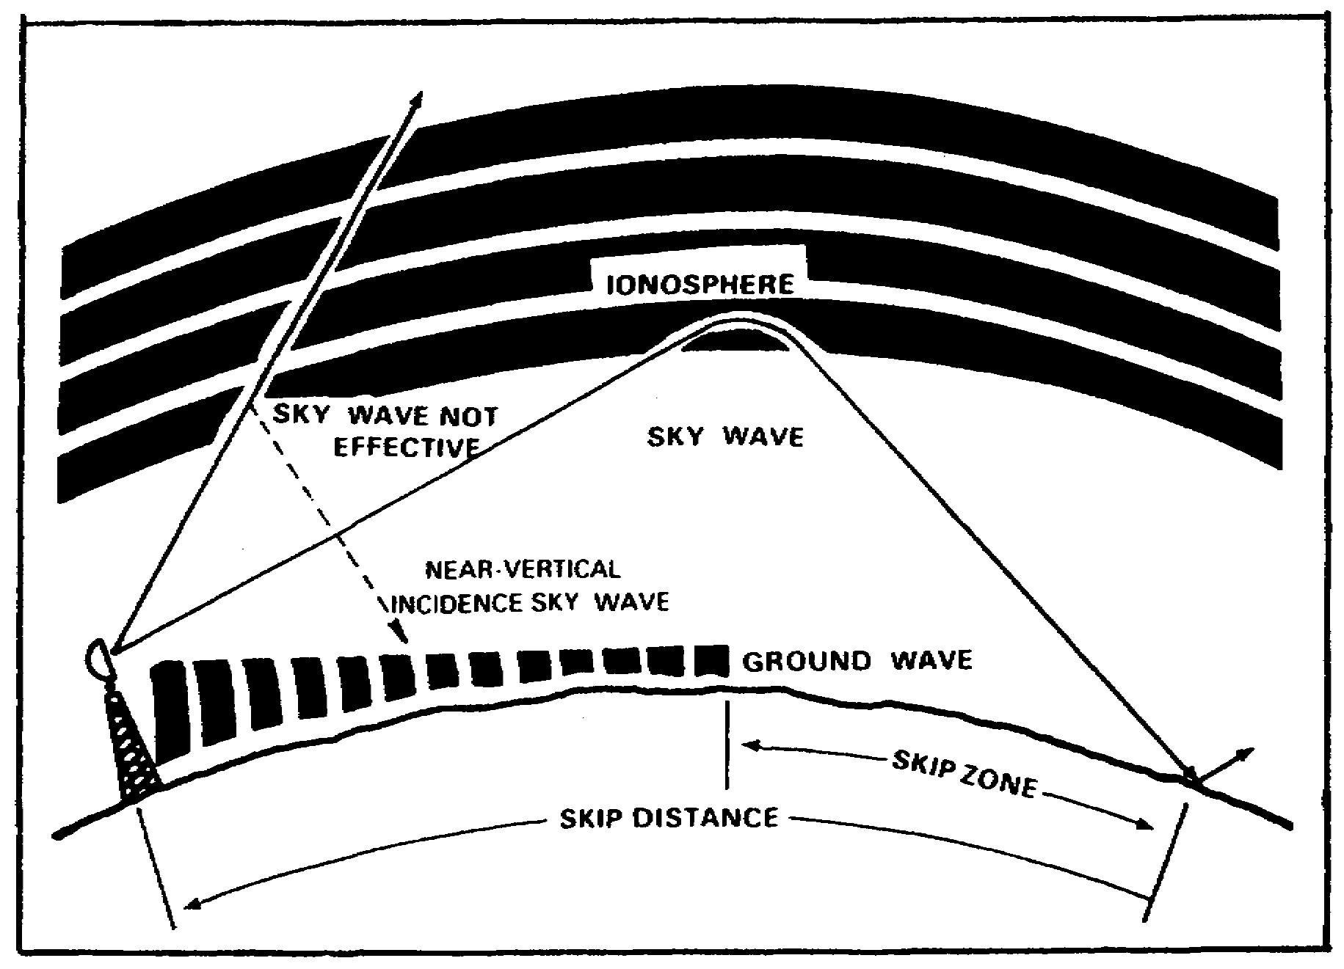
Figure 25. Skip zone.

37

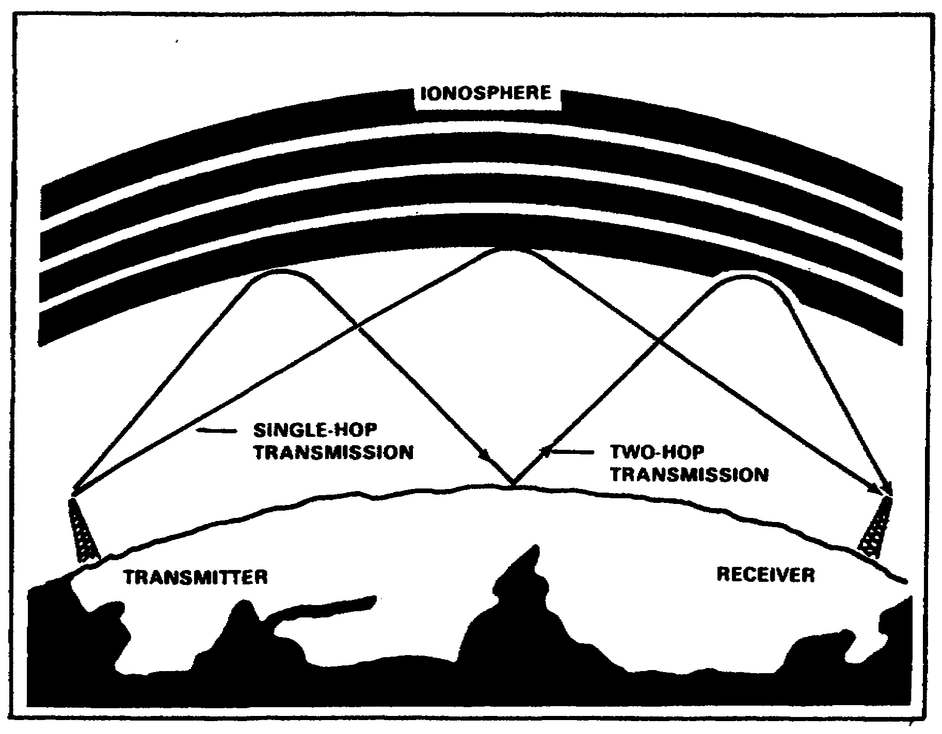

Figure 26.

38

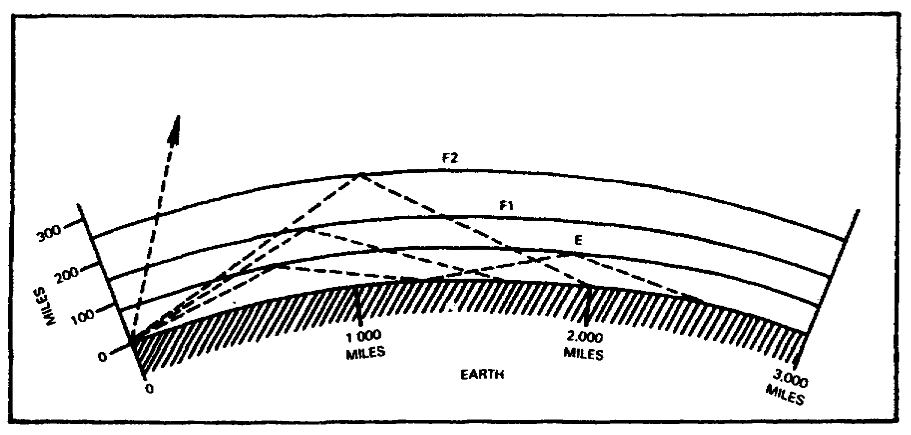
Figure 27. Relating reflected waves to distances along earth's surface.

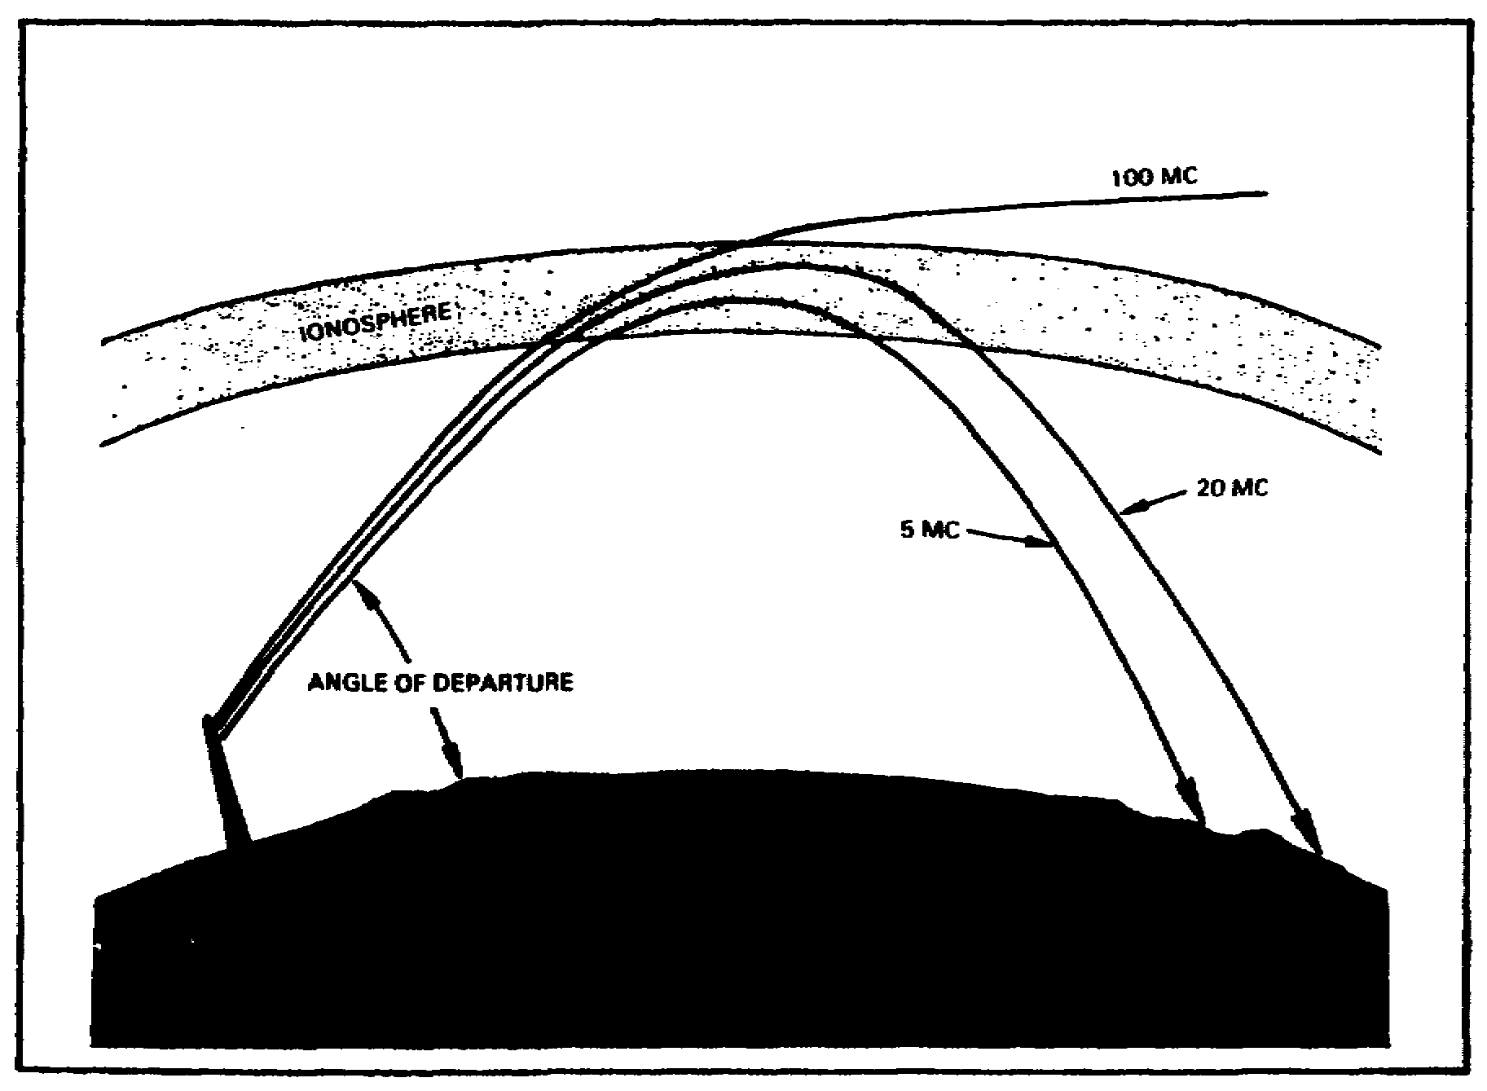
Figure 28. Frequency versus distance for returned waves.

39

c. Lowest Usable Frequency (LUF). For a given distance, there is also a frequency which will be returned and which any further decrease in frequency will result in no communication. The decrease in frequency results in having all lower frequencies absorbed by the ionosphere or the earth. This is called the LUF.

d. Optimum Working Frequency (FOT). The frequency we select should be a compromise between the MUF and the LUF. With the fluctuations of the ionosphere, communication might not be possible using the MUF or LUF. We therefore choose a frequency that is lower than the MUF and higher than the LUF. This frequency is referred to as the FOT.

e. Signal Strength. There are several factors that affect the received signal strength. The orientation of the transmitting antenna, if possible, should be broadside to the direction of the receiving station (s). Likewise, the receiving antenna should be broadside to the transmitting station(s). As the radio signal passes through the layers, partial absorption takes place. Part of the signal is also lost when the signal is reflected from the earth. Fading is the rapid fluctuations of ionization of the layers, causing the signal to reflect off different layers.

40

LESSON 1/LEARNING EVENT 2

PRACTICE EXERCISE

Instructions: Select the BEST response, and circle the correct answer.

1. The direct wave uses--

a. ionosphere.

b. troposphere.

c. atmosphere.

d. none of the above.

2. A maximum sunspot number--

a. means you can use higher frequencies.

b. means you can use lower frequencies.

c. has no effect on frequency selection.

d. means a longer direct wave.

3. A sunspot cycle is--

a. 4 years.

b. 8 years.

c. 11 years.

d. 15 years.

4. The 27-day cycle relates to--

a. moon's rotation.

b. earth's rotation.

c. frequency rotation.

d. sun's rotation.

41

5. To be refracted higher frequencies--

a. requires less ionization.

b. requires more ionization.

c. requires the use of the atmosphere.

d. requires the use of the stratosphere.

Turn to page 168 to check your answers.

42

LESSON 1

COMPREHENSIVE PRACTICE EXERCISE

Instructions: Select the BEST response, and circle your answer.

1. Which of the following frequency bands has the longest ground-wave range?

a. 30 kHz to 300 kHz.

b. 3 MHz to 30 MHz.

c. 30 MHz to 300 MHz.

d. 300 MHz to 3,000 MHz (3 GHz).

2. Which of the following frequency bands has the longest sky-wave range?

a. 300 kHz to 3 MHz.

b. 3 MHz to 30 MHz.

c. 30 MHz to 300 MHz.

d. 300 MHz to 3,000 MHz (3 GHz).

3. Sky wave uses--

a. the troposphere.

b. the C layer.

c. reflection.

d. a vertical radiation pattern.

4. The various layers are created by--

a. recombination.

b. the atmosphere.

c. ground wave.

d. the sun.

43

5. If you are in the skip zone you would--

a. not receive a signal.

b. receive a signal.

c. receive ground wave only.

d. receive sky wave only.

Turn to page 168 to check your answers.

44

LESSON 1

IDENTIFY CHARACTERISTICS OF WAVE PROPAGATION



45

Lesson 2/Learning Event 1

LESSON 2
CALCULATE ANTENNA LENGTH

TASK: Calculate antenna length, and identify antenna properties.

CONDITIONS: Given this lesson material, pencil, paper and without supervision.

STANDARDS: Demonstrate competency of the task skills and knowledge by correctly responding to 70 percent of the multiple-choice test covering calculating antenna length and identifying antenna properties.

Learning Event 1: CHARACTERISTICS OF ANTENNAS.

Half-Wave and Quarter-Wave Antennas

1. Basic Theory.

a. The antenna is part of the electrical circuit of the transmitter and receiver. As mentioned earlier, radio waves travel in free space at 300,000,000 meters per second. Our antenna is not in free space but erected over and near terrain features which affect antenna length. For that reason, the physical length of the antenna is shorter than the electrical length.

b. There are several factors which cause the antenna to be physically shorter. As the diameter of the antenna wire increases, the velocity or speed of the radio waves is slowed, decreasing antenna length. See Figure 29.

46

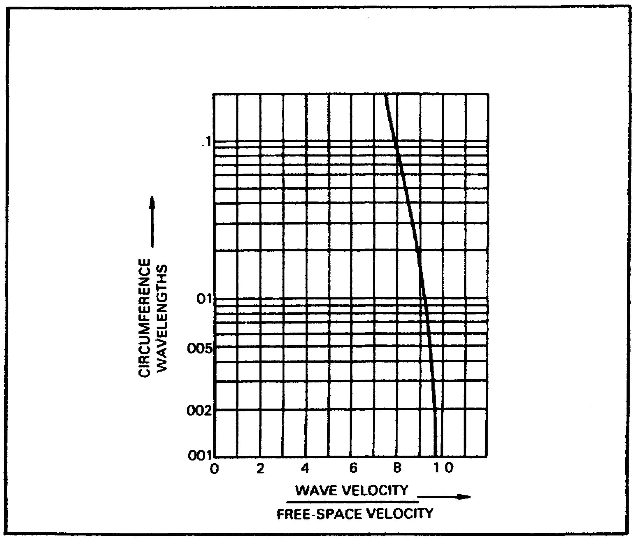
Figure 29. Effect of antenna circumference on wave
velocity.

c. Another factor that affects antenna length is the feed line that connects the transmitter to the antenna. The insulators also affect antenna length. This is called end effect and is compensated by making the antenna 5 percent shorter. Thus to find antenna length you use the formula

N = number of half waves

L = .95(492/F) or said another way L = N-.05(492)/F

L = 468/F (F = frequency in megahertz)

d. The half-wave antenna is the shortest antenna that a transmitter will load efficiently. This is called a resonant antenna. Resonant means that the electrical length matches or equals the physical length of the antenna. The purpose of the antenna is to radiate as much of the power of the transmitter as possible.

e. Impedance. Half-wave antennas fed in the center have an impedance of 73 ohms. Half-wave antennas fed at the end have an impedance of 2500 ohms. Off-center fed antennas normally have an impedance of 500 to 600 ohms.

47

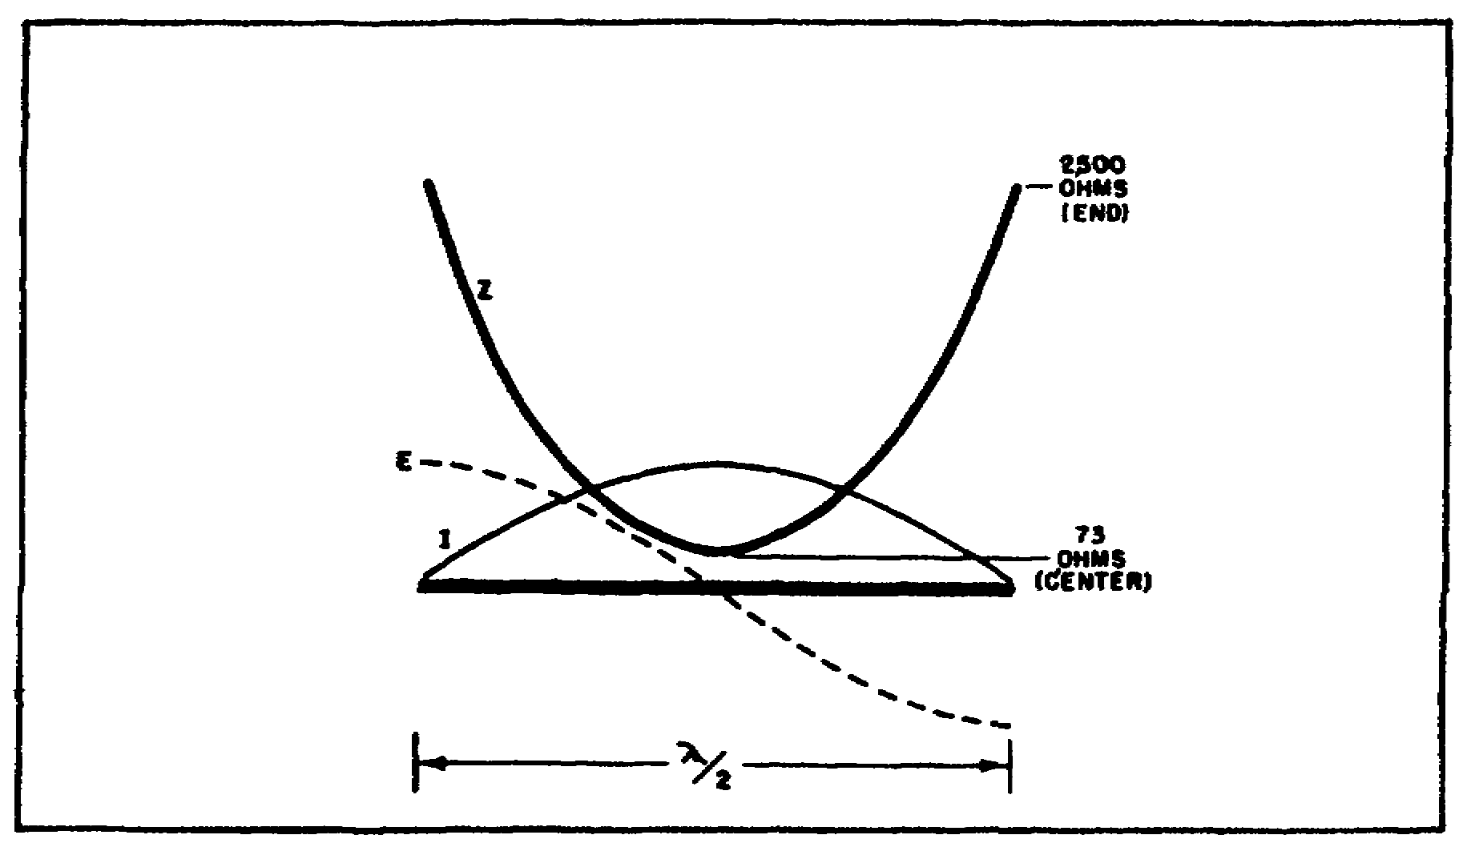
Figure 30. Impedance along half-wave antenna.


SWR (standing wave ratio). Radio energy travels on a correctly cut antenna in sine waves consisting of voltage and current. When the antenna is the proper length the sine wave begins at one end of the antenna and ends at the other end of the antenna. When the antenna is not the proper length, too short or too long, the sine wave doesn't match the antenna length, causing standing waves, or reflected waves. High SWR could result in no radiated energy. It also causes RF feed back, radio energy backing up making components, mikes, key, etc., hot to the touch. SWR reading should be less than 1.5 to 1, but SWR reading up to 3 to 1 will work.

48

TRANSMISSION LINES

Introduction.

A transmission line is used to carry the RF energy from the transmitter to the antenna. There are times when the antenna is connected directly to the transmitter. Normally, however, the antenna is located some distance away from the transmitter. The transmission line should transfer the power with the least possible loss.

(1) Transmission lines dissipate power in three ways:

(a) Radiation. The transmission line radiates like an antenna, especially if its length matches the antenna.

(b) Heating. Any current flow results in heat. The greater the power the more heat is produced. To reduce skin effect, the cross sectional area of the center conductor is increased.

(c) Reflection. Radio energy emitted by the transmitter goes to the antenna in what we call traveling waves. If there is no load (antenna), the traveling waves are stopped abruptly. This causes the waves to be reflected back to the transmitter causing loss.

(2) Types of transmission lines.

(a) Single wire line. This is the simplest type of transmission line - a single wire connected to the antenna with the earth acting as the return path. Since there is only one conductor, the line is considered to be unbalanced. The disadvantage is that the line radiates much like an antenna, causing high line loss, because of no return path. The other disadvantage is that because of no return path, it is difficult to match the line to the antenna. An antenna tuning unit is required to match the transmitter to the line and antenna. However, there are times when the advantages of easy installation far outweigh the disadvantages. Some transmitters are broad enough to load across many types of transmission lines and antennas.

(b) Twisted pair. Two insulated wires (WD-1) can be used as a transmission line. It offers easy installation, but has high loss and should not be used above 15 MHz.

(c) Coaxial lines. When one conductor is placed inside the other separated by foam or plastic it transfers the RF power to the antenna with a minimum of loss. There is some loss as the frequency is increased. To offset this, the cross sectional area

49
of the center conductor is increased. This is the best transmission line to use, because it has the least power loss.

BASIC FEEDER SYSTEMS

Introduction.

The transmission line transfers the RF power from the transmitter to the antenna. There are two general types of transmission lines: resonant (tuned) and nonresonant (untuned).

(a) Resonant feeder line is the same length as the antenna. It is rarely used in tactical applications.

(b) A nonresonant transmission line is one that has an SWR of less than 1.5. In order to achieve this, the impedance of the antenna and the transmission line must match. An antenna tuning unit is used in some applications to match the transmitter to the line and antenna.

(1) Single-wire feed. A single wire can be used as a nonresonant feed line. Because the impedance of a single-wire feed is 500 to 600 ohms, a point on the half-wave antenna must be selected that will match the impedance of the line. The antenna impedance varies from 2500 at the end to about 73 ohms in the center. A point 14 percent from the center of the antenna will provide the 500 to 600 ohms required (A of figure 31). To reduce radiation or coupling make sure the single-wire feed is at right angles to the antenna. A good electrical ground connection is also required to provide a return path to the transmitter.

(2) Twisted-pair feed. WD-1 can be used in an emergency to provide a feed line from the transmitter to the antenna (B of figure 31). The impedance requirement of a twisted pair is 70 to 80 ohms. The center of the half wave antenna provides that impedance. This type of feed should be used only as a last resort because of the very high power loss.

50

Figure 31. Single-wire and twisted-pair feed systems.

(3) Coaxial line feed. A coaxial feed provides a two conductor line which offers the least line loss of all practical field feed systems.

51

BASIC RADIATION PATTERNS

Introduction.

An antenna radiates energy in a particular pattern in free space. It is useful to examine these radiation patterns. It is possible to design an antenna system to provide us with the best possible communication.

(1) Radiation types and patterns.

(a) An example of a source that radiates in all directions is the sun. This type of radiator is called an isotropic radiator. If we could measure the sun's radiation as we move around it in a circle, we would find it was the same all along the circle.

Figure 32. The sun as an isotropic source of radiation.

(b) Another type of radiator is called anisotropic. An example is a flashlight. The light beam radiates only a small portion of the total space around the flashlight. If we move in a circle around the flashlight, we find the level goes from zero to maximum then back to zero again.

52

Figure 33. Flashlight as anistropic source of radiation.

(2) Dipole antenna radiation.

(a) The terms dipole and doublet are used interchangeably. Both are used to indicate a basic half-wave antenna.

(b) Radiation pattern of a doublet. The doublet is the simplest form of an antenna. The radiation pattern is similar to the flashlight. See figure 34. There is a vertical as well as a horizontal radiation pattern. As you can see, the pattern is in the form of a doughnut. Whether it is seen from the side or from the top, the pattern is full.

53

Figure 34. Development of vertical and horizontal plane
polar patterns from solid radiation pattern.

54

Figure 35. Radiation pattern of dipole (half-wave) antenna.

(c) By looking at figure 35, you can see that the antenna can be mounted either vertically or horizontally. The radiation patterns are similar. The difference is that a horizontal antenna radiates horizontally in two directions, while a vertical antenna radiates horizontally in all directions. Figure 36 indicates the beam width and relative power patterns.

55

Figure 36. Beam with measured on relative field
strength and relative power patterns.

PRACTICAL HALF-WAVE ANTENNAS

1. Introduction.

a. We have discussed how to calculate a half-wave. Now, let's discuss the patterns half-wave antennas make. We have shown in figures 34 and 35, the radiation pattern of an antenna in free space. Since our antennas must be erected over earth, the patterns created are different.

b. The ground has the greatest effect on the medium and high frequency antennas which are mounted fairly close to it in terms of wavelength.

2. Ground Effects.

a. If a horizontal antenna is erected some distance above ground, its radiation pattern is as shown in figure 37. Notice that some of the energy travels directly to the distant station. Notice also that part of the energy strikes the ground directly in front of the antenna. As we have learned earlier, phase reversal takes place and may cancel out the direct wave if the ground-reflected wave and the direct wave arrive at the same time and are out of phase. If they arrive in phase, the ground reflected wave adds to the direct wave, making it stronger. As the height of the antenna is increased, the ground reflected signal either adds to the direct wave or creates a null. This action results in a series of radiation lobes. As we have also

56
learned, radio energy goes into the earth before it is reflected. The conductivity of the earth will determine how deep the signal will penetrate and how much of the signal is reflected.

Figure 37. Reflection produced by ground plane.

3. Ground-Affected Radiation Patterns.

a. Reflection factor. If we assigned the direct wave a value of 1 and the ground reflected wave a value of 1, then the maximum signal we could have would be 2. As we see from Figure 38, there are varying vertical angles of maximum and minimum radiation lobes. The number of lobes vary as the height of the antenna above ground is increased.

b. Horizontal half-wave antenna. Let's apply the reflection factor to a horizontal antenna erected at distance above ground. Notice figure 38. Patterns A, C, E, and G are the vertical radiation patterns. Patterns B, D, F, and H are the vertical radiation patterns at right angles to the antenna. Figure 39 shows a better picture of the radiation produced. Both figures 38 and 39 show a half-wave antenna.

c. Notice that in figure 38, as the height is increased from a quarter wave length above ground, the lobe divides into two lobes. Notice also that the number of lobes equal the number of quarter waves. At four quarter waves or one wave length above ground, there are four lobes. Notice also that for odd quarter wave heights above ground the major lobe is at 90 degrees.
57

Looking At The Looking At The
Antenna Broadside Antenna From The End

Figure 38.

58

Figure 39. Solid pattern produced by horizontal half-wave
antenna located a half-wavelength above ground.

d. Vertical half-wave antenna. Ground reflection also affects vertical antennas. See figures 40 and 41. Notice that a vertical antenna erected 1 quarter wave above ground has two lobes. As the height is increased, the number of lobes increases. An antenna 1 wave length in height has 6 lobes.

e. It now can be seen that the ground reflection factor and the antenna height play a major role in the radiation of radio energy. In later sections we will see that we can select a particular antenna height for a certain distance of transmission. For example, for short distances the antenna height should be less than a quarter wave. For long distance communication, the antenna should be a half wave or more in height. We can improve the ground reflection through the use of a counterpoise or radial ground. This increases the conductivity of the earth and lessens the energy lost going into the earth.

59

4. Changes in Radiation Resistance.

a. The radiation resistance at the center of a half-wave horizontal antenna erected in free space is 73 ohms. The actual resistance of the same antenna erected over varying ground conductivity and heights is zero to approximately 100 ohms.

b. See Figure 42. The change in resistance occurs because of the ground reflected wave. It occurs in the following manner: Let's say that a given power is applied to an antenna in free space. The radiation resistance is 73 ohms because there was no ground reflection. But, suppose that the same antenna is erected at a given distance above the ground. The ground reflects part of the energy back to the antenna, adding to the existing current and lowering the resistance. It is assumed that the ground reflected wave was in phase with the direct wave; therefore, adding to the original current. If the two waves are not in phase, the overall current is less, resulting in a higher radiation resistance.

c. The change in radiation resistance of a vertical half-wave antenna is much less than that of a horizontal antenna. The maximum resistance is 100 ohms at the center of the antenna at a height of a quarter-wave above ground. It decreases to about 70 ohms at a height of a half-wave length.

60

Figure 40. Vertical-plane radiation patterns produced by
vertical half-wave antennas.

61

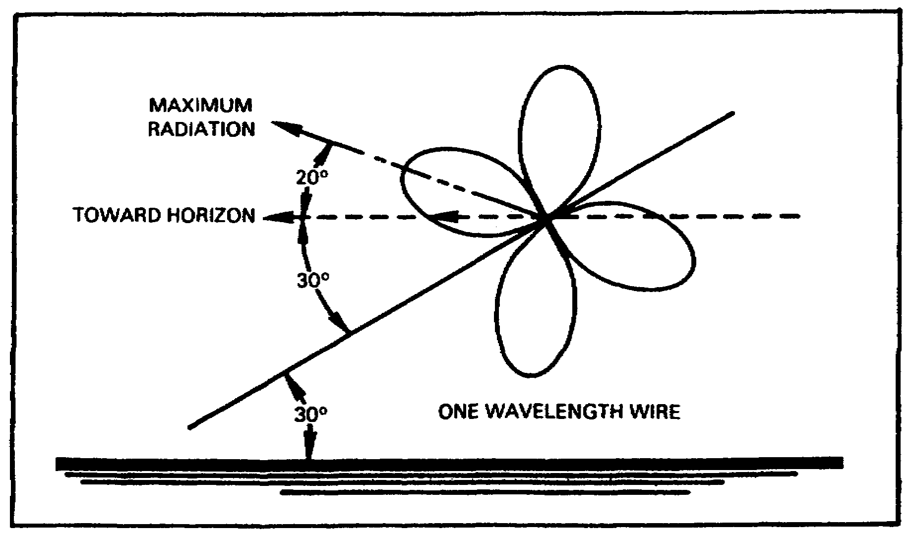
Figure 41. Solid patterns produced by vertical half-wave
antenna located a half-wavelength above ground.

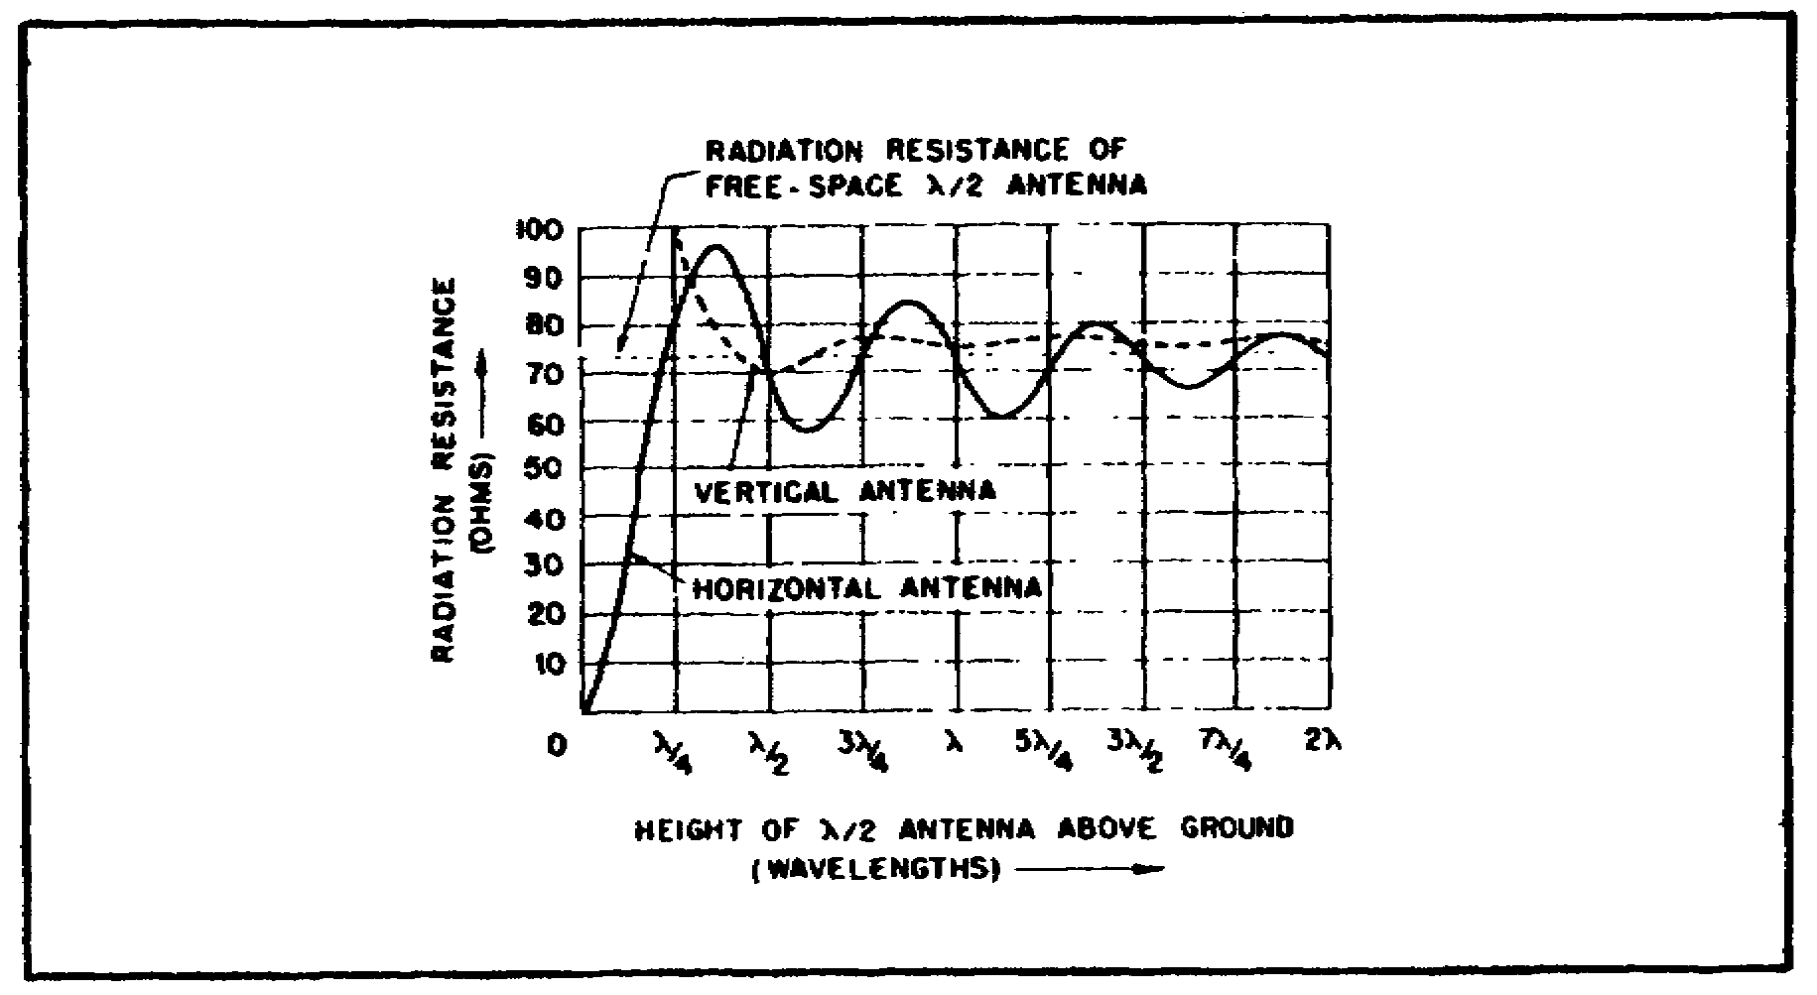
Figure 42.

62

Table 6. Ground Material Conductivity.

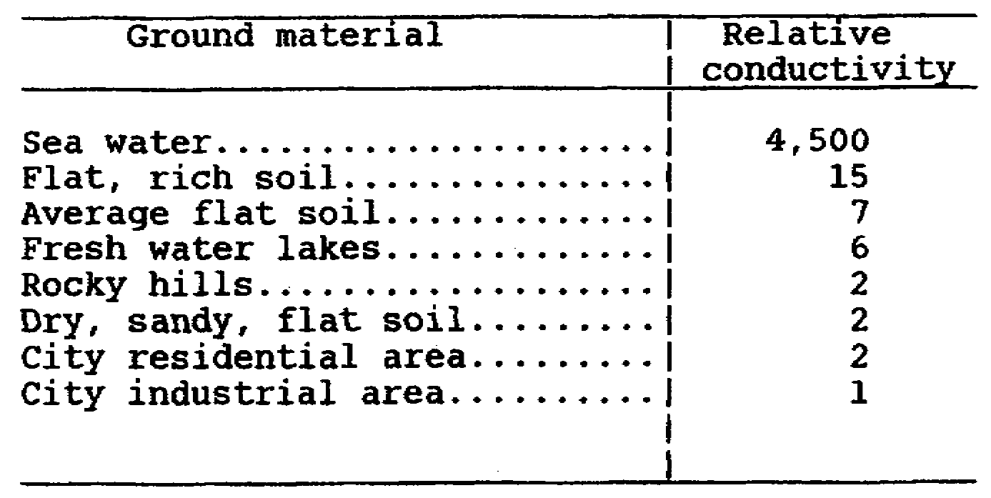

5. Effects of Practical Grounds.

a. Up to this point we have discussed the reflection factor over a uniform high conducting ground. As we can see from table 6, the conductivity varies over different types of ground. How does this affect a reflected signal? Instead of having a maximum reflection factor of 2 (1 from the direct wave and 1 from the ground reflected wave), we might have the direct wave only. This could occur if the antenna was erected over a poor conducting ground. In addition, incomplete nulls might be produced. This would happen if the reflected wave was in phase with the direct wave and both waves not of equal amplitude. Also, the reflected wave could be absorbed by the earth.

b. Frequency effects. Not only does the ground affect the radiation pattern, it has a pronounced effect on certain frequencies. At low and medium frequencies, the radio waves go into the earth to a depth of about 50 feet. The lower the conductivity, the further the wave goes into the earth. At high frequencies, the wave penetrates to a depth of about 5 to 10 feet. Ground absorption is considerable for takeoff angles below 12 degrees. As the frequency is increased, the ground reflected wave is further absorbed until only the direct wave is left. The radiation resistance over imperfect ground is less than it is over a good conducting ground.

c. Antenna height. The question of how high an antenna actually is above ground is not an easy one to answer. Since the wave goes into the earth, it is difficult to determine the true height of an antenna. We can make any ground a better reflecting conductor by using a counterpoise or radial ground, to create a definite starting point.

63

6. Polarization.

a. The band of frequencies we use will determine the best polarization. At low and medium frequencies, vertical polarization should be used. This will take advantage of the surface wave which travels vertically. A horizontal antenna has a horizontal wave that will be short-circuited and will travel less than a vertical wave at the same frequency. The disadvantage of using a vertical antenna at these frequencies is that a sky hook will have to be used to hold the antenna up. For example, a 2 MHz antenna that is a quarter wave long is 117 feet. It would not be possible to erect a practical field antenna 117 feet high. We, therefore, would be forced to use a horizontal antenna. We would be forced to make a compromise - like it or not. At frequencies above 3 MHz, the polarization is immaterial. However, for a sky wave, a horizontal antenna should be used. For a ground wave, a vertical antenna should be used. The disadvantages of a vertical antenna are that it radiates in all directions. Also, if its a whip, a high loss occurs caused by the loading coils trying to compensate for the whip being too short.

b. The choice of whether an antenna is vertical or horizontal, in some cases, is out of our hands. If we are mobile or mobile at a halt, obviously, the only choice is a vertical antenna. Likewise, if we are in a jungle area, our choice must be horizontal. A desert or arctic location also presents a challenge of how to install a mast section to support a horizontal antenna. In most cases, most of our nets are of short distance (0 to 35 miles). This makes communication difficult because you can't communicate by ground wave only, nor can you communicate by sky wave only, especially if the antenna is a whip. For short distance sky wave a horizontal antenna should be used erected a quarter wave or lower above ground. Lower antenna heights can be used with some degradation of the transmitted signal. If a whip is used for sky wave then it should be bent at a 45° angle.

64

LESSON 2/LEARNING EVENT 1

PRACTICE EXERCISE

Instructions: Select the BEST response, and circle the correct answer.

1. Which of the following affect the physical length of an antenna?

a. Terrain features.

b. Wire cross section.

c. Insulators.

d. All the above.

2. The most efficient antenna length is--

a. eighth of a wave.

b. quarter of a wave.

c. half a wave.

d. one wave.

3. SWR is caused--

a. by an antenna cut to proper length.

b. terrain features.

c. ground conductivity.

d. by an incorrect antenna length.

4. Which of the following makes the best feed line?

a. Twisted pair.

b. TV lead in.

c. Single wire.

d. Coax.

Turn to page 169 to check your answers.

5
Lesson 2/Learning Event 2

Learning Event 2: COMMON ANTENNAS.

HORIZONTAL ANTENNAS

1. Doublet. The doublet antenna is the most common HF antenna used by the military. The doublet usually comes in kit form. The kit consists of either wire on a reel or metal tape on a reel. A coax is the feed line. Forty foot mast section kits are also used with the kit. As shown in figure 43, when the antenna is longer than 120 feet, a third mast section should be used to prevent sag. As shown in figure 44, a counterpoise may be used. The purpose of the counterpoise is to prevent the ground reflected wave from being absorbed. The signal strength of the radiated signal will be improved if a counterpoise is used. A counterpoise (see figure 44) is an artificial reflecting surface used to reflect the reflected wave. This adds to the direct wave making the transmitted signal stronger. A counterpoise can also make communication worse if connected to the equipment ground. Always try communicating first without the counterpoise attached to the equipment ground. Then try with it attached to the equipment ground. Use whichever is best. The terms doublet and dipole antennas are used interchangeably. The maximum radiation is at right angles to the antenna.

66

Figure 43. A Typical Doublet.

Figure 44. Doublet for path of 100 miles or less, showing
use and placement of counterpoise.

2. The 14 percent off-center fed antenna. The antenna is a wire which is a half wave in length. The feed line is a single wire attached to the antenna 14 percent from the center. A counterpoise may be used to reduce the absorption of the ground reflected wave. The transmission line should be at right angles to the antenna to reduce radiation and coupling back to the antenna. See figure 45. The radiation resistance is 500 to 600 ohms. Your transmitter would need an antenna tuning unit to load this antenna, or the transmitter would have to have the capability of loading antennas over a wide impedance range. Because of the single wire feed this antenna has a high power loss.
67

Figure 45. Fourteen percent off-center fed antenna.

3. The inverted L antenna. The inverted L antenna (figures 46, 50) is a half wave or a quarter wave in length. It is end fed. It uses a single wire feed that can be a quarter wave in length, or may be connected directly to the whip binding post. The impedance of an inverted L is 2500 ohms. An antenna tuning unit is needed to load this antenna, or the transmitter must be able to load antennas over a wide impedance range. A counterpoise may be used to reduce ground absorption. The counterpoise should be 3 to 4 inches above ground using tent pegs. However, the antenna will perform without the counterpoise. The counterpoise ensures that the ground reflected wave is not absorbed but adds to the direct wave.

68

Figure 46. Inverted "L" antenna.

69

Figure 47.

4. The slant-wire antenna. The slant-wire antenna (figures 48, 49) is two quarter-wave lengths of wire. The impedance is 73 ohms. A quarter wave counterpoise may be used. The direction of radiation is in the direction of the counterpoise. This is the best compromise antenna to make use of both the ground wave and sky wave. The terms slant wire and sloping wire antennas are used interchangeably.

70

Figure 48.

Antenna has to be a quarter-wave in length.

Figure 49.

71

Figure 50.

Figure 51.

72

Figure 52.

GROUNDED ANTENNAS

1. Quarter-Wave Antennas.

a. In our previous discussion of the ground reflected wave, we determined that at medium and high frequencies, the ground plays an important part in re-enforcing the direct wave. If the ground is of high conductivity, we can make our antenna a quarter-wave length instead of a half-wave in length. By driving a ground rod into the earth and attaching our equipment to the rod, the earth becomes the other quarter-wave of our antenna. See figure 53.

73

Figure 53. Quarter-wave antenna connected to ground.

Figure 54. Formation of image flashlight.

74

b. A grounded antenna, in which the ground is part of the antenna, can be compared to a person shining a flashlight into a mirror. While standing directly in front of the mirror, the light from the flashlight shines directly into your eyes. The light we see is coming from the flashlight's image. This is similar to the image antenna in a grounded vertical antenna. There is no quarter-wave antenna in the ground. However, the ground reflects the wave much like the mirror reflects the light. Grounded antennas are often referred to as Marconi antennas. Ungrounded antennas are referred to as Hertz antennas.

c. The disadvantage of a vertical antenna is the vertical support needed. It makes practical field antennas impossible to erect. To compensate for length requirements, loading coils are used to stimulate the true length. The disadvantage of loading coils is that they use up RF power while compensating electrically for the actual physical required. Six MHz is the lowest practical frequency for which a vertical quarter-wave antenna can be erected with the present issue mast kits (40 foot AB-155).

Figure 55. Distribution of voltage and current on
a grounded quarter-wave antenna.

75

Figure 56. Electric field around a grounded quarter-wave
antenna.

2. Radiation Characteristics.

a. The radiation pattern of a quarter-wave grounded antenna is similar to that of a half-wave vertical antenna that is not grounded. A grounded quarter wave vertical radiation pattern favors long distance communication (750 miles) with low take off angles, while short distance communications 0-100 miles requires a radiation pattern straight up. See figure 57. The difference is the radiation resistance. An ungrounded half-wave antenna has an impedance of 73 ohms, while a grounded quarter-wave antenna has an impedance of 36 ohms (¹/₂ of a half-wave). This presents a problem to the transmitter which normally requires a 50 ohm load. This causes a mismatch between the antenna and transmitter, which results in a loss of radiated energy. The transmitter's loading coil matches the transmitter to the antenna but uses up some of the RF power while doing so. The shorter the antenna, the more matching required, and the more loss, until you have only a fraction of the original RF power left to radiate into space.

76

Figure 57. Radiation pattern produced by a grounded
quarter-wave antenna.

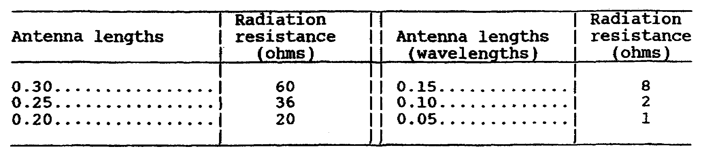

b. In order to decrease the mismatch and the loss, you can make the antenna longer. An antenna slightly less than a half wave in length will match the transmitter's 73 ohm output.

77

Figure 58. Vertical-radiation patterns produced by grounded
vertical antennas of various lengths.

3. Types of Grounds.

a. It is important that communication equipment be grounded. The equipment ground is a safety measure that shunts a potential electrical hazard to earth. The standard ground rod issued with communication equipment should be driven into the earth and then attached to the shelter or equipment. When operating in a building, a cold water pipe may be substituted for the ground rod connection.

b. Sometimes it is difficult to get a good ground, connection especially in sandy locations. Then you must treat the soil with common table salt and water or coal dust and water. The area must be retreated periodically in order to maintain a good ground connection.

c. A method of obtaining an artificial reflecting surface is through the use of a radial ground system. The purpose of the radial is to reflect the ground reflected wave and to add to the direct wave. The radial ground system is an artificial ground or reflecting surface used to compensate for the poor conduction quality of the soil. The most common radial ground system is 36 lengths of wire a tenth to a half-wave in length buried 6 to 8 inches and connected to a ground rod.

78

Figure 59. Ground system for vertical antennas.

d. Still another method of obtaining an artificial reflecting surface is the use of a counterpoise. The counterpoise is elevated above ground several inches. The counterpoise could be a single wire or several wires, but must be the same length as the antenna. Otherwise, the size and shape is immaterial.

e. A radial or counterpoise forms an artificial ground to reflect the ground reflected wave. They are useful for ground or sky wave communication. A grounded vertical should always use a counterpoise or radial ground system. A horizontal antenna doesn't require a ground system near as much as a vertical antenna. The equipment has its own electrical ground. Before a radial or counterpoise is grounded to the equipment ground, a test communication should be made. Then, hook the radial or counterpoise to the equipment ground and check the results. Sometimes, hooking the radial or counterpoise to the equipment ground makes communication worse. Be sure to check communications with and without a ground system. Remember that all antennas will work without a radial or counterpoise system. In all cases, the equipment must be grounded.
79

Figure 60. Wire counterpoises.

80

Figure 61. Vertical quarter-wave antenna.

81

Figure 62. Vertical doublet.

82

4. Bent Antennas.

a. A bent antenna is a compromise antenna when not enough room exists to install a horizontal antenna or supports high enough to erect a vertical antenna are not available.

b. Inverted L antennas come in varied configurations. One configuration is a half wave. The flattop portion could be a quarter wave with a counterpoise as the other quarter wave. See figure 63. Another configuration is only a quarter-wave long. The horizontal portion is an eighth wave and the down lead is the other eighth wave. The other quarter wave is a ground return, a radial, or a counterpoise may be used.

Figure 63. Inverted-L military antenna.

5. Ground Plane Antenna.

a. A ground plane antenna is an antenna with a vertical section of a quarter wave in length, and with spokes, normally three or four in number, each of which is a quarter wave or longer in length. The spokes form the artificial ground. The ground plane is used at VHF (30 - 300 MHz) and higher frequencies. The ground plane is normally mounted on top of a mast and is called an elevated ground plane antenna.

83

Figure 64. Typical ground-plane antenna.

84

Figure 65. Jungle antenna (elevated ground-plane).

85

Figure 66. Vertical ground-plane antenna.

b. When maximum radiation is wanted in a horizontal direction, the spokes are tilted down to an angle of about 50 degrees. The input impedance of a ground plane is 20 to 25 ohms. When the spokes are bent downward, the impedance rises to about 50 ohms.

c. Whip antenna. The worst antenna to use is the whip antenna. The term whip in our case means an antenna that is 15 feet in length. The only good thing that can be said of a whip is that it is convenient for mobile or mobile at a halt situations. We can improve our whip (in the AN/GRC-142) by adding sections to its normal 15-foot length. We should add three more sections (for 2 -12 MHz use) or until our whip approaches a quarter wave (234/f) in length. Because the mast base loses some of its rigidity, you may have to guy the whip. The reason the whip is so poor is

86

because of the loading coils used to match the transmitter to the antenna. Most of the power is consumed doing the matching.

Figure 67. Typical whip antennas.

87

Figure 68. Best directivity of whip antenna mounted on
vehicle.

d. When a whip is mounted on a vehicle, the metal of the vehicle affects the radiation pattern. The maximum radiation is across the vehicle on the opposite side that the whip is mounted on. See figure 68.

e. To improve sky-wave communication using a whip, the antenna should be bent down so that a 45 degree angle is formed. See figures 69 and 70.

f. An important point to remember is that a whip is a poor substitute for a quarter-wave vertical or half-wave horizontal antenna.

88

Figure 69. 0-200 mile net.

89

Figure 70. Tying the whip antenna down.

6. Long-Wire Antennas.

a. Long-wire antennas are antennas that are longer than a half-wave in length. There are two advantages that a long-wire antenna has over a half-wave antenna: directivity and gain. In our discussion of long-wire antennas, the focus will be on practical antennas for VHF (30 -300 MHz) applications. Antennas that are several wavelengths long are not practical for tactical HF (3 to 30 MHz) communications. Antennas several wavelengths long at HF frequencies would be several hundred feet in length.

b. Antenna gain. Antennas discussed previously develop no gain in any particular direction. They either radiate in all directions or radiate in two directions only. A point can be made that a horizontal antenna has gain as compared to a vertical antenna. Power to a vertical antenna goes in all directions, while power to a horizontal antenna goes in two directions.

90

7. Harmonically Operated Antennas in Free Space.

a. Calculation of length. We learned earlier that an antenna in free space is longer than an antenna erected over ground. The effects of the insulators and the earth made the antenna shorter. The insulators are at the ends of the antenna. In order to compensate for the end effect, we must shorten the antenna by 5 percent using the formula below. The formula for a harmonic or long-wire antenna is:

length = 492(H-.05) = 468
frequency frequency

where H equals the number of half waves.

b. Directivity and gain. The gain of a long-wire antenna can be seen from the chart below. As you can see there is very little gain until the antenna is six wave lengths long. For each three db gain, its like doubling your transmitter's output power.

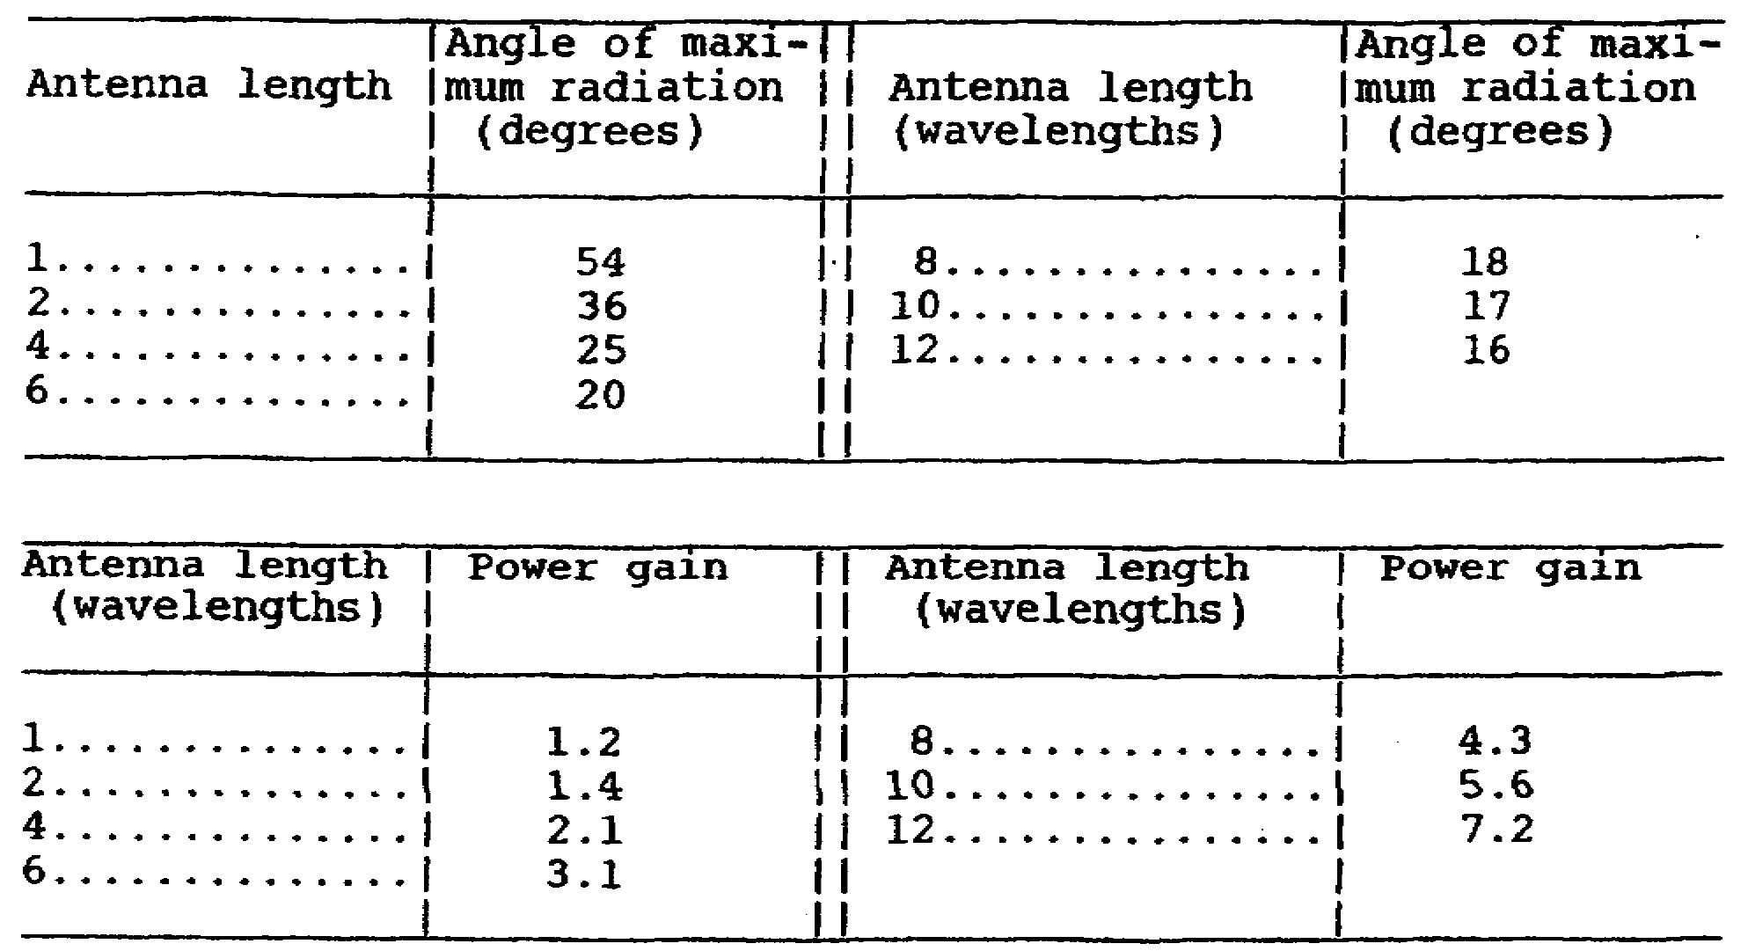

c. In figure 71, we can see the radiation pattern developed from various harmonic antenna lengths. As the number of half waves are increased, the number of lobes are also increased.

91

Figure 71. Radiation patterns of harmonic antennas.

8. Nonresonant Antennas.

An antenna has traveling waves that move up and down the antenna. If we terminate one end of the antenna with a resistance, while feeding the other, the waves can travel in one direction only. This is called a nonresonant antenna. The radiation is in the direction of the resistance. This type of antenna radiates efficiently over a wide range of frequencies.

9. Half-Rombic Antenna.

a. A half-rombic antenna is similar to an inverted V in shape. It radiates in a vertical direction. In figure 72, you see a comparison of two different half-rombics - one terminated, the other not. You can see that the advantage of the terminated half-rombic is that its radiation pattern is in one direction only. The lobes that are missing in B have combined with the remaining lobes. The terminating resistor is 500 ohms with a power rating of one-half the transmitter's RF output.
92

Figure 72. Development of radiation pattern of
half-rhombic antenna.

b. The half-rombic should be at least two wavelengths long at the lowest operating frequency. For example, at 30 MHz, two wavelengths is approximately 65 feet. A counterpoise is used with a half-rombic antenna to reduce ground loss.

There are four half waves in two wavelengths.

93

A more convenient formula for a 2 wavelength half-rombic antenna is--

N = Number of full waves

Because the length is not critical the factor .025 may be dropped, leaving the formula--

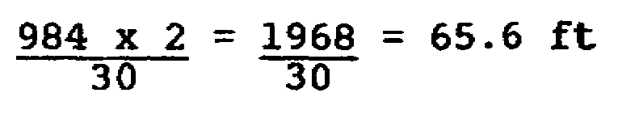

c. The half-rombic can be used for frequencies as high as three to four times the lowest frequency. For example, a half-rombic cut for 30 MHz should be good at 90 MHz, which is more than enough to cover the entire range of our VHF sets.

Figure 73. Typical military half-rombic antenna.

94

10. Near Vertical Incidence Sky-Wave (NVIS).

The disadvantage of HF communication is that at times it is unreliable as compared to FM communication. What one forgets is that even though HF transmitters are often high powered, their most effective frequency range (2 to 5 MHz) works against them. If we try to use a whip, most of the RF power is used up by the loading coils trying to match the antenna to transmitter. In some cases, the FM set has more effective radiating power than the HF set. What to do? To maximize the sky wave, when forced to use a whip, add additional sections (3-116 for frequencies, 2-12 for AN/GRC-142) so that the length will nearly equal a quarter wave. Bend the antenna down until it is at a 45 degree angle. Do not use the extended whip in a vertical position unless our stations are within ground wave range (consult ground wave book), because the radiation takeoff angle is too low to be effective for short distance sky-wave communication (0 to 100 miles). To be effective, our radiation pattern needs to be straight up. The slant or sloping wire antenna will also offer a good compromise short distance sky wave communication. A doublet, 10 to 30 feet high, is the best antenna. Orientation of the antenna is immaterial.

11. Electromagnetic Pulse.

a. During a nuclear war, your equipment could be destroyed without your even knowing about it. You and your equipment could be hundreds of miles away from the blast area. After a nuclear blast, an electric charge is sent out many times stronger than a lightning bolt. The charge travels through space and is attracted to antennas and power lines. A lightning bolt may have 50,000 volts while a nuclear EMP charge might have 1,000,000 volts. The bolt follows a path to ground. When we upgraded our equipment from tubes to solid state, we made our equipment susceptible to EMP. We have known about this problem since the early sixties, but we have not known about what to do from a practical point of view.

b. There is no simple and inexpensive solution to the problem. The Russians on the other hand have decided to take a step backward as a solution to the problem. When a MIG-25 pilot defected to the west it was noted that the air frame was made of steel, not a lightweight metal. Also, some of the electronics were not solid state, but of vacuum tube design.

c. During a nuclear test in the sixties, circuit breakers tripped causing a power blackout 800 miles away in Hawaii at the exact instance of the blast. Several years went by before the two events were put together as one related incident.

95

d. Another effect of EMP is a radio blackout lasting from a few seconds to several hours, depending on the frequency. After a blast, the ionosphere becomes superionized and absorbs all frequencies. The upper frequencies will come back first, with HF and the lower bands coming back last.

e. What can you as an operator do to lessen the effect of EMP? Very little. Some progress has been made toward hardening communication equipment - extra shielding around cables, air vents, etc. Some basic precautions are: equipment not needed should be turned off. Antennas should not be installed until needed. Bury all power cables. Equipment not used should be left unplugged when not in use. Never use commercial power. Always ground your equipment. Rethinking of our use of communication equipment is in order. Some of our net radios as well as our multichannel links should be turned off. Have only one net up at a time to lessen the effect of EMP.

12. FM Squelch Capture Effect.

a. We are familiar with the obvious methods of jamming, but not of subtle jamming. We have a characteristic in our FM radios that make them highly susceptible to this type of jamming.

b. When we listen to our FM radios we don't want to be bothered with noise when no one is transmitting. We have a squelch circuit that eliminates that noise. To overcome the squelch, a friendly radio transmitter, as part of his signal, transmits a 150 hertz cycle tone (NEW SQUELCH POSITION) that deactivates the squelch enabling another station to communicate with him. To let him know a call is coming in, the CALL LIGHT lights. A jamming station on the other hand, will not transmit a 150 hertz tone. The CALL LIGHT will not light. Therefore, you will not know if someone is calling you or not because the jamming signal will be many times stronger.

c. What can you do? Things you can do violate signal security, such as commo checks. Radio checks are unnecessary on an established radio circuit. By contacting other stations, you compromise your location. Valuable signal intelligence can be gained even though the net is encrypted. An electronic signature identifies all units and their locations. One thing you can do that doesn't violate signal security is to put the squelch switch to OFF. If you hear noise, you know you are not being jammed.

96

How often should you do this? It depends on the flow of traffic at the time. If there was a constant flow of traffic and then all of a sudden there is none, be suspicious. Turn the squelch off. However, if traffic is infrequent and there is no traffic for a while, again, be suspicious and turn the squelch off. If you are being jammed, don't forget to submit an interference report. One precaution should be noted, however; the Russians have a jammer that transmits noise. What to do? Change the MHz knob a megacycle up or down, then listen. If there is noise you know you are not being jammed. Move the MHz knob back to correct MHz position.

97

LESSON 2/LEARNING EVENT 2

PRACTICE EXERCISE

Instructions: Select the BEST response, and circle the correct answer.

1. The most common military antenna is the--

a. doublet.

b. inverted L.

c. slant wire.

d. half rombic.

2. A compromise antenna that is good for sky and ground wave use is--

a. doublet.

b. whip.

c. a whip bent at a 45-degree angle.

d. slant wire.

3. Loading coils are used primarily for what type antenna?

a. Doublet.

b. Whip.

c. Long wire.

d. Hertz.

4. Which frequency is the most practical for a half-rombic antenna?

a. 60 MHz.

b. 10 MHz.

c. 5 MHz.

d. 2 MHz.

98

5. The terminating resistor used in a half-rombic antenna is--

a. 500 ohms.

b. 2,500 ohms.

c. 73 ohms.

d. 36 ohms.

Turn to page 169 to check your answers.

99

Lesson 2/Learning Event 3

Learning Event 3: SITING

HF PATH AND SITE ENGINEERING

1. In tactical situations, we are always making compromises. Selecting a communication site is one of them. Seldom will a site satisfy all the physical, electrical, or security requirements. In some situations, the ground is too hard or there is foliage that surrounds us.

2. Site Criteria. An ideal site should meet as many of the following criteria as possible:

a. Level ground, or sloping towards the distant station.

b. Adequate amount of real estate on which to locate equipment and antennas.

c. Away from the base of mountains in the path of transmission.

d. Preferably no foliage under the antenna, or at least not as high as the antenna. Proper separation from wooded areas to meet the needed take-off angle for the distance to distant station (pages 149 and 150).

e. Good earth ground conditions. (Use a radial/counterpoise for vertical antennas.)

f. Away from major highways.

g. Away from power lines.

h. Away from sources of reflection or absorption such as metal buildings, other antennas, high fences, etc.

i. Meet site security requirements. Clear area around the site for at least 100 yards. Surrounding hills should be occupied by friendly troops.

3. Intervening Terrain Considerations. Intervening terrain can play an important part in HF communication, especially short ground wave and long distance sky wave communications.

100

a. Short distance (0-250 miles). For stations within 25 miles of one another, ground wave can be used. In order for good ground wave to be used, the intervening terrain should be flat with no mountains or thick foliage. For short distance sky wave, intervening terrain has little or no effect because of the high take-off angle. The exception are trees, separation from trees, for the transmitting antenna must be maintained if communication is to be maintained. To make the signal stronger, a counterpoise or radial ground should be used. The only requirement for short distance sky wave is having room enough for the antenna and being away from reflecting objects. Antenna heights should be less than a quarter wave, 10 to 30 feet high. Assuming the correct frequency was used, transmit antenna heights of a λ/10 to a λ/4 can be used without noticeable loss of signal at the receiving station(s). (See figure 88 on page 113.) Notice transmit antenna heights of 2 feet at 6 MHz produced a 8 dB loss of signal at the receiving station. Transmit antenna heights of 10 feet will work with some loss of received signal when using frequencies between 2 and 9 MHz, while frequencies above 9 MHz suffer less loss. As the transmit antenna is lowered, the antenna must be made longer because of the ground effect. The loss of received signal is like cutting your transmitter power output in half for each 3 dB loss in received signal. For an 8 dB loss in received signal it is like cutting your transmitter power from 100 to 12 watts.

b. Medium distance (250-1500 miles). There is no ground wave possible at this distance, unless transmitting over water. The same requirements are needed as there were for short distance, except that the antenna should be a half-wave high.

c. Long distance (1500 miles and over). The same requirements as for medium distance, except that the antenna should be as high as possible.

Ground Conductivity For Various Terrain

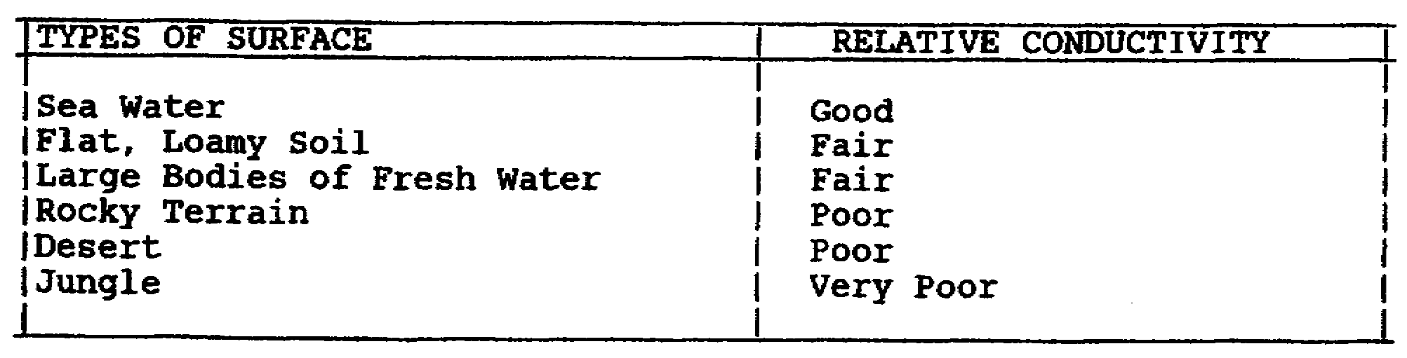

101

Single-hop Skip Distances at Various Vertical Take-off Angles

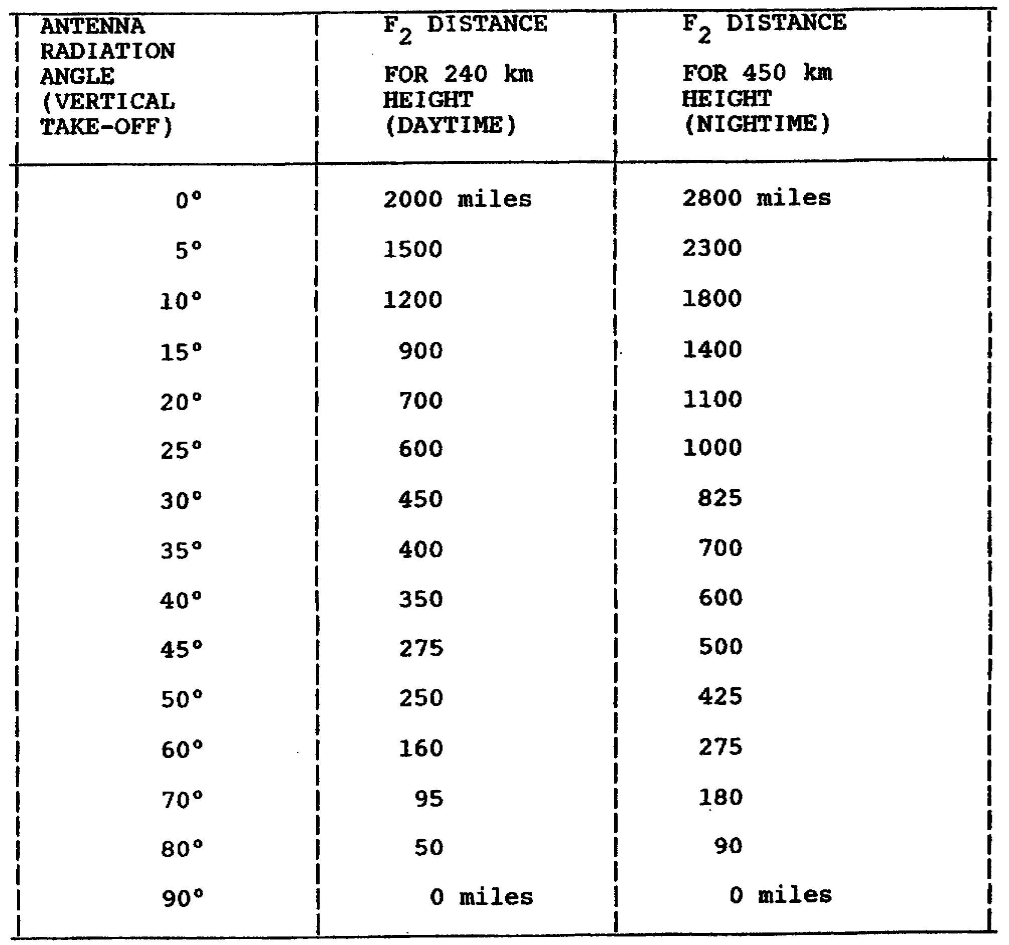

NOTE: Further distances must use multiple hops. This table does not include refraction from E, F or sporadic E layers.

4. Atmospheric Problems.

In certain areas of the world, especially the hot climates around the equator, the atmospheric noise is very high. This forces you to use higher frequencies to get above the noise. The further you get away from the equator, the quieter it becomes. As you approach the pole, the aurora (northern lights)
102

forces you to lower your frequencies because the layer ionization levels are less at the poles.

5. Frequency Planning Table.

The table below is an average for planning the frequencies to use for certain distances during a maximum or minimum sunspot cycle. We should always use the FOT and not the MUF or LUF. Fluctuations in the ionization levels of the ionosphere could raise or lower our frequency beyond the MUF or LUF.

Frequency Planning Guide

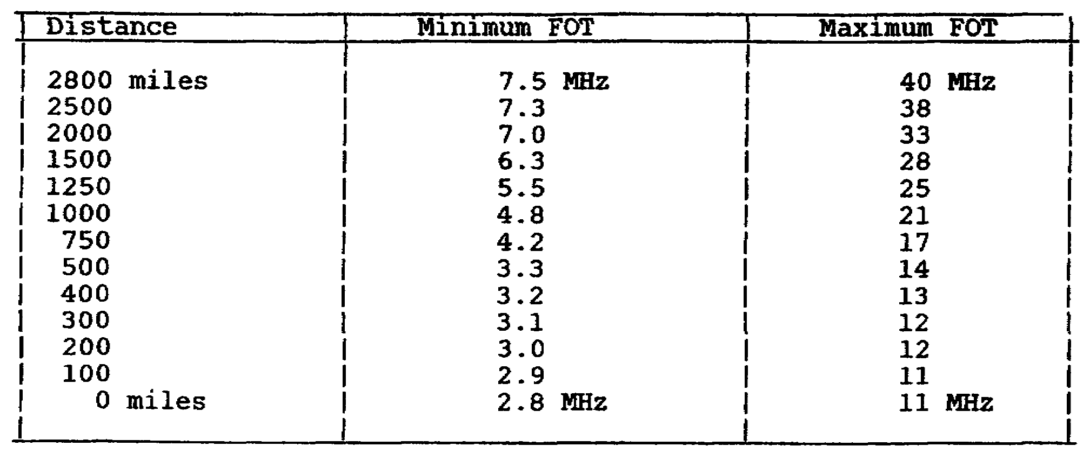

NOTE: Use with single-hop skip distance table for determining required vertical take-off angle and antenna frequency coverage for specific path lengths.

6. Effects of Trees and Bushes on Antennas.

In a wooded or jungle area, the best antenna is a horizontal antenna. A vertical antenna's radiation is absorbed by the vegetation. The denser the vegetation - the more the absorption. Antennas that are affected are the whip, L, slant, and sloping antennas. Metal objects also effect vertical antennas.

7. Planning an HF Vehicular Radio System.

During displacements we must use a whip antenna. What factors can we use to improve and make better this type of communications?

103

(1) Aim the vehicle to the distant station. See figure 74.

(2) Select a frequency as near the FOT as possible, not the doublet's LUF. A frequency above 10 MHz might be possible to take advantage of the ground wave (terrain permitting) if stations are within 25 miles of one another.

(3) Add three additional mast sections (24 feet) so that the whip will be near a quarter-wave in length. If time permits, use a counterpoise or radial ground system. If using ground wave, make sure antenna is completely straight. If sky wave is to be used, bend the antenna at a 45-degree angle. If no contact try a better antenna-slant wire.

(4) Select a hill or a flat clear area. Make a good ground connection.

(5) If time permits, install a "quickie" antenna such as a sloping antenna. See figure 77.

Figure 74. Vehicle chassis counterpoise.

104

Figure 75. Use of the counterpoise with a vehicle.

105

Figure 76. L antenna.

NOTE: Try to make elements one quarter and one half wavelengths, respectively, but antenna will still work well if shorter vertical and horizontal wires are used, provided antenna tuner is used.

106

Figure 77. Sloping wire antenna.

Figure 78. Sky-wave only system.

107

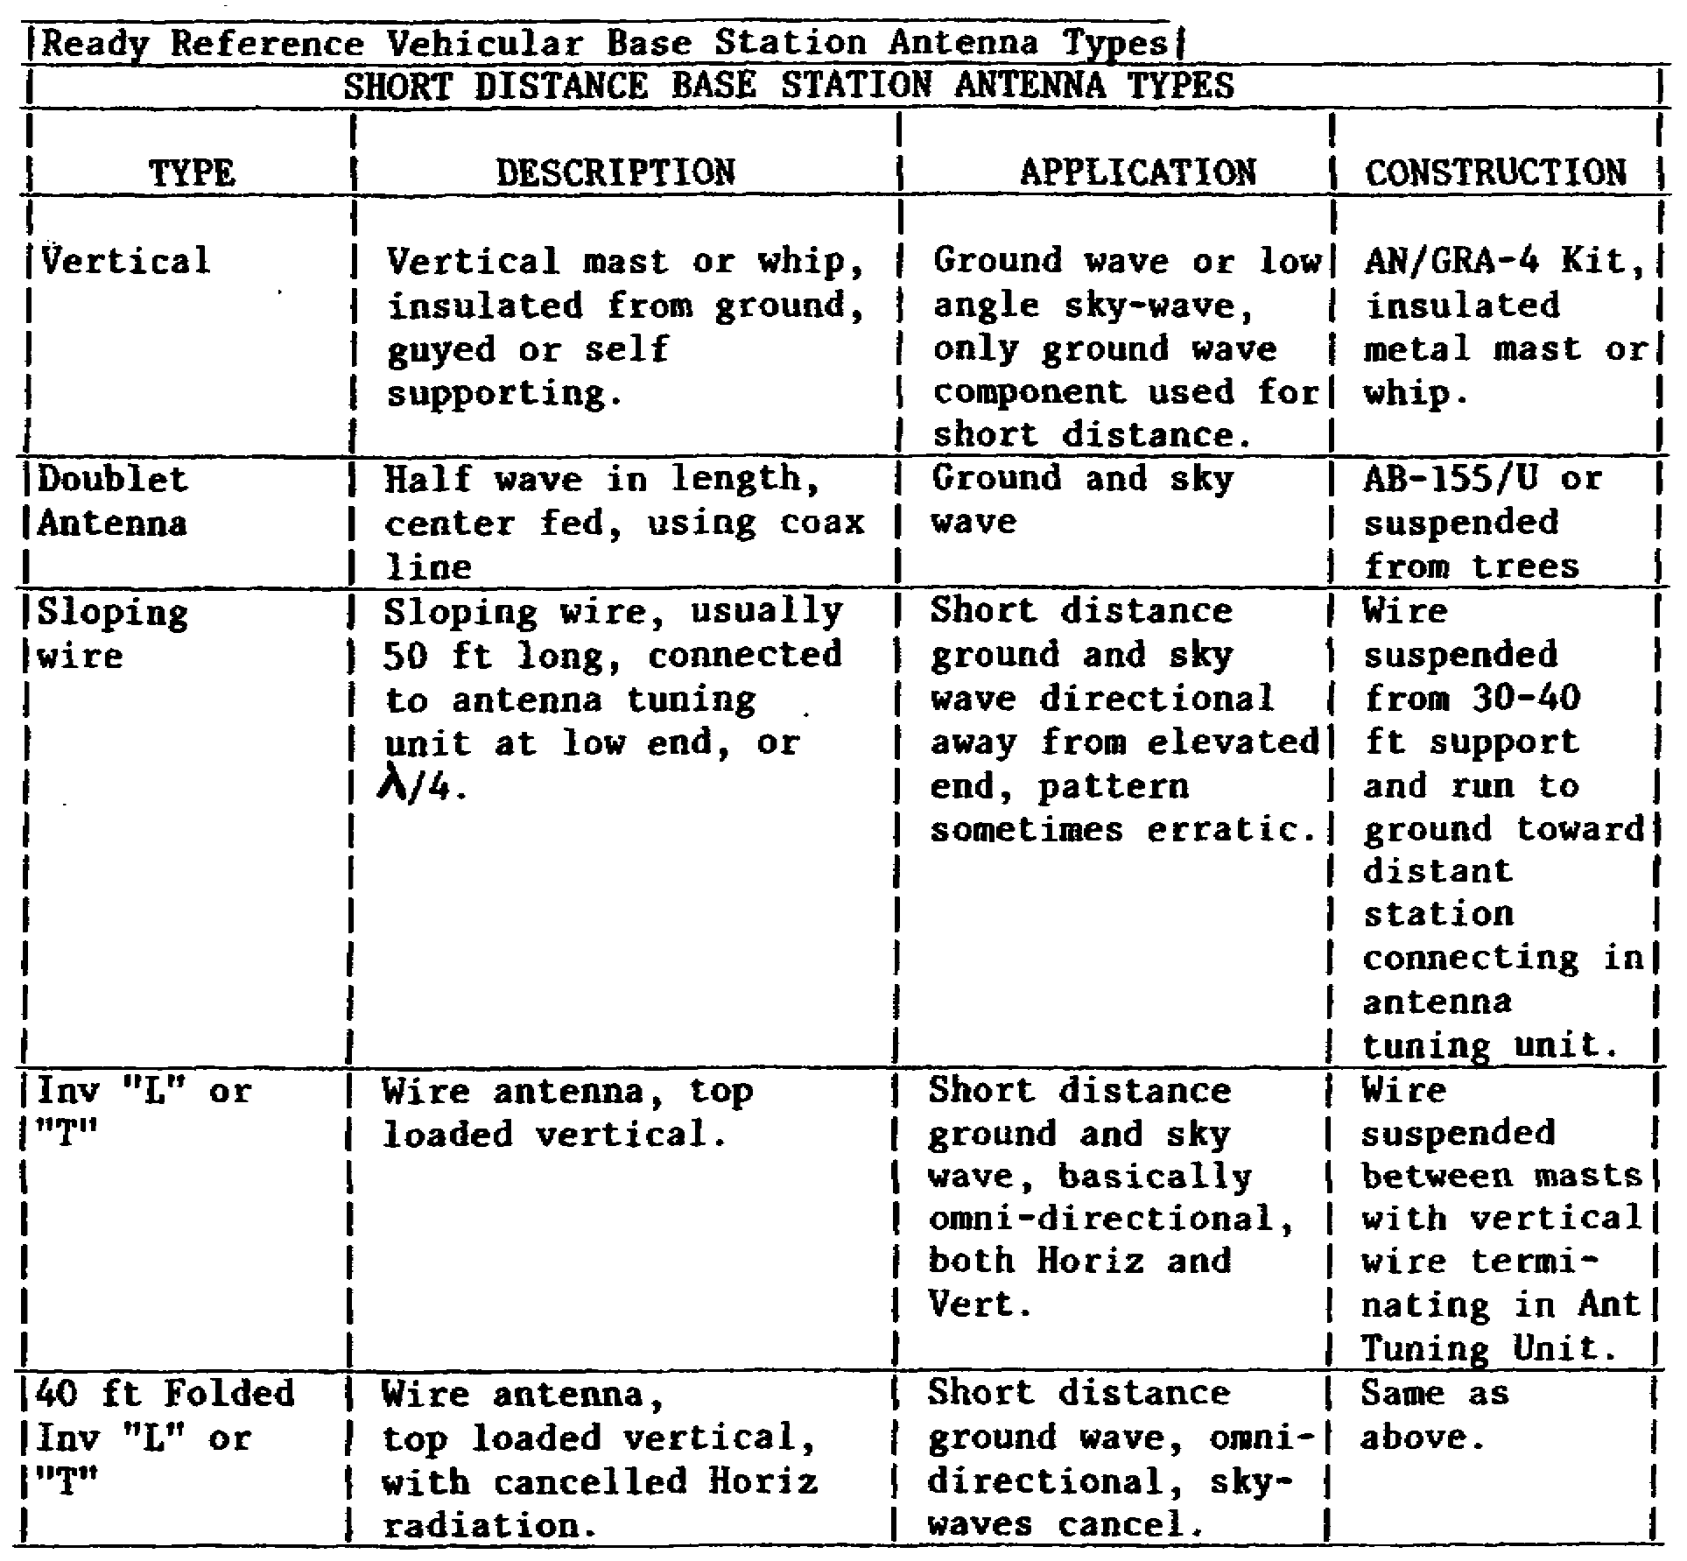

8. The Short Path Sky Wave.

a. Frequencies used should be near the FOT and the antenna should be a doublet. Height should be less than a quarter wave. See figures 79 and 80. A counterpoise should be used.

108

Figure 79. A λ/2 dipole in free space.

Figure 80. Effect of ground doublet radiation pattern
(height 20 - 40 feet above ground).

b. Sag. Antennas erected for low frequencies tend to be very long, over two hundred feet long. Antennas that long tend to sag unless supported in the middle. Significant signal loss can result if the antenna is not supported. See figure 81. To

109

prevent coupling or radiating from the transmission line, make sure that the feed line is at right angles to the antenna. See figure 82.

Figure 81. Doublet antenna sag.

At angles of 20° to 80° from the horizontal, signal loss can be expected. Keep antenna as horizontal as possible.
SAG APPROXIMATE SIGNAL LOSS

20° 0 db
30° -1 db
40° -2.5 db
50° -5 db
60° -16 db
70° -24 db
80° -25+ db

Figure 82. Doublet feed
line problems.

At angles of 45 to 60° from a perpendicular plane to the doublet, up to 5 db antenna gain can be lost. Keep feed line as perpendicular from antenna toward earth as possible.
APPROXIMATE INCLINATION
ANGLE LOSS

ANGLE LOSS

0 - 40° 0 db
50° -1 db
60° -5 db
70° - 80° No statistics
very poor

c. The disadvantage of the doublet is its narrow operating range. See figures 83 and 84.

110

Figure 83. A typical doublet.

Figure 84. Doublet for path of 100 miles or less, showing
use and placement of counterpoise.

d. Jumpers can be used to increase the operating range. See figures 85 and 86. The inverted vee is a variation of the doublet. So that you don't have to raise and lower the antenna, you can use a multidoublet which covers several frequencies.

111

Figure 85. Multifrequency doublet.

Figure 86. Construction of multifrequency doublet.

112

Figure 87. The multiple doublet antenna.

Figure 88. Approximate gain of a doublet as a function
of height in open and in jungle based on a
frequency of 6 MHz.

113

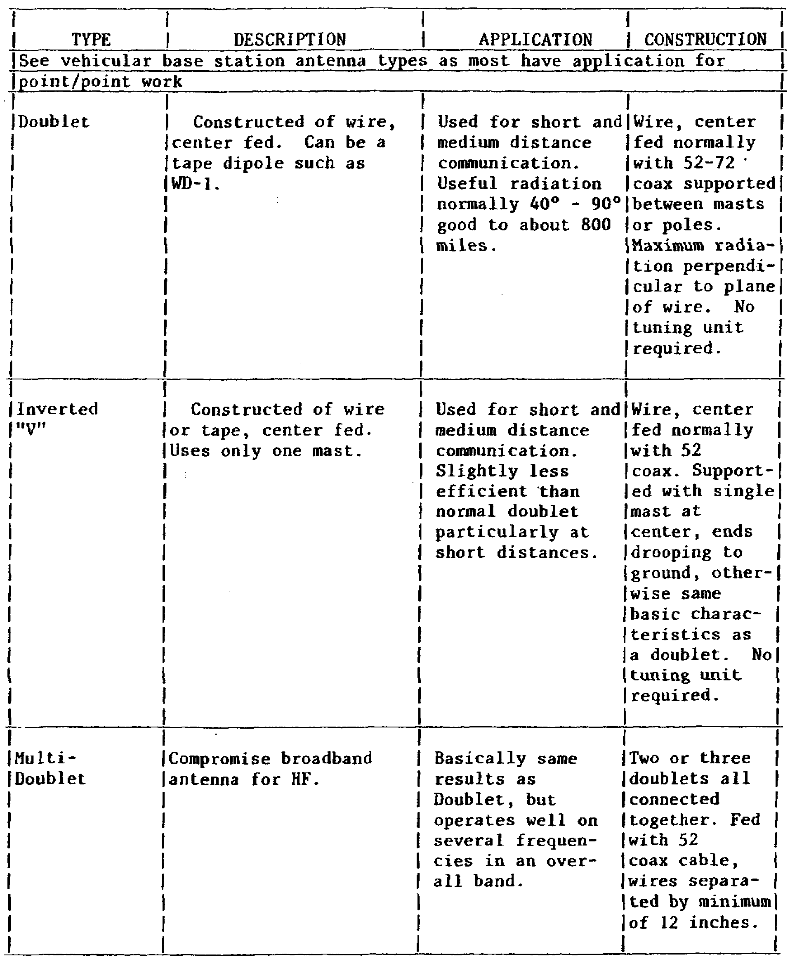

e. Communication between 250 to 800 miles. The same problems encountered for short distance communication also holds true for the medium distance path. In some cases, it is the most difficult circuit path. The doublet is the best antenna over

114

this distance and should be at least a quarter-wave high. Usable frequencies fall between 3 to 14 MHz. Reliability may fall below ninety percent.

f. Communication between 800 to 1500 miles. Communications over this distance require antennas with a low take-off angle. A doublet a half-wave high will work reasonably well. Reliability may fall below ninety percent. Frequencies can be from 4 to 25 MHz .

g. Communication over 1500 miles. There may be times when a tactical facility may be required to communicate to a station over 1500 miles away. The only antenna available to the tactical communicator is the doublet. The percent of reliability will fall significantly. To communicate effectively over 1500 miles you need a more powerful transmitter and a better antenna system than what is available. We must accept less than desirable performance when communicating long distances during tactical situations.

TACTICAL RADIO SYSTEM ANALYSIS

During and after an exercise, an analysis of the communications needs to be accomplished. Copies of logs, if necessary, need to be forwarded to indicate time of and reason for outages. Careful evaluation of the facts will determine if the assigned frequencies are too high or too low. If interference is a factor, report the interference, and if you have to, change to another frequency. Unfortunately, it is very seldom that we evaluate our HF net effectiveness. From time to time over the sunspot cycle, different frequencies need to be assigned. The same frequencies will seldom work over a sunspot cycle (a sunspot cycle is just over 11 years). Communication is always better during a maximum sunspot cycle. Higher frequencies are more useable, because ionization by the sun increases the density of the layers which will support higher frequencies. A higher FOT daytime frequency will be needed in a sunspot maximum cycle. The FOT does increase at night, but not significantly.

Most of our communication outages can be traced to incorrect frequency assignments. In most cases the assignment is too low, in the 2 to 3 MHz band. Severe interference should be expected. In most cases the LUF for a doublet is used, whereas the LUF for a whip should have been used, because some of the outages are usually when we are mobile or mobile-at-a-halt.

115

LESSON 2/LEARNING EVENT 3

PRACTICE EXERCISE

Instructions: Select the BEST response, and circle the answer.

1. For short distance communication (0-250 miles), antennas should--

a. have a high take-off angle.

b. have a low take-off angle.

c. take-off angles have no effect on communications.

d. be a half wave high.

2. Which of the following terrain features favors site selections?

a. Power lines.

b. Metal buildings.

c. Other antennas.

d. Level, clear area.

3. Which take-off angle favors long distance?

a. 5 degrees.

b. 45 degrees.

c. 75 degrees.

d. 90 degrees.

4. Near the equator as compared to a polar location you would--

a. use a higher frequency.

b. use a lower frequency.

c. use the same frequency.

d. use the surface wave.

116

5. Which frequency has a greater daytime communication range?

a. 7 MHz.

b. 10 MHz.

c. 12 MHz.

d. 15 MHz.

Turn to page 169 to check your answers.

117

Lesson 2/Learning Event 4

Learning Event 4: FREQUENCY SELECTION.

1. Prior to selecting frequencies for a radio circuit, thought must be given as to what type of antenna will be used. Often, during displacement or during an alert, at least two types of antennas will be used -- a whip while moving; a doublet or suitable compromise antenna while mobile at a halt. Antenna selection will determine the choice of frequency, not the other way around.

Looking at the various Immediate Sky-Wave Distance (ISD) charts, page 125 to page 141 (we will use column 5 on the charts) for various antennas, we see that the most reliable antenna is a doublet with reliability dropping until we reach the poorest antenna -- the whip. We also see on the ISD charts that for the same distance, the frequency increases with each type of antenna, with the whip having the highest frequency. What conclusions can we draw from these comparisons? First, we must have two frequencies for sky wave use -- a day and a night frequency. Also, when forced to use a whip, a higher frequency than that used by a doublet must be chosen in order to offset the power loss caused by the short length of the whip. A nighttime whip frequency should be selected and not a nighttime doublet frequency. The reason is that in all cases, the poorest antenna used will determine the frequency selection. Any frequency selected for the whip will work with the doublet. A frequency selected for a doublet will not necessarily work reliably with a whip because of the shortness of whip and the inevitable power loss caused by the transmitter's loading coils. If we increase the frequency in order to compensate for the whip's power loss, we might exceed the MUF for the radio circuit.

118
2. Antenna orientation is not a consideration for short distance sky wave use. If possible, use a radial ground system, especially with a whip, using 36 radials which should be as long as the antenna. Sometimes a radial system makes communication worse when it is connected to the equipment ground. To be sure, always try to communicate first without the radial ground connected to the equipment ground, then with it.

3. From a signal security standpoint, we are in trouble. In order to increase the reliability of the whip, we use higher frequencies which provide the enemy with a better opportunity to monitor and jam our signal. Most of the time, if we use a whip, we must sacrifice signal security in order to maintain the radio circuit. If we use a doublet, we could use the LUF which makes monitoring and jamming more difficult. During displacement, communications is very crucial but also marginal in reliability if we use a whip. We must therefore make a compromise and ease our signal security concerns in order to increase the reliability of the radio circuit by using the whip's LUF. With 100 nets requiring the same FOT/LUF, obviously not all nets can use the same LUF or FOT. More compromises are necessary. Frequency assignments will be close as possible to the FOT down to the whip's LUF.

4. Usually, most of our units communicate less than 50 miles (closer to 5 - 25 miles). One consideration to make is the use of ground waves for short distance radio circuits. Let us compare some charts for various antennas. Look at the ground wave charts, page 156 to page 161, especially for a 15-foot whip (use column 7). Notice that if we use any frequency from 12 -25 MHz, a ground wave will meet our circuit path requirements of 25 miles.

Ground Wave Range (p 159) Ground Wave for 32-Foot Whip
At 0200 Hours (p 160)

For 15-Foot Whip
At 0200 Hours For
Column 7 (300 to 499
Watts) For RTTY 60
WPM (p 158)

02 Hours (7) (7)
15-Ft 32-Ft
Whip Whip

2 MHz 9.0 27
3 MHz 14 28
5 MHz 17 29
7 MHz 20 32
10 MHz 24 33
12 MHz 25 33
15 MHz 26 33
20 MHz 26 32
25 MHz 25 6.8
30 MHz 24 2.4

119
5. Another consideration to make for sky wave communication when using a whip is to bend the whip forming a 45° angle. We must also consider adding additional whip mast sections so that the whip will approach a quarter of a wavelength. We might have to guy the whip to keep it from leaning too much if we make use of the ground wave. However, tuning the whip will be easier when it is at least a quarter wave in length. When the whip is shorter than a quarter wave, there will be a power loss due to the matching done by the loading coils of the transmitter. This is most evident when we operate the whip below 15 MHz. To calculate the length of the quarter wavelength whip, use the formula 234/F (F is in MHz and 234 is 1/2 of 468). Lets calculate the power loss for an AN/GRC-142 with a 400 watt output and operating at 2 MHz using a whip. What percent of a quarter wave is a 15-foot whip at 2 MHz?

F = 2 MHz

234/2 MHz = 117 feet

15 feet/117 feet = 12%

400 watts x 0.12 = 48 watts output (roughly)

48 watts is all that is actually going to the antenna. The rest of the power is used up by the transmitter's loading coils.

6. For our 25 mile radio circuit, we selected the highest FOT from the 100 mile MUF/FOT chart on page 129. We selected daytime frequency, during a low sunspot (SSN10) period: FOT 5.7 MHz at 1200 hours and from the 15-foot whip LUF chart on page 134, we selected the highest LUF of 6.7 MHz at 1200 hours. Our daytime frequency will be 5.7 MHz. We shouldn't use the LUF of 6.7 MHz because it exceeds the FOT. As you can see all the LUF for the whip is less than 90 percent reliable, closer to 0 to 20 percent.

7. Nighttime presents other problems. The frequency band of 2 to 3 MHz is filled with powerful commercial stations. Even though our LUF ISD charts indicate that this band is the one to use, there will be too much interference from these stations. We are forced to go up in frequency. Look at the ground wave chart for a 15-foot whip on page 159. We see that the ground wave range for 12 MHz is 25 miles. If we select a frequency that makes the best use of a ground wave, we might have one difficulty - the interference from an incoming sky-wave signal might be stronger than our ground wave signal. If that happens, try other frequencies until you find one that is relatively free of interference. Even if we were to use a 32-foot whip instead of a 15-foot whip while operating on the same frequencies, we can still expect a reliability of less than 90% (LUF chart on page 136).

120
8. When using a doublet, we must consider its height above ground. For a 0 to 25-mile circuit using sky wave, we must erect the antenna less than a quarter wavelength above the ground. We might have to vary the height from 15 to 30 feet. For short distance sky wave, we want the radiation pattern straight up (Near Vertical Incidence Sky Wave (NVIS)). The highest frequency will determine our antenna height. For example: A quarter wave at 12 MHz is 19 feet. Our doublet antenna should not exceed 19 feet in height. As we lower the doublet, the ground effects make the antenna electrically longer. Therefore, you might have to lengthen the antenna. Your SWR meter will indicate whether you need to lengthen it or not.

9. You're probably thinking, "Now wait a minute! I don't have a choice of frequencies. I use what is listed in the CEOI." You're right. However, if those frequencies don't work, inform your frequency manager at Division, Corps, Army, or Theater, and you will be given additional frequencies. The bottom line is that you are not stuck with any frequency that doesn't work. Remember also that there is no such thing as a sole-user frequency. You will share your frequency with hundreds of users throughout the World. The following frequency bands need to be avoided because of powerful ship-to-shore or international broadcast stations located there:

BAND STATIONS

2 - 3 MHz Ship-to-Shore

4.75 - 4.95 MHz Broadcast

5.95 - 6.2 MHz Broadcast

9.50 - 9.77 MHz Broadcast

11.70 - 11.97 MHz Broadcast

15.10 - 15.45 MHz Broadcast

17.70 - 17.90 MHz Broadcast

21.45 - 21.75 MHz Broadcast

25.60 - 26.10 MHz Broadcast

These bands might seem to work during the day. At night, you might experience severe interference from these stations. Anytime you experience interference submit a M1J1 report, then request another frequency, until you get one that will work. Don't keep using the same frequency when you know it won't work. Keep reporting it until you receive a better frequency. There are always spare frequencies.
121
10. The Immediate and Short Distance Sky-Wave books can be had just for the asking. Write to:

Commanding General
USAESEIA
ATTN: ASC-E-TP
Fort Huachuca, Arizona 85613-5300

or call AUTOVON 879-7685. Every division or higher level unit should have a book for their area. There are 35 volumes covering all areas of the world. For our use, we will use column 5 from the ISD book and column 7 from the GW book.

11. Let's do a couple of sky-wave frequency selection problems.

a. Situation 1.

Let us say that we have a radio net with only two stations which are 50 miles apart. The radio set used is the AN/GRC-142. We are using radioteletype during a period of low sunspot activity. We need to select two frequencies for 24-hour communications. We will use a doublet antenna erected less than a quarter wavelength above the ground for our highest frequency so that our radiation pattern is straight up. Keep in mind that we might have to vary the antenna height from 40 feet down to 10 feet (any lower than 10 feet, we have safety problems). Turn to the sky-wave extracts, the Index to the Lowest Usable High frequency (LUF) on page 128. Look down the left side until you find Radioteletype, NSK, 60 WPM. Now, look across the top of the columns for our power output, 400 watts. We will use the column which has our power output (201-600) falling in between. Look down this column until it intersects with our type of service. Five is the column that we will use on our sky wave LUF charts. Turn to the MUF/FOT chart on page 129. Look down the low sunspot column (SSN 10) for 100 miles. We will select the highest and lowest FOT. They are 5.7 MHz and 2.5 MHz. Look at the doublet or dipole LUF chart on page 130 for 100 miles, low sunspot, 33 feet high, column 5. The highest and lowest LUF is 2.0 MHz. We can now assume that a daytime high frequency selection can be from 2.0 to 5.7 MHz. These frequencies will give us a 90% reliability. (See page 125.) Let's keep in mind the problem of ship-to-shore stations and eliminate from consideration frequencies between 2 to 3 MHz. Now we have a daytime high frequency between 3 to 5.7 MHz and a low nighttime frequency of just above 3 MHz. We must compromise because of possible interference. If we check the ISD extracts, we will see that a doublet and a sloping long-wire antenna are the only antennas that give 24-hour 90% reliability.

122

The sloping long-wire antenna and a sloping quarter-wave wire antenna have similar performance characteristics. Since we are using short distance sky wave, again, antenna orientation is not a factor. Let's take a look at the ground wave charts to see how far our ground wave will reach. Turn to the index to ground wave ranges on page 158. Look down the left side to find our type of service, RTTY, single channel, FSK, 60 W/M. Next, look across the top for our power in watts, 300 to 499. Where these two columns intersect, is the column number for our charts. We will use 7. Now, turn to our 15-foot whip antenna chart on page 159, the 32-foot whip on page 160, and sloping-wire on page 161. As you can see, our ground wave range for 3 to 5.7 MHz is approximately 14 to 37 miles. During a 24-hour period this means that ground wave propagation cannot be used for this circuit.

b. Situation 2.

(1) Let us assume that we have a radio circuit in which our stations are 100, 750, and 1500 miles away from the net control station (NCS). We are using an AN/GRC-142 in radioteletype mode during a low sunspot period. Let's select two frequencies for 24-hour operation. One of the problems in operating in a net like this is that some of the stations might be close while others are far away. Will the same two frequencies work for all stations all of the time? Probably not. You might have to set up two or three nets with two or three radios at the NCS location to accommodate the stations of varying distance. Of course, it is easy to say. However, if you don't have the resources, what will you do? Select frequencies that provide communication for the majority of stations and then rely on relaying to get the traffic through. The stations with which you will have the most difficulty are the closest stations, while the ones further away will be easier to communicate with.

(2) We will use a doublet at least 40 feet high above the ground. Long distance communications is best when our antenna is over a half wavelength (at the lowest frequency, if possible) above the ground. The antenna should be broadside to the majority of the stations. Let's find the highest and lowest FOT and then the highest and lowest LUF for 100, 750, and 1500 miles.

123

It will probably be impossible to select a frequency or frequencies that will provide communications to all the stations all of the time. We will select frequencies which will allow communications to the middle-distance station (750 miles). There will be times, probably at night, when all stations hear, and other times when only one station hears. In that case, the station that hears must act as a relay for the others. For daytime, use any frequency between the highest FOT 12.0 MHz and the highest LUF 7.2 MHz, probably in the middle or 9.6 MHz. For nighttime, any frequency between the lowest FOT 4.5 MHz and lowest LUF 2.0 MHz will work (move to 3 MHz to escape ship-to-shore stations). To make communications better, a third frequency might be considered. You can see from the LUF charts that direct communication with station C (1500 miles) is less than 90% reliable. Upon checking other antennas, you will find that they are even less reliable.

(3) Suppose that we were forced to use a 32-foot whip for this net. What would be the consequences? Ground wave would be out of the question. As you look at the LUF charts, you can see that the overall reliability is very low, on the order of 50%. Station A (100 miles) is the one we will have the most trouble with. Station B (750 miles) will be doing a lot of relaying. The reason that the reliability of station A is poor is because a whip is a vertical antenna and it favors sky wave with a low take-off angle. Station A is too close for these low take-off angles and too far for ground wave. Station B is at the optimum range for a vertical antenna. Even so, the reliability for a 32-foot whip is 60 to 80 percent. It also radiates in all directions - another disadvantage.

124

VOLUME 8, CENTRAL EUROPE

There are 35 separate volumes covering all areas of the world. Predictions are for minimum and maximum sunspot periods. Some of the more common terms are:

MUF (Maximum Usable Frequency): The highest frequency which is expected to be completely reflected from the ionosphere on at least 50 percent of the days of the month.

FOT (Optimum Traffic Frequency): The highest frequency that will be reflected from the ionosphere on at least 90 percent of the days of the month.

LUF (Lowest Usable Frequency): The lowest frequency that will be reflected from the ionosphere on at least 90 percent of the days of the month. When there is no frequency that will provide at least 90 percent reliability, the LUF will be listed followed by a letter to represent the reliability.

B = 80 to 89 percent reliability
C = 60 to 79 percent reliability
D = 40 to 59 percent reliability
E = 20 to 39 percent reliability
F = Less than 20 percent reliability

The volumes cover six two-month periods: January-February, March-April, May-June, July-August, September-October, and November-December.

There is a chart that covers each two-month period listing the FOT and MUF over a 24 hour period. Additional charts list the LUF over a 24 hour period. The charts cover the following distances: 100, 250, 500, 750, 1,000 and 1500 tiles. Predictions are given for sunspot minimum and sunspot maximum. The LUF charts are prepared for the following antenna types:

Half-wave horizontal dipole thirty-three feet high.

Half-wave horizontal dipole sixty-six feet high.

Fifteen foot vertical whip.

Thirty-two foot whip.

Sloping long wire.

Inverted vee.

Other antenna types are listed, but this subcourse covers only those antennas that are considered practical from a field point of view.

125

ASBH-SET-P 8 August 1986

PREDICTED SUNSPOT NUMBERS (SSN)

FOR USE WITH

THE INTERMEDIATE AND SHORT DISTANCE (ISD)

AND AIR/GROUND (A/G)

SKY WAVE PROPAGATION CHARTS

1987

JANUARY 15
FEBRUARY. 17
MARCH 19
APRIL 22
MAY 25
JUNE 28

NOTE: LIST OF UPDATED SUNSPOT NUMBERS WILL PERIODICALLY BE PROVIDED TO YOUR OFFICE.

126

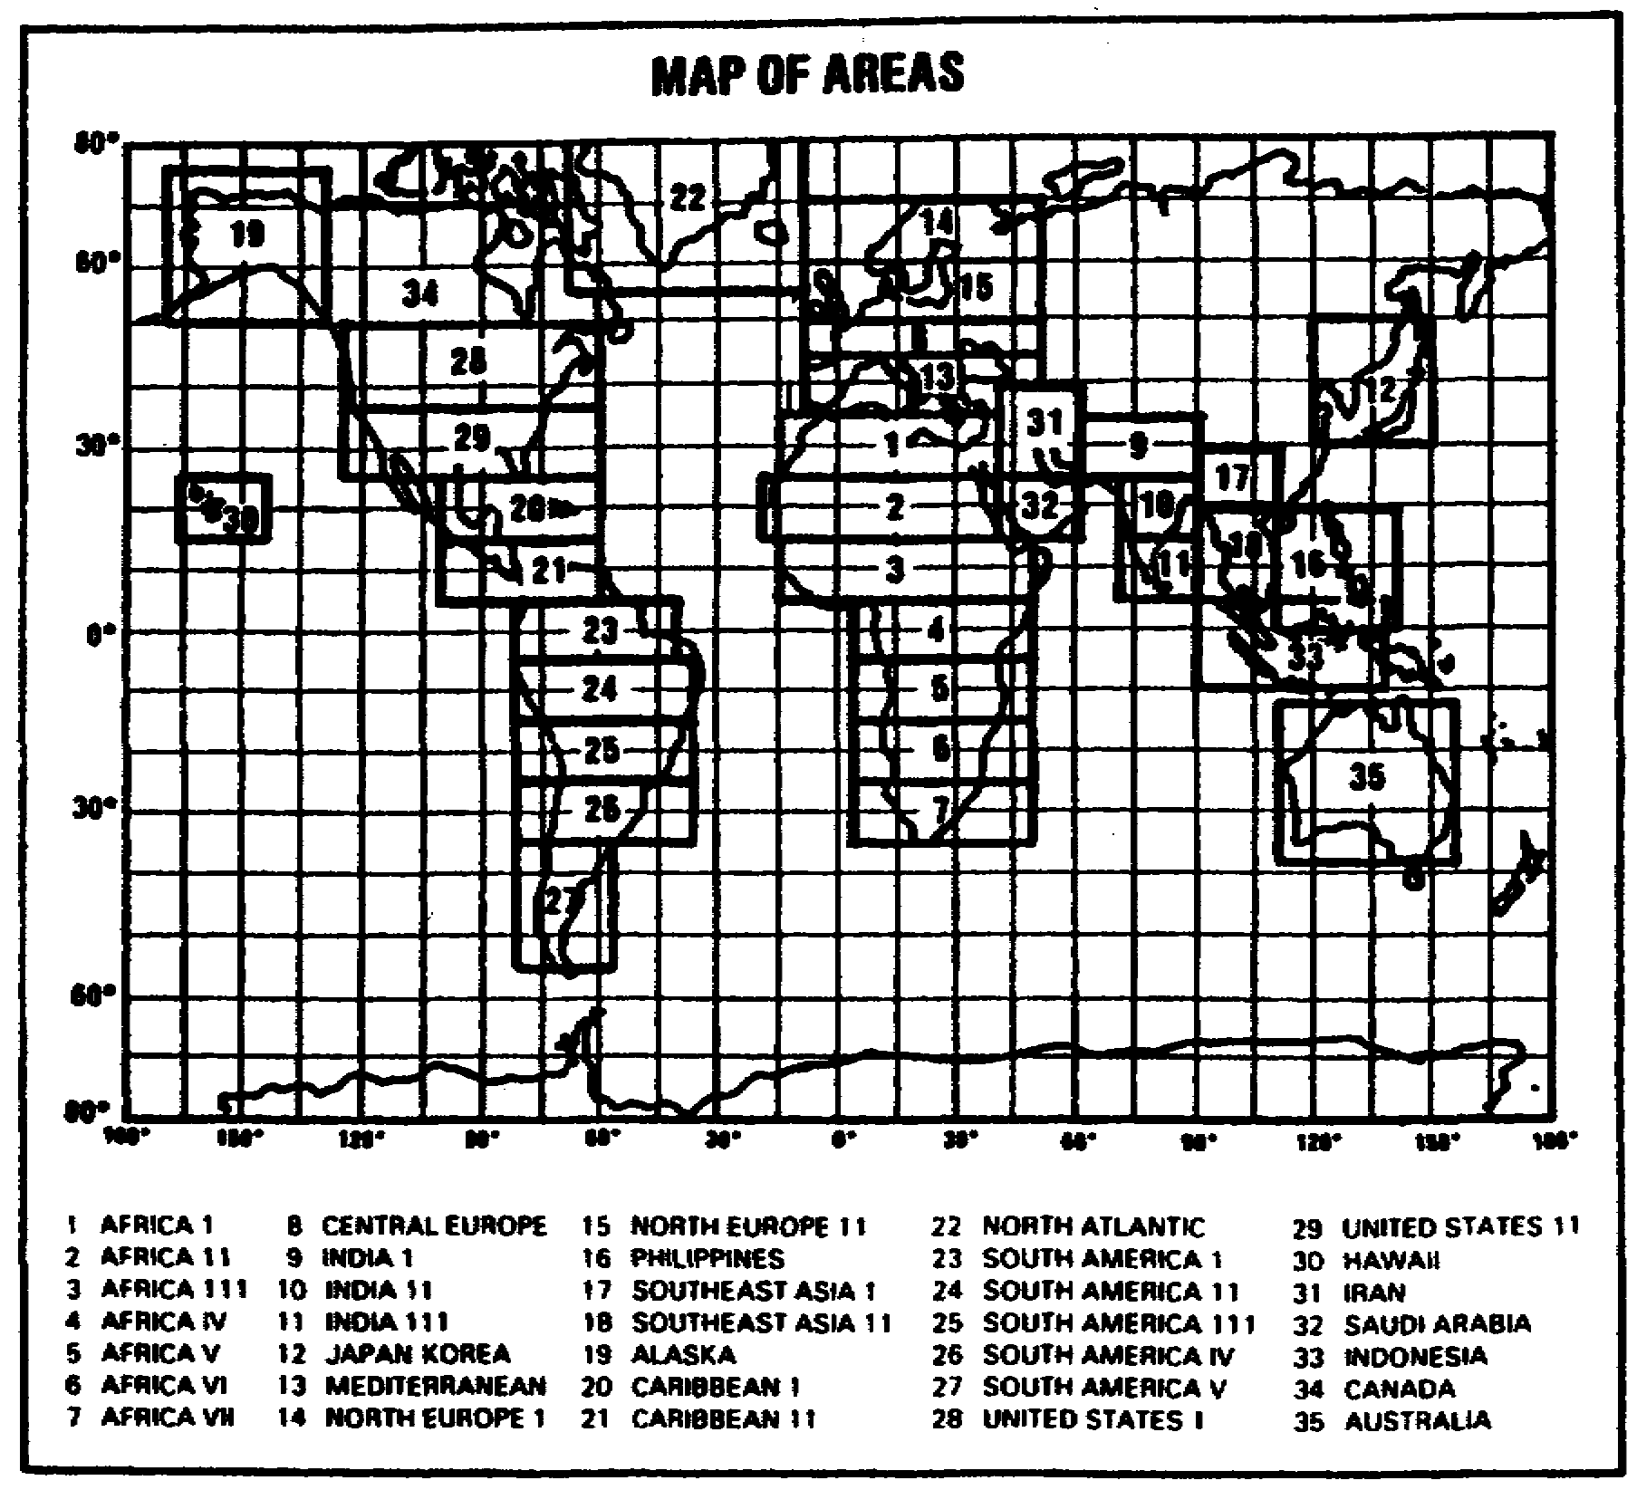

127

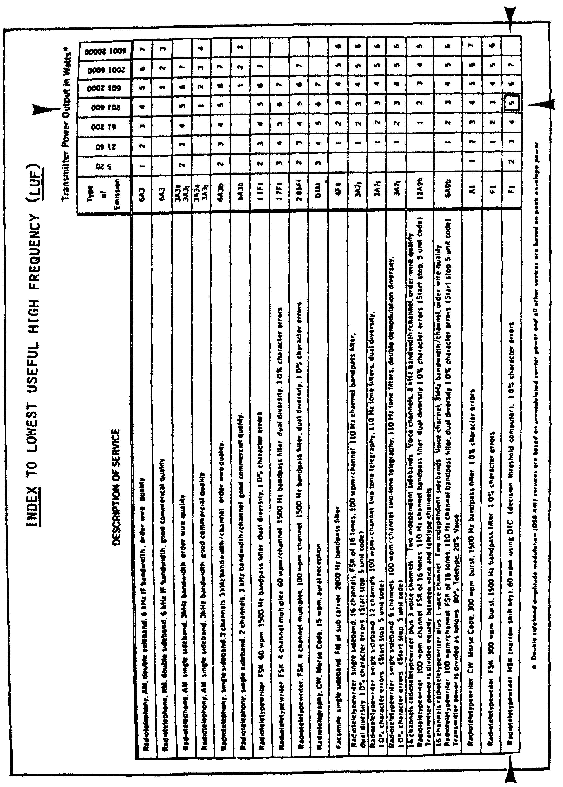

128

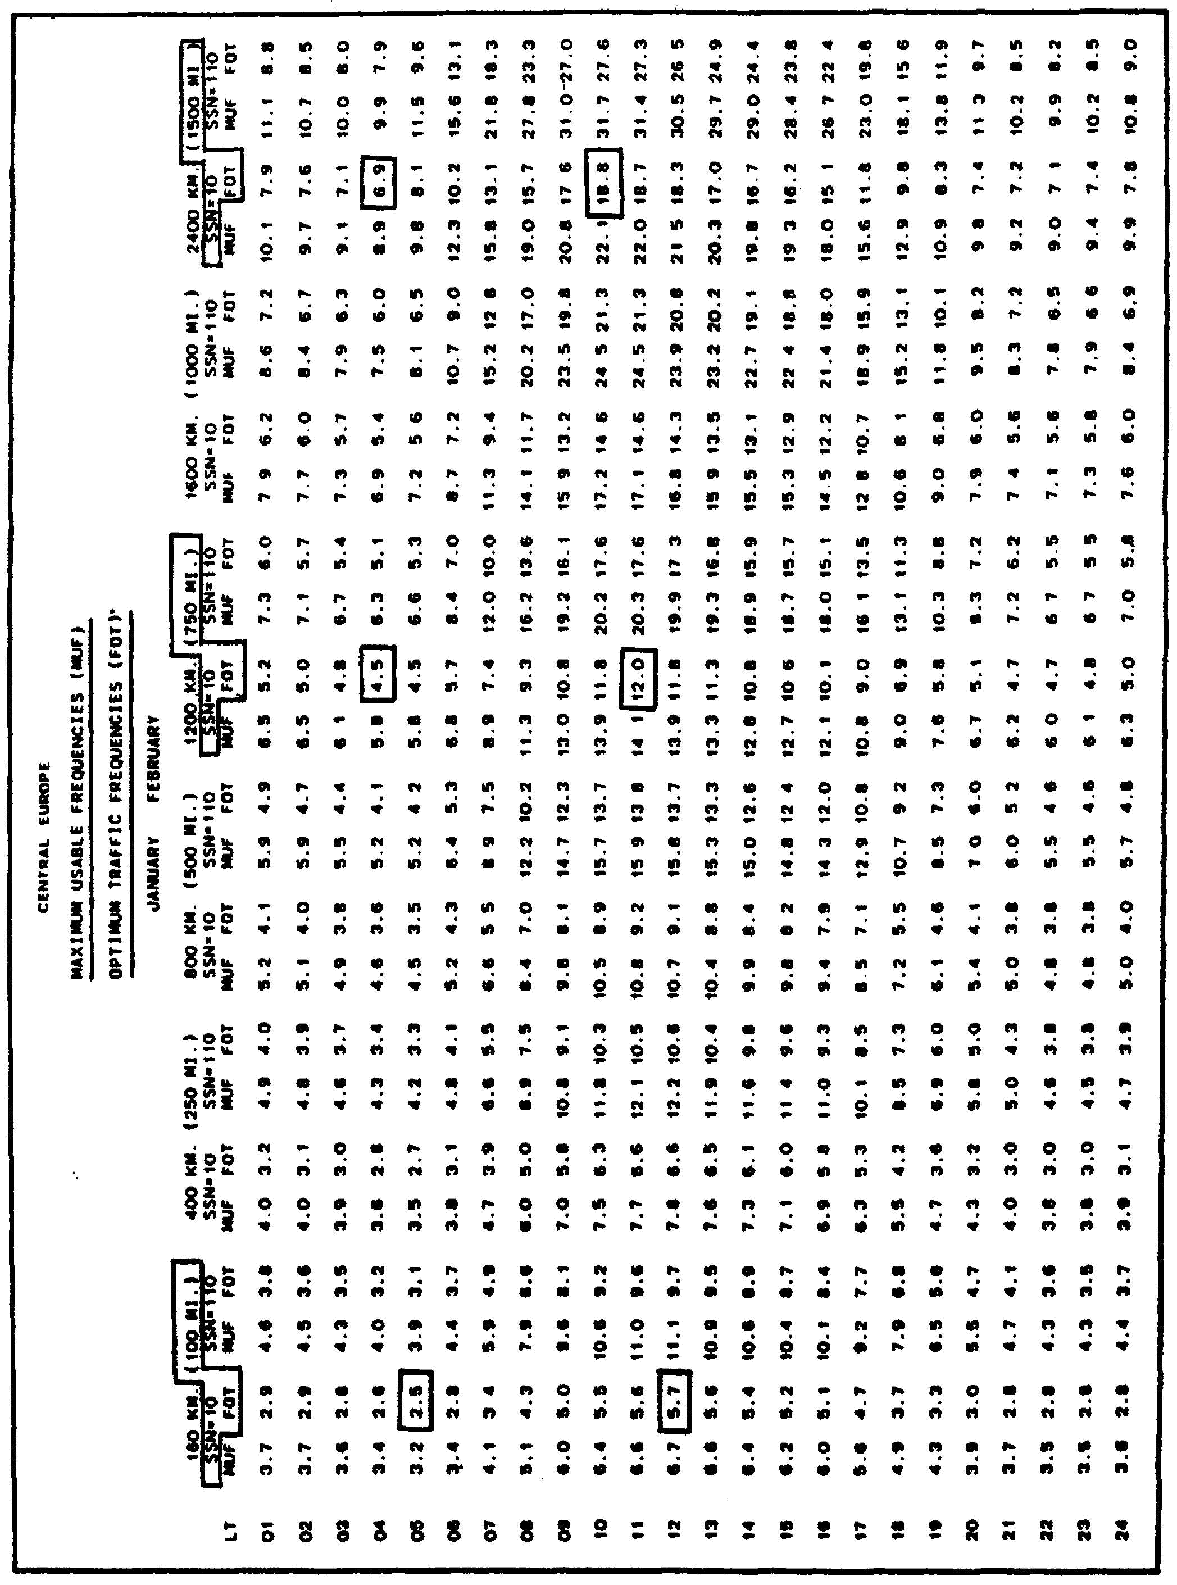

129

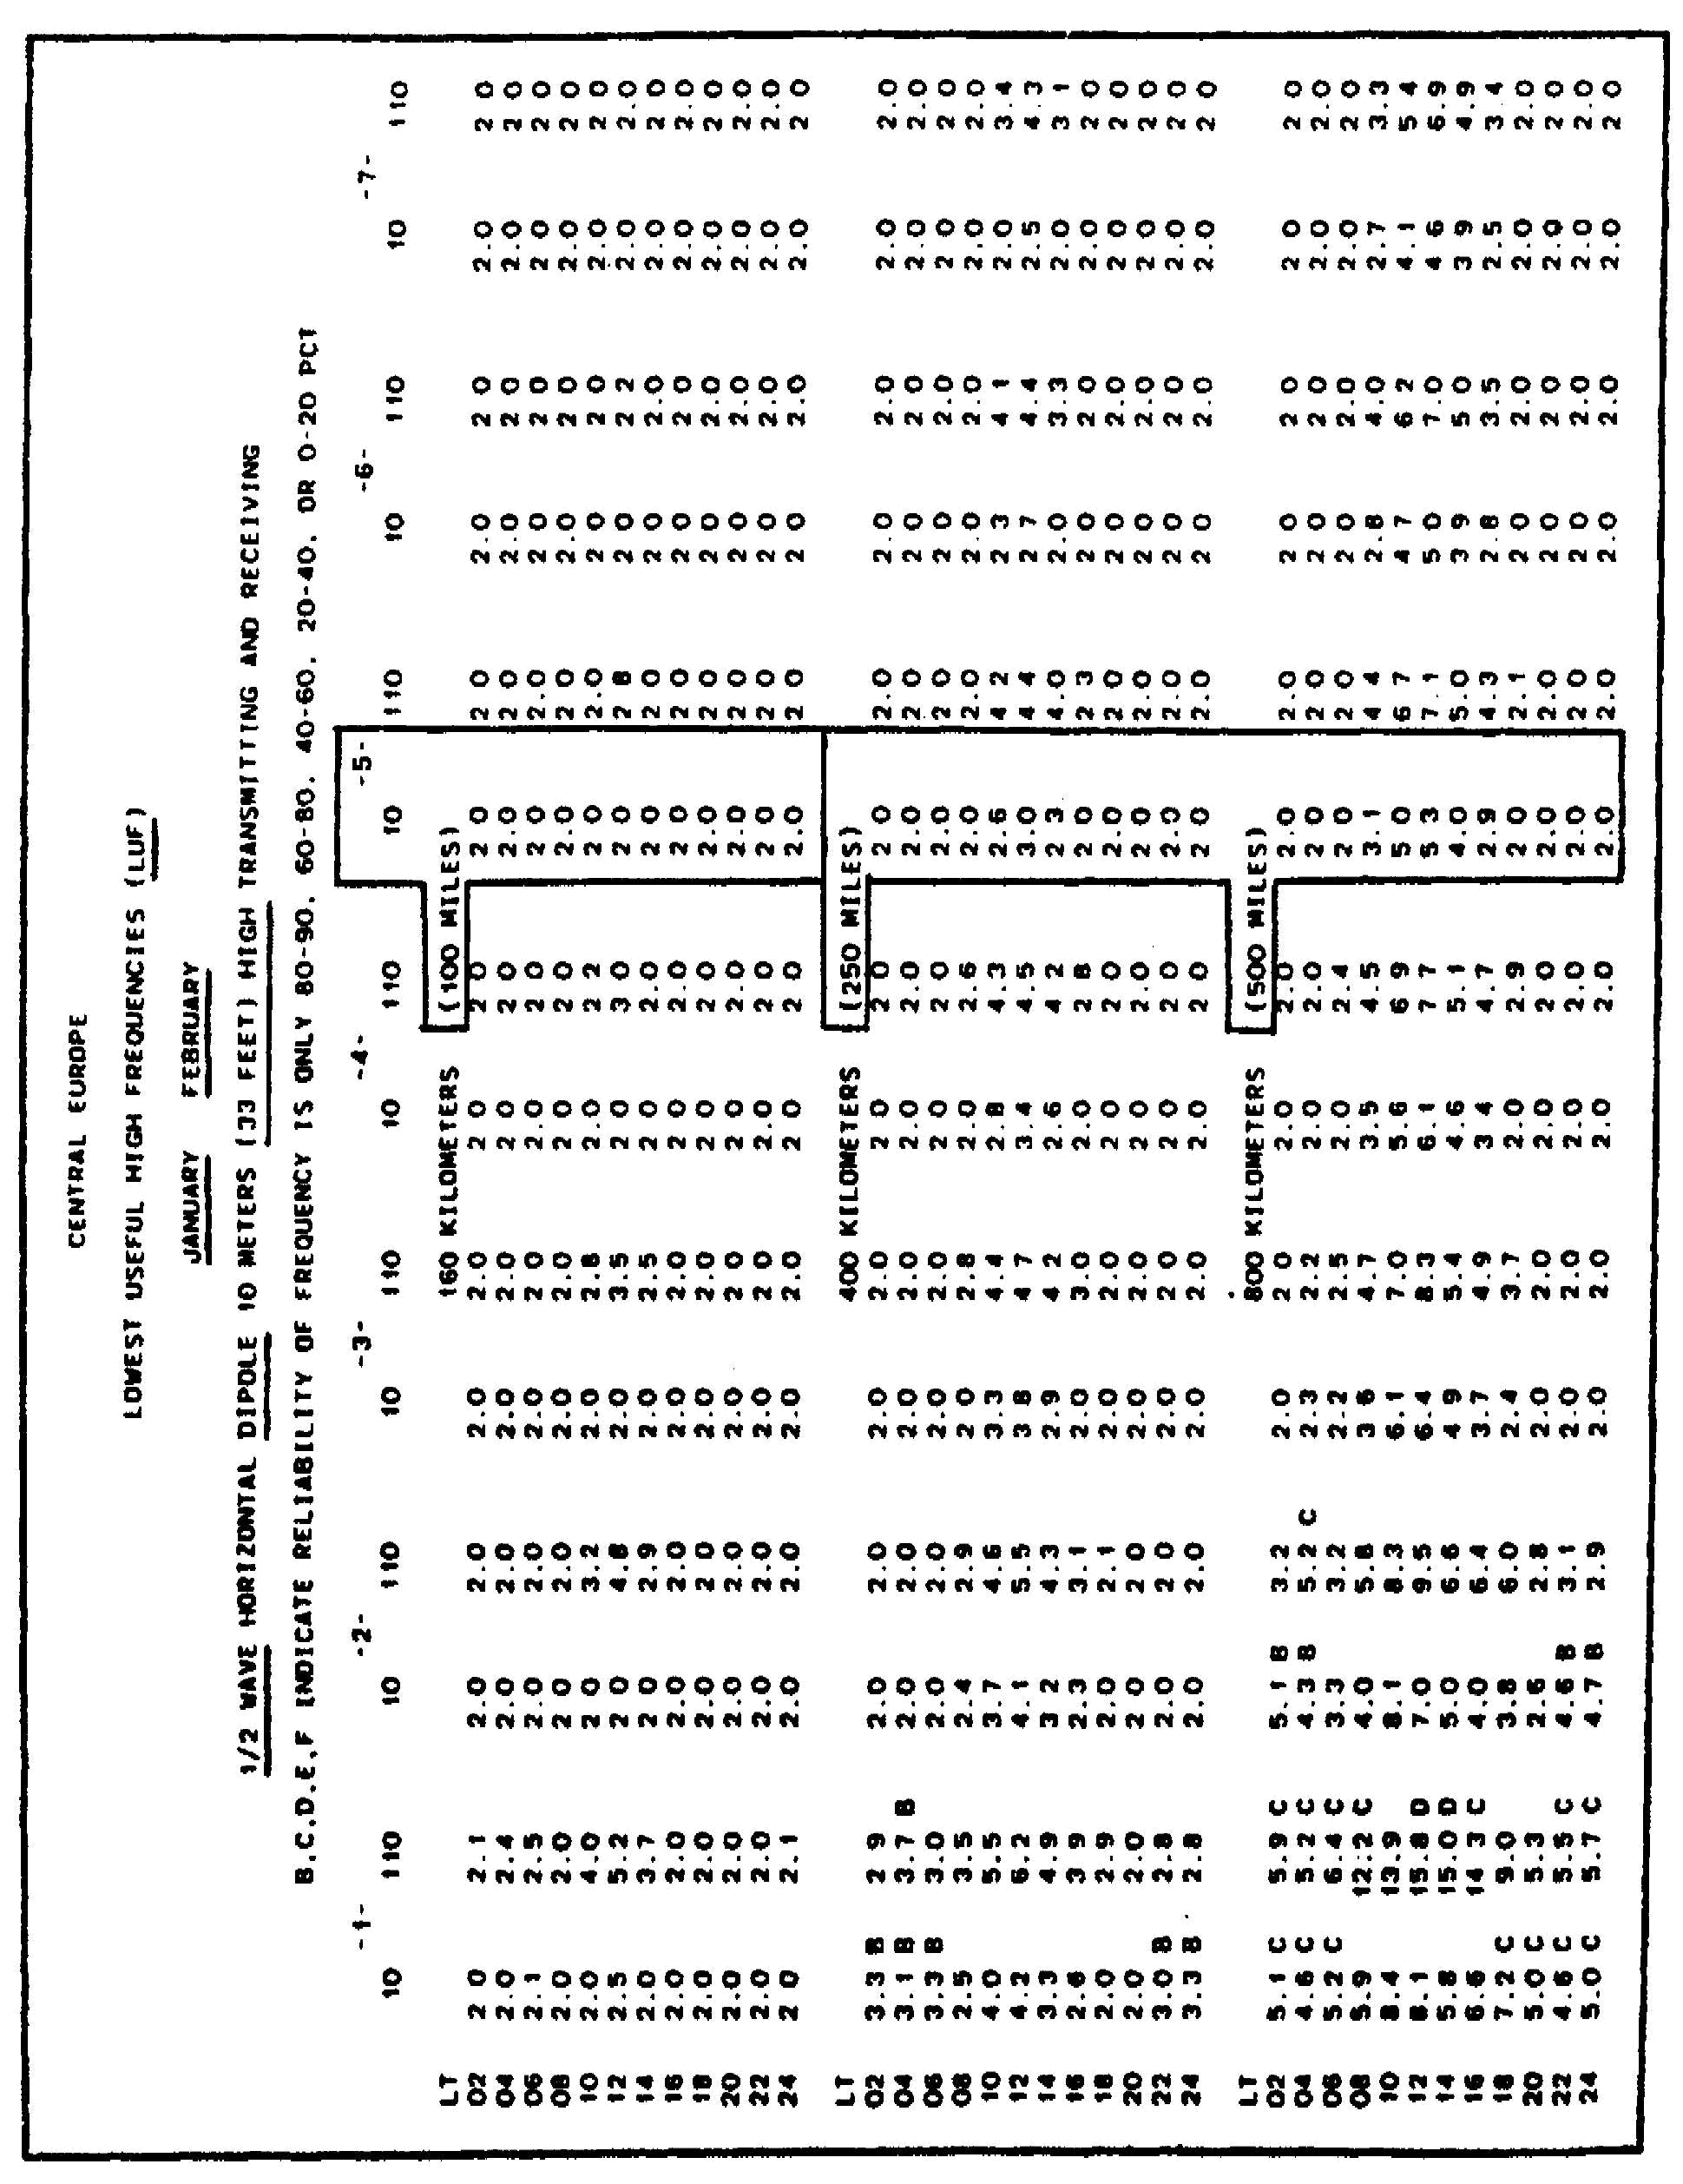

130

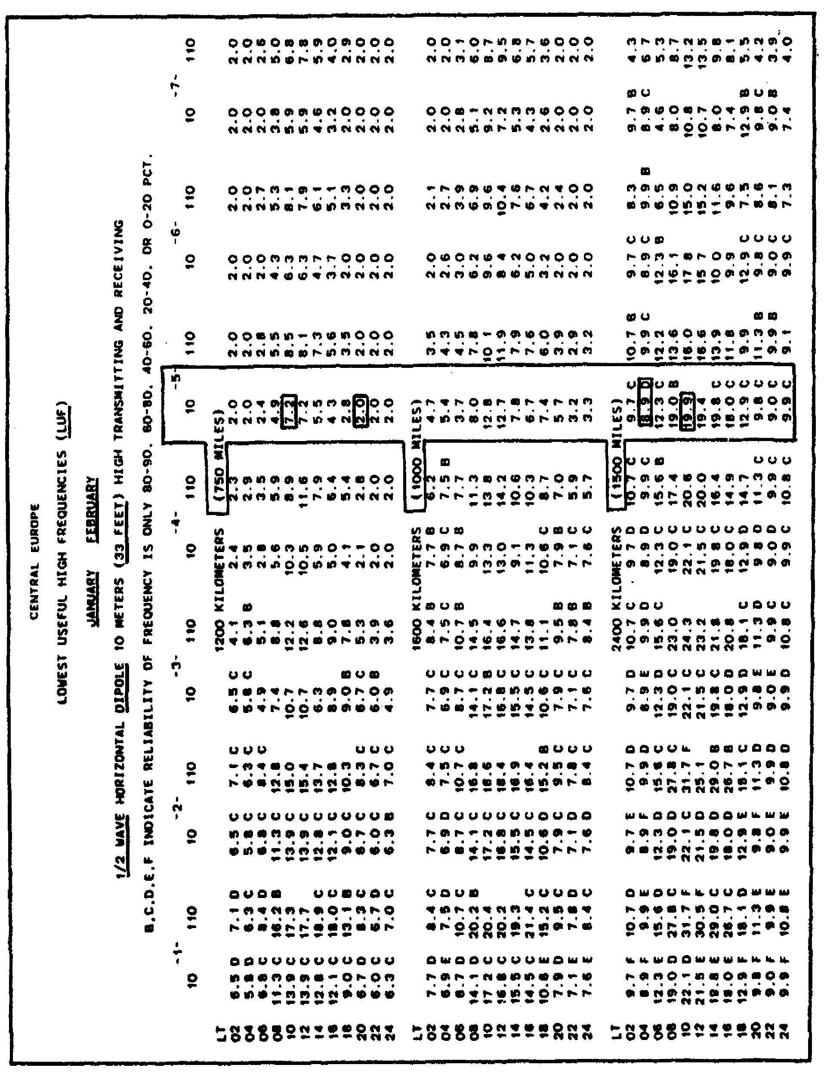

131

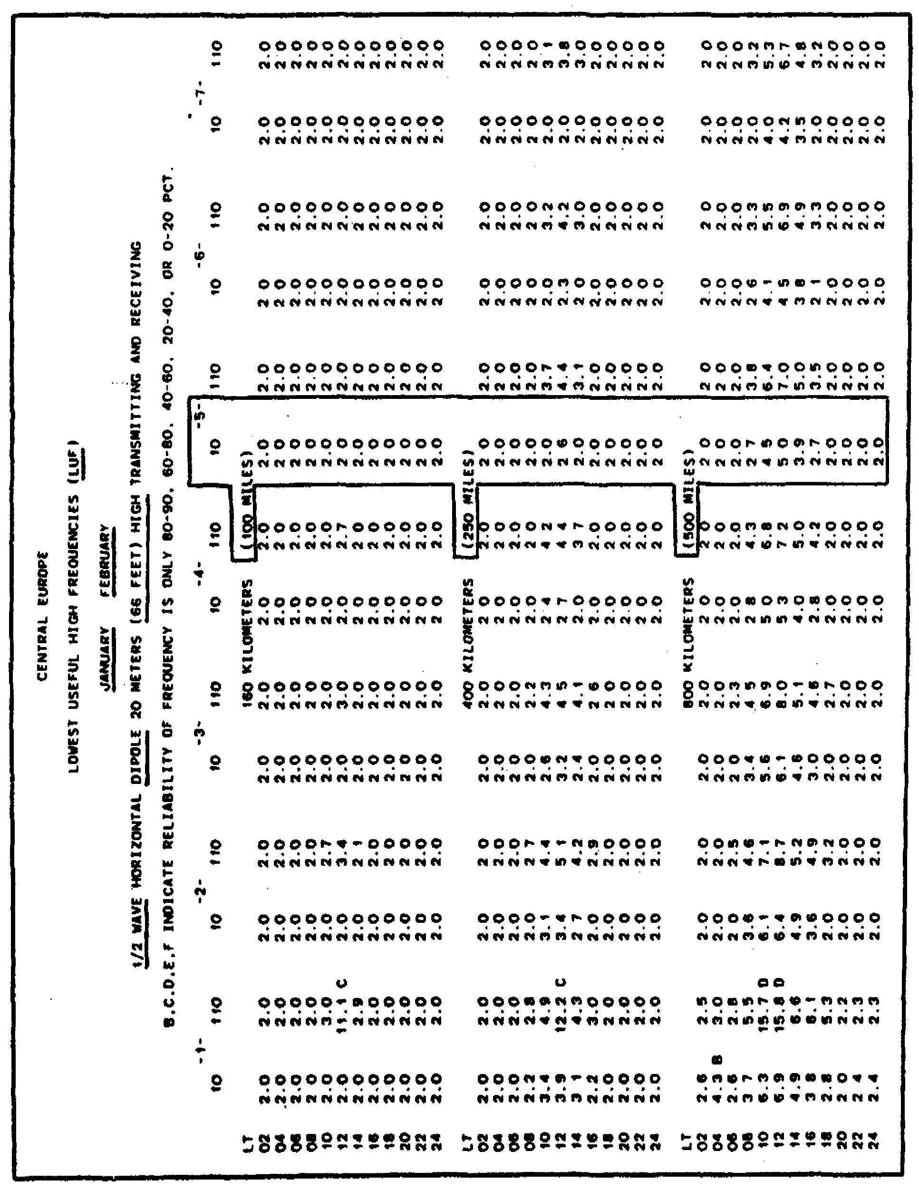

132

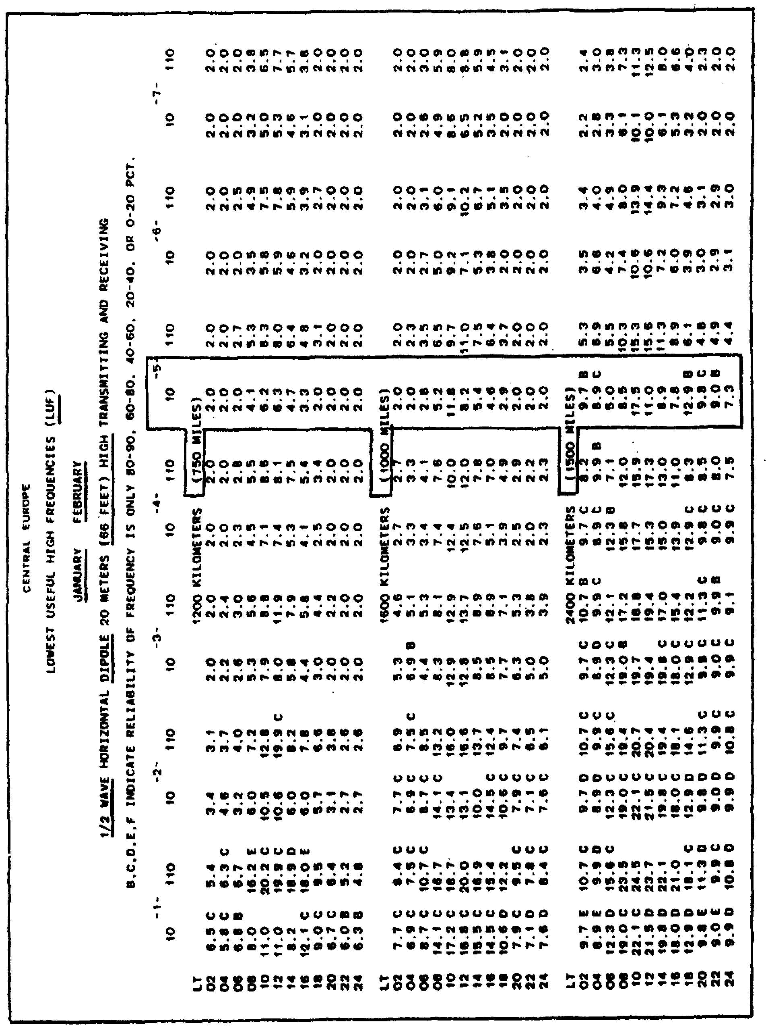

133

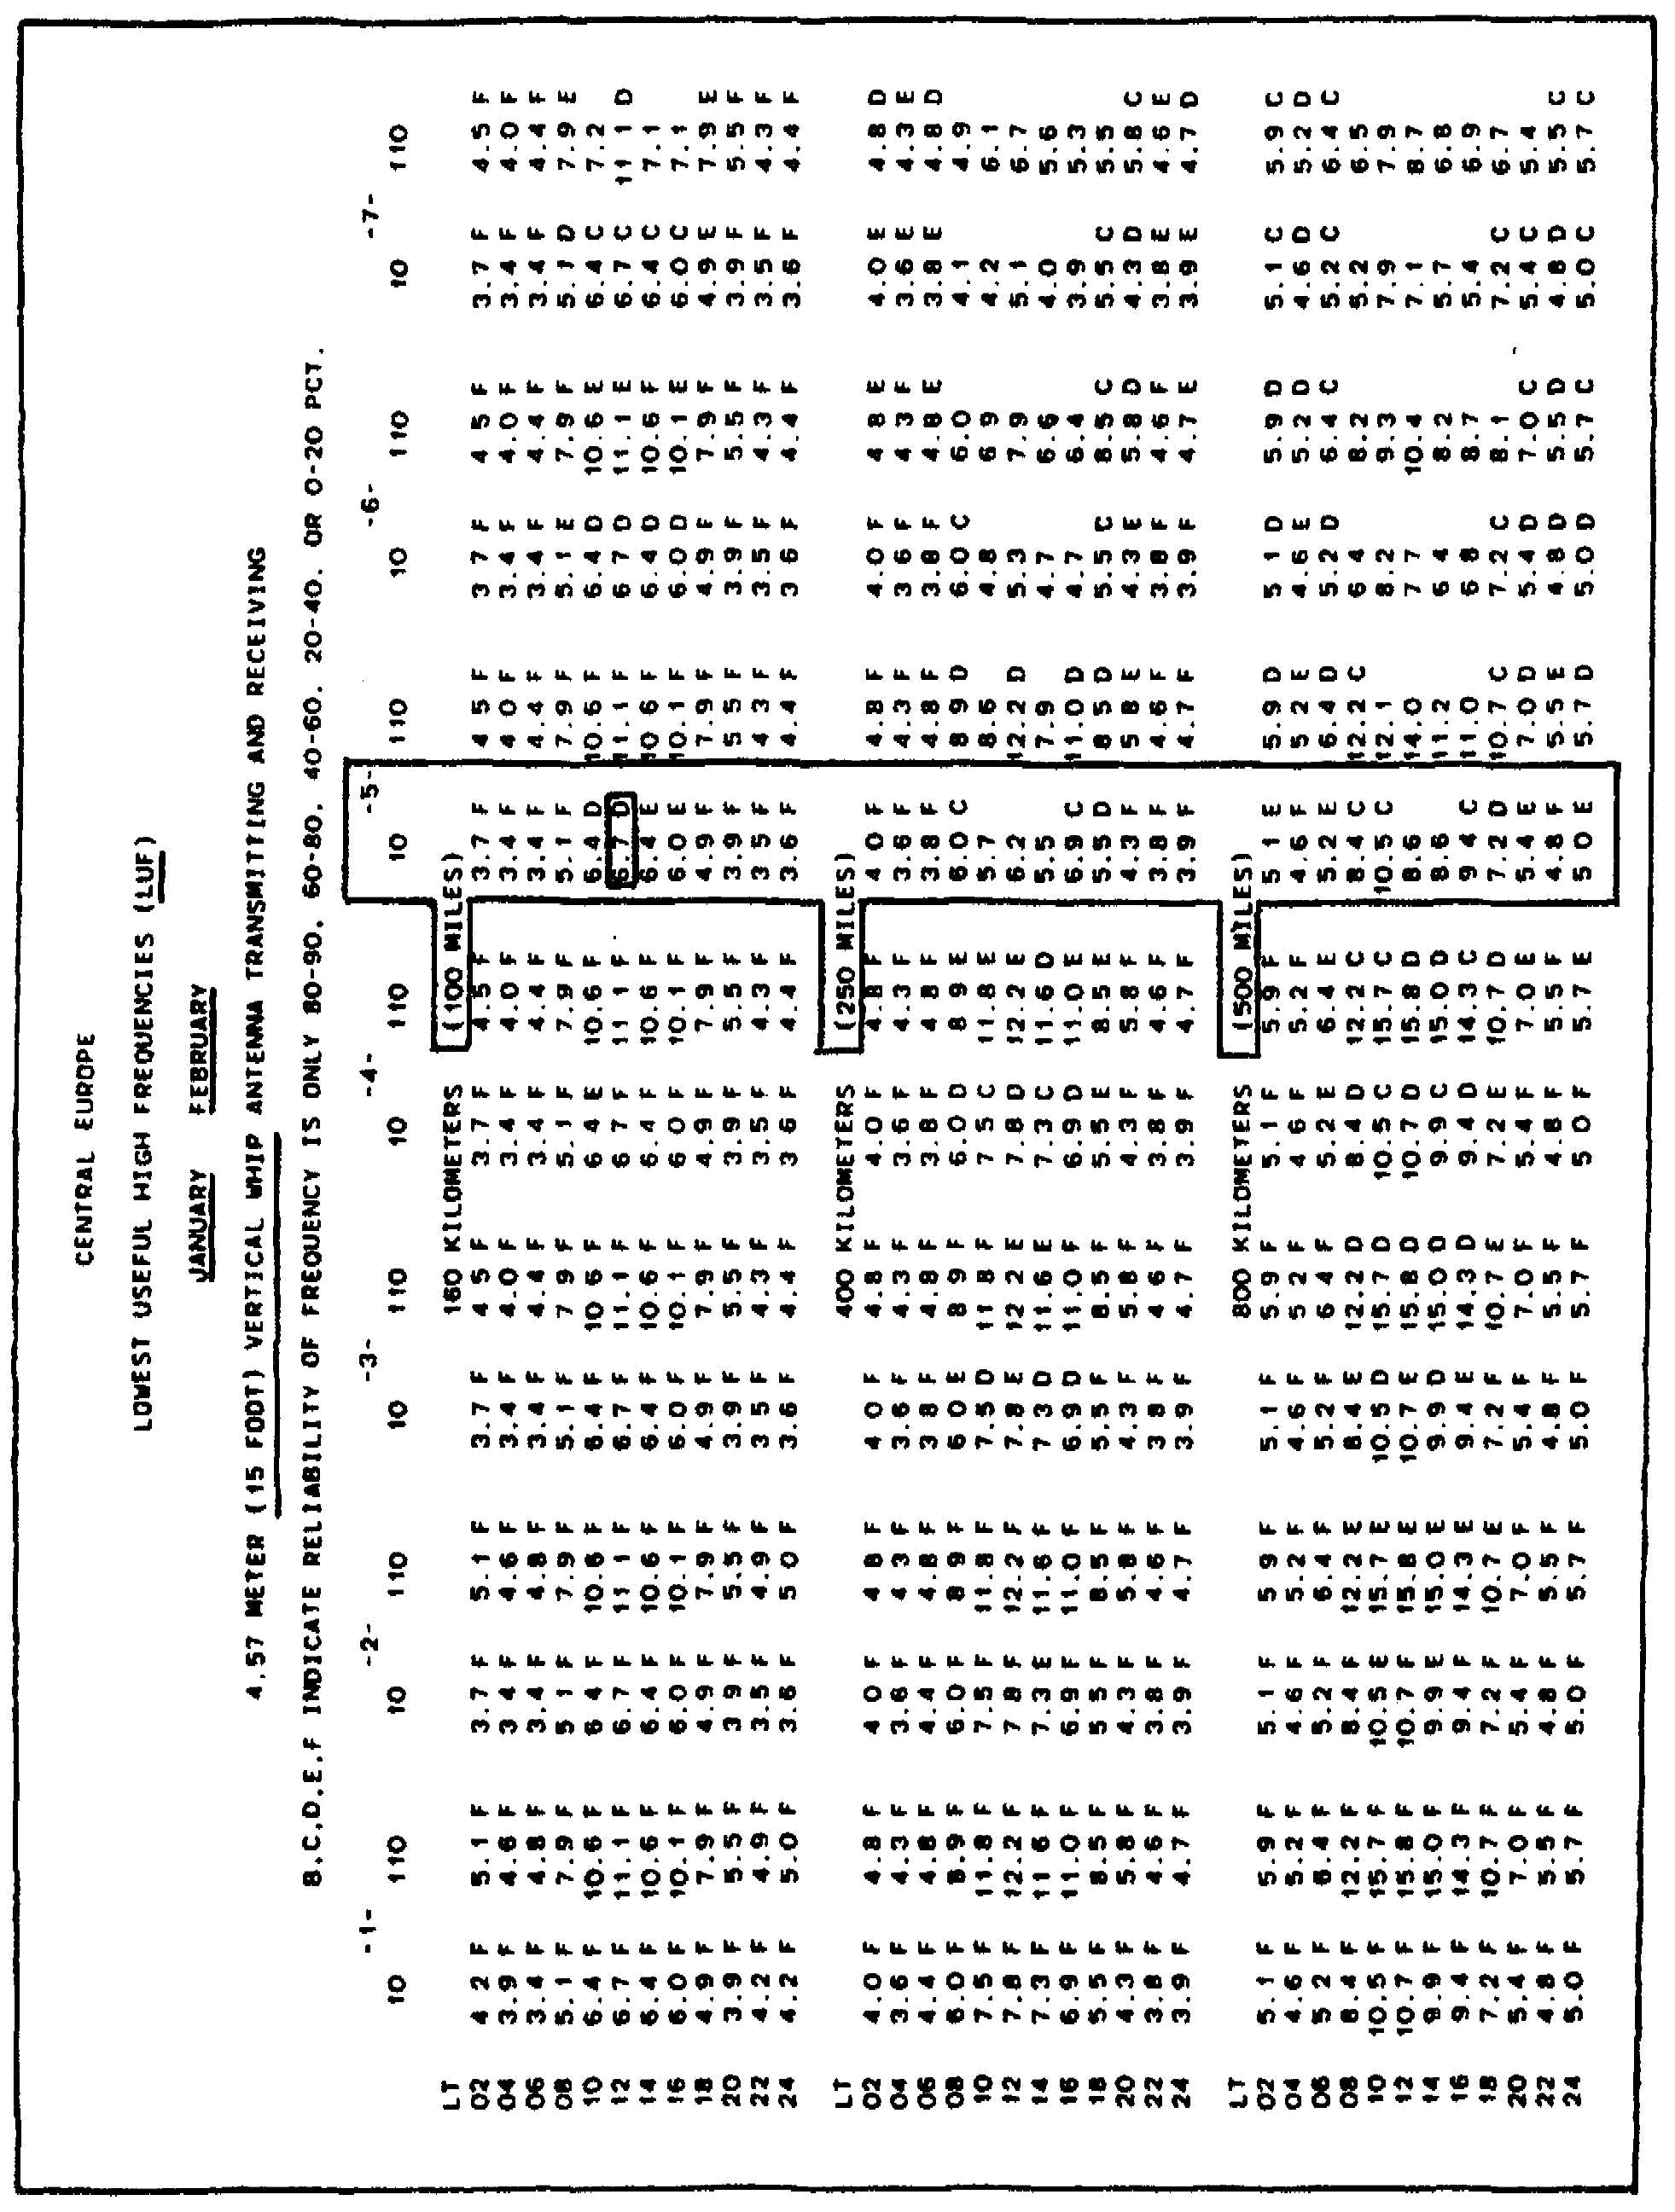

134

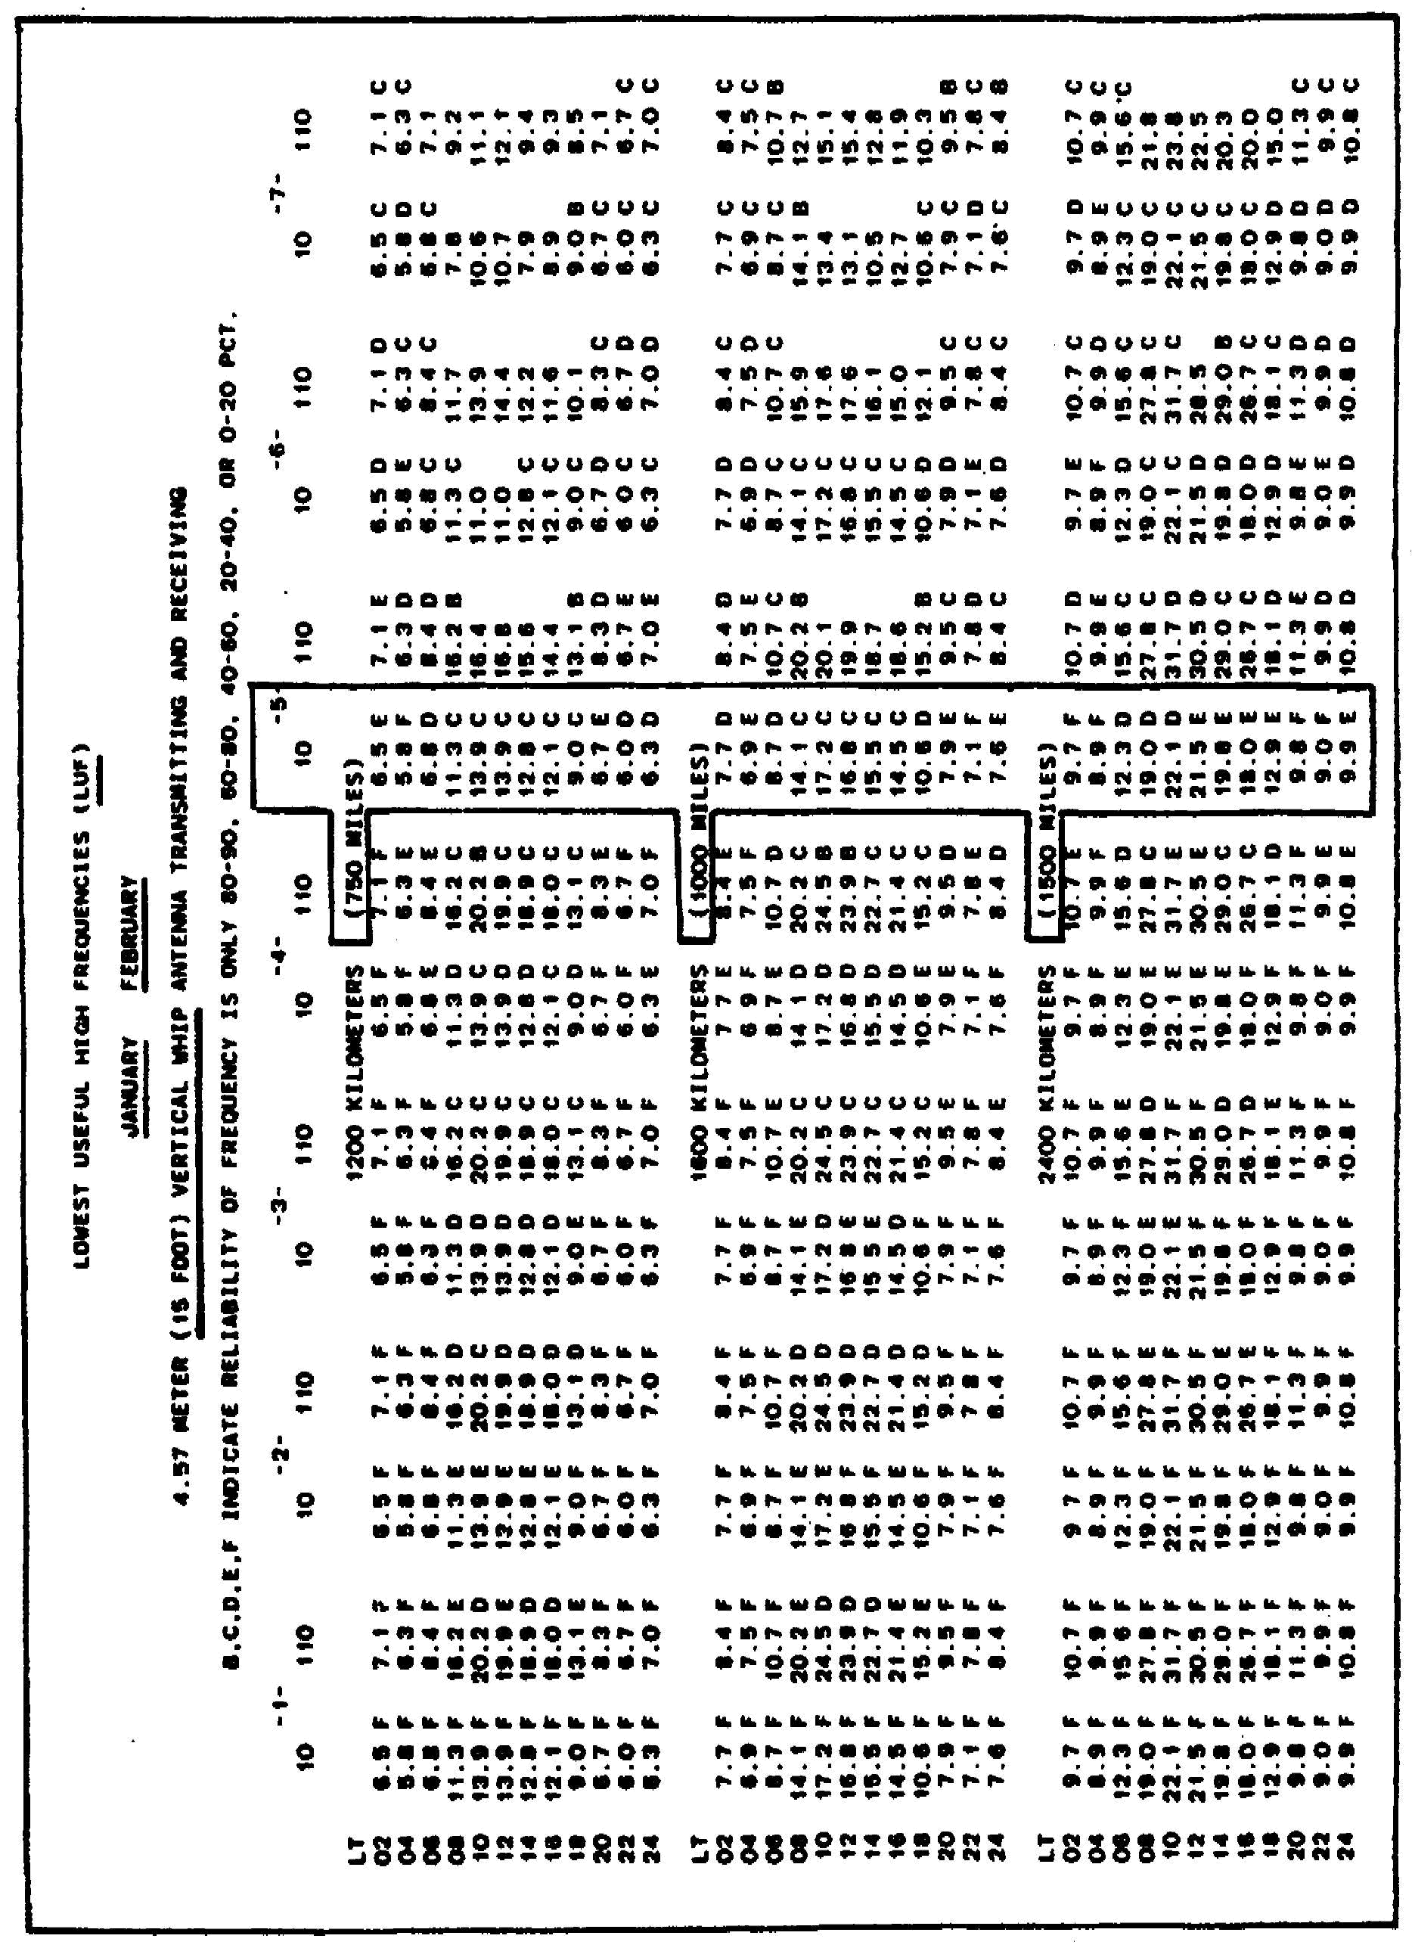

135

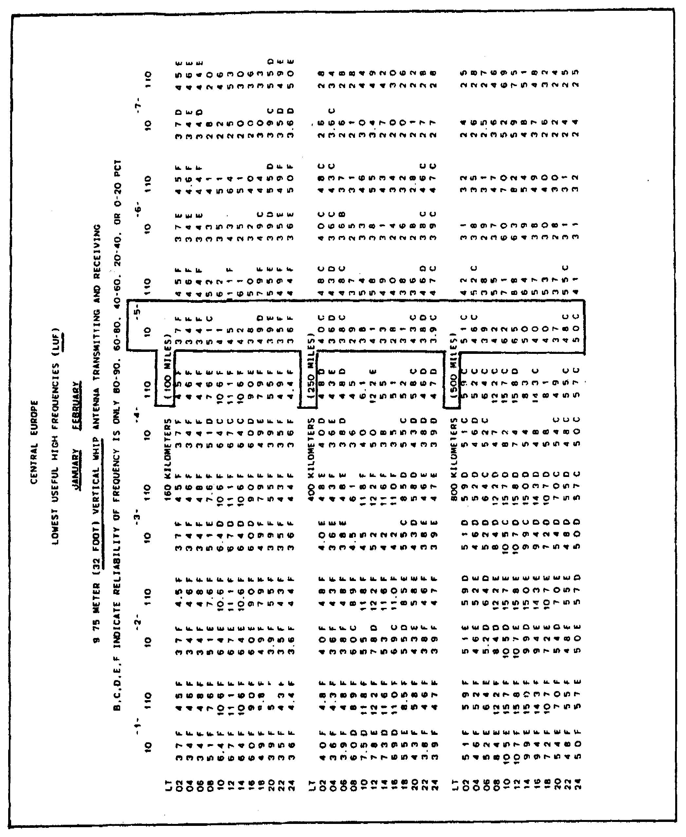

136

137

138

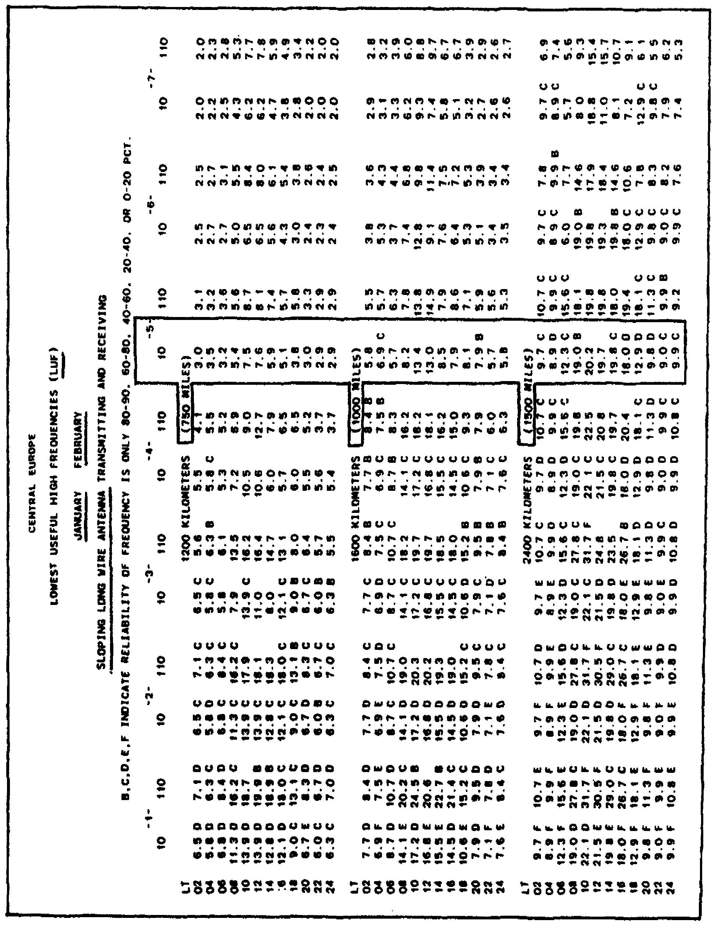

139

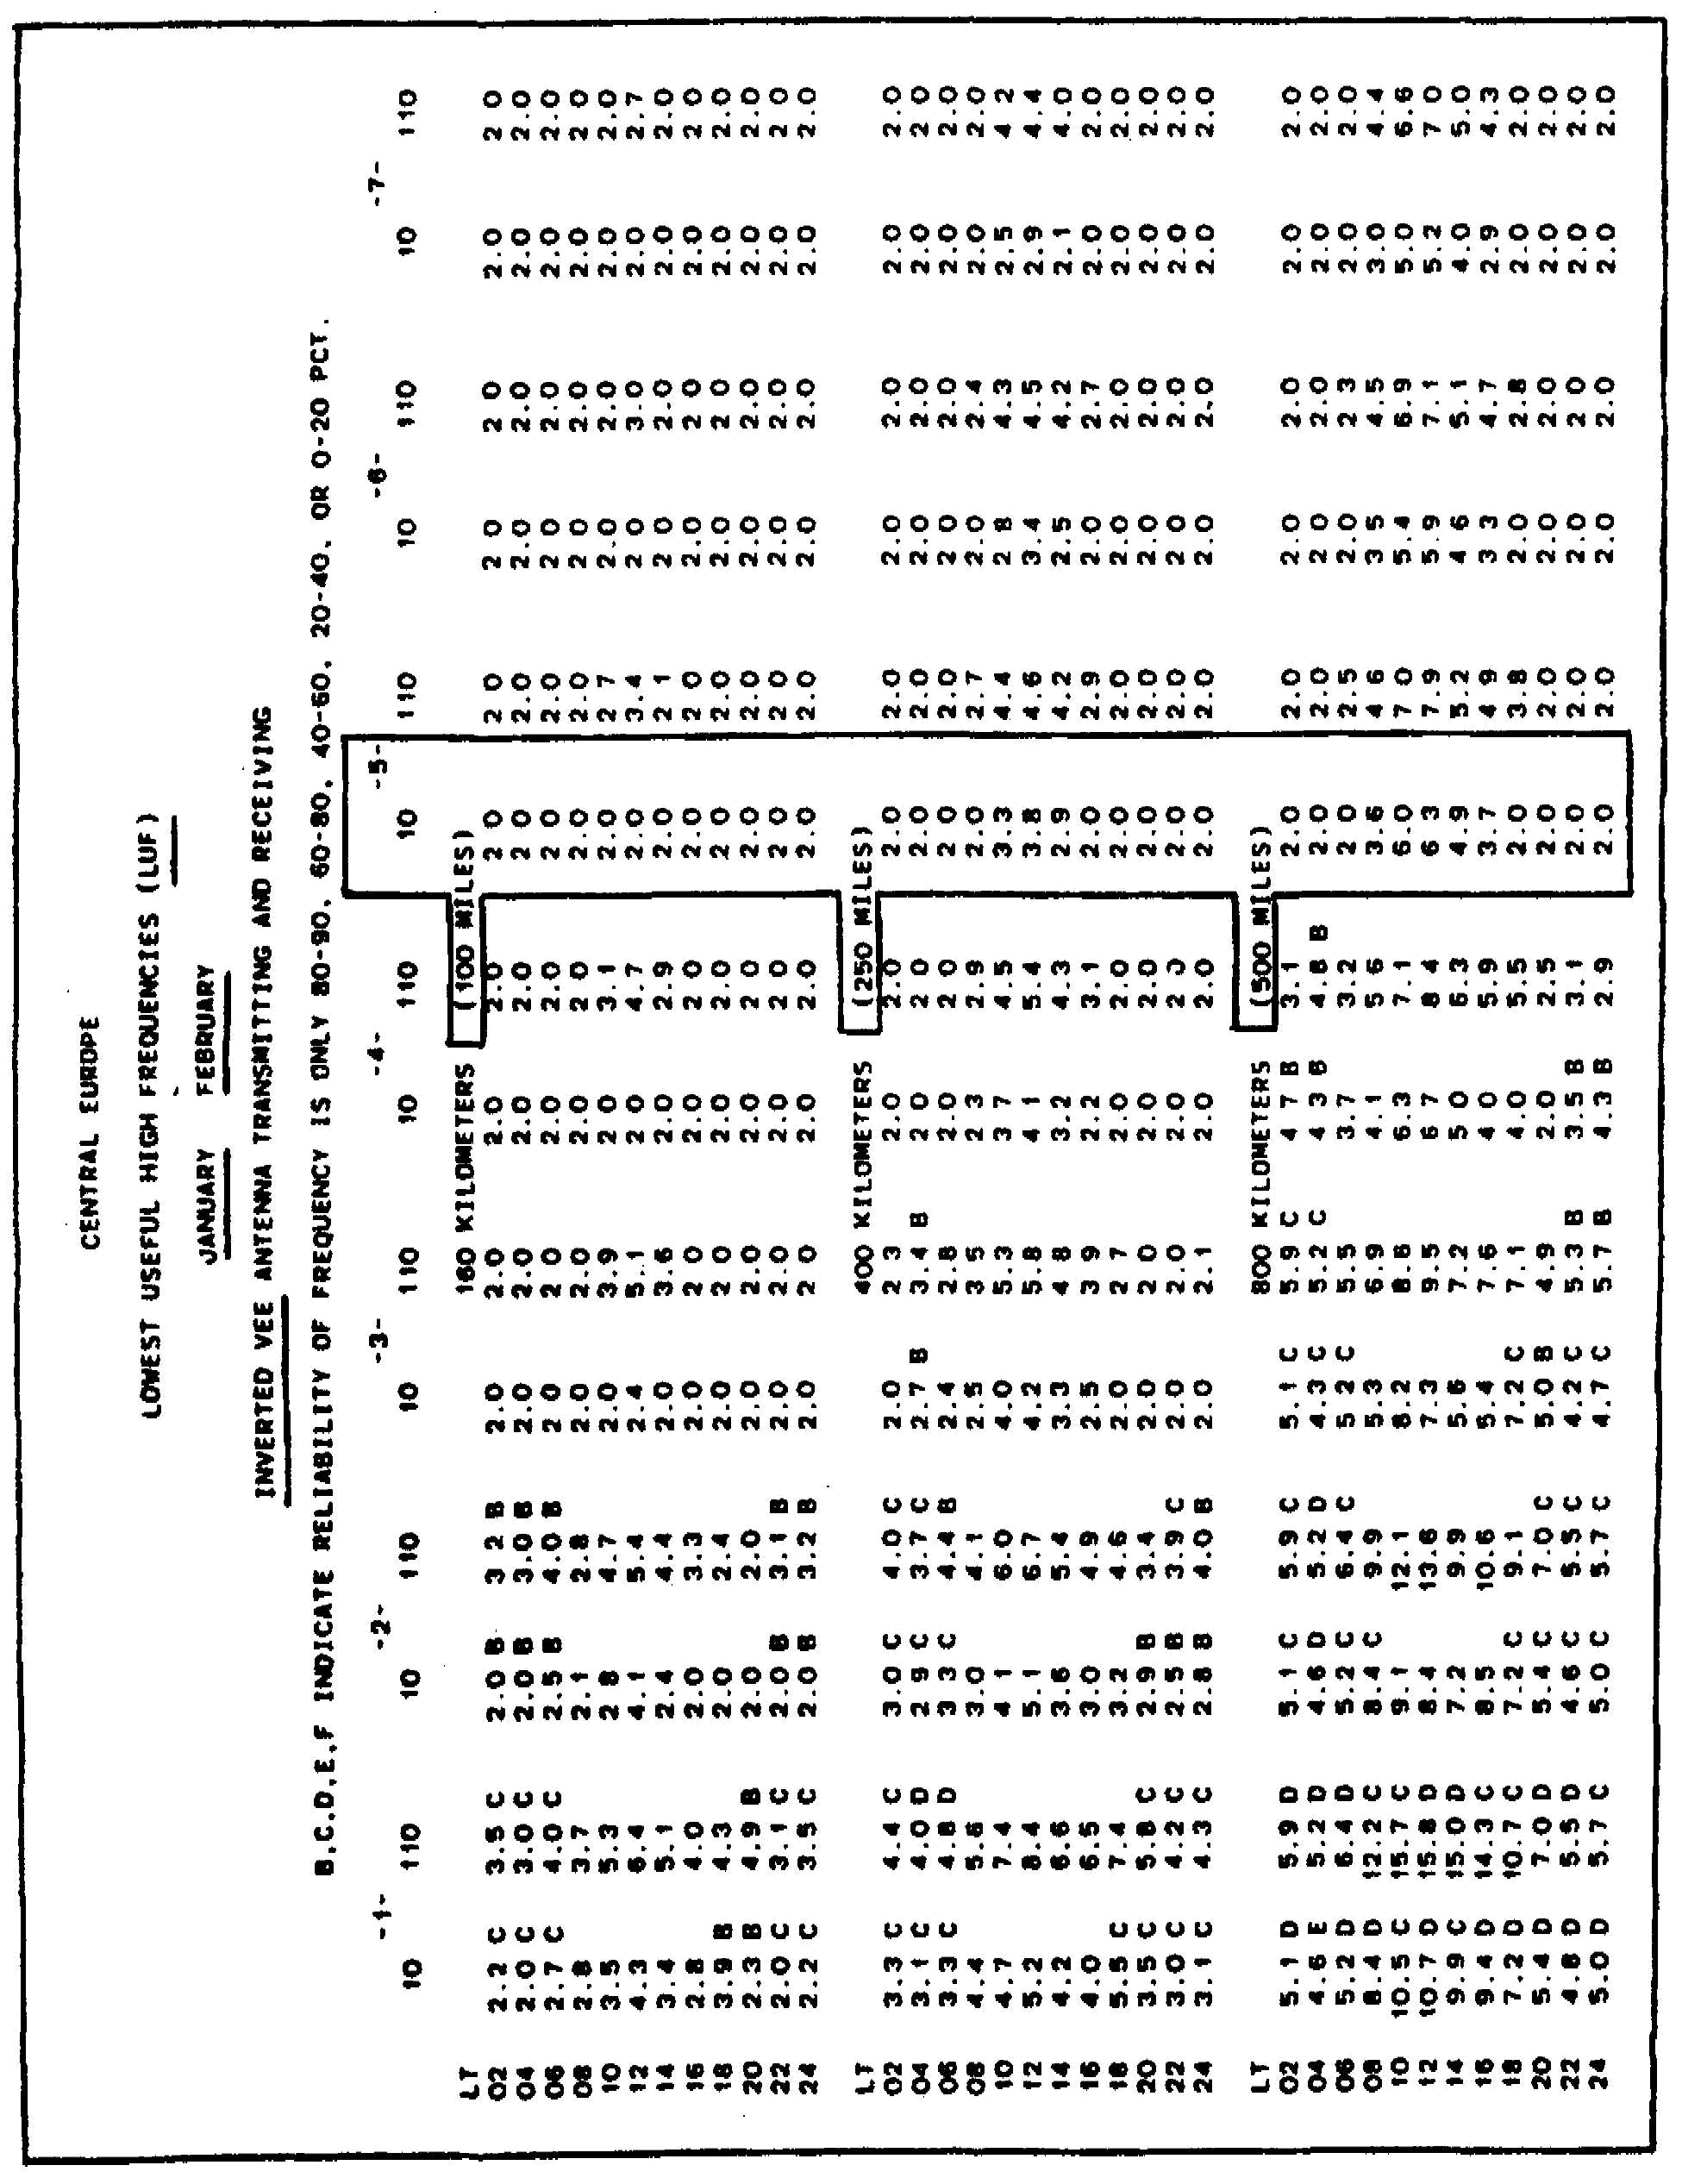

140

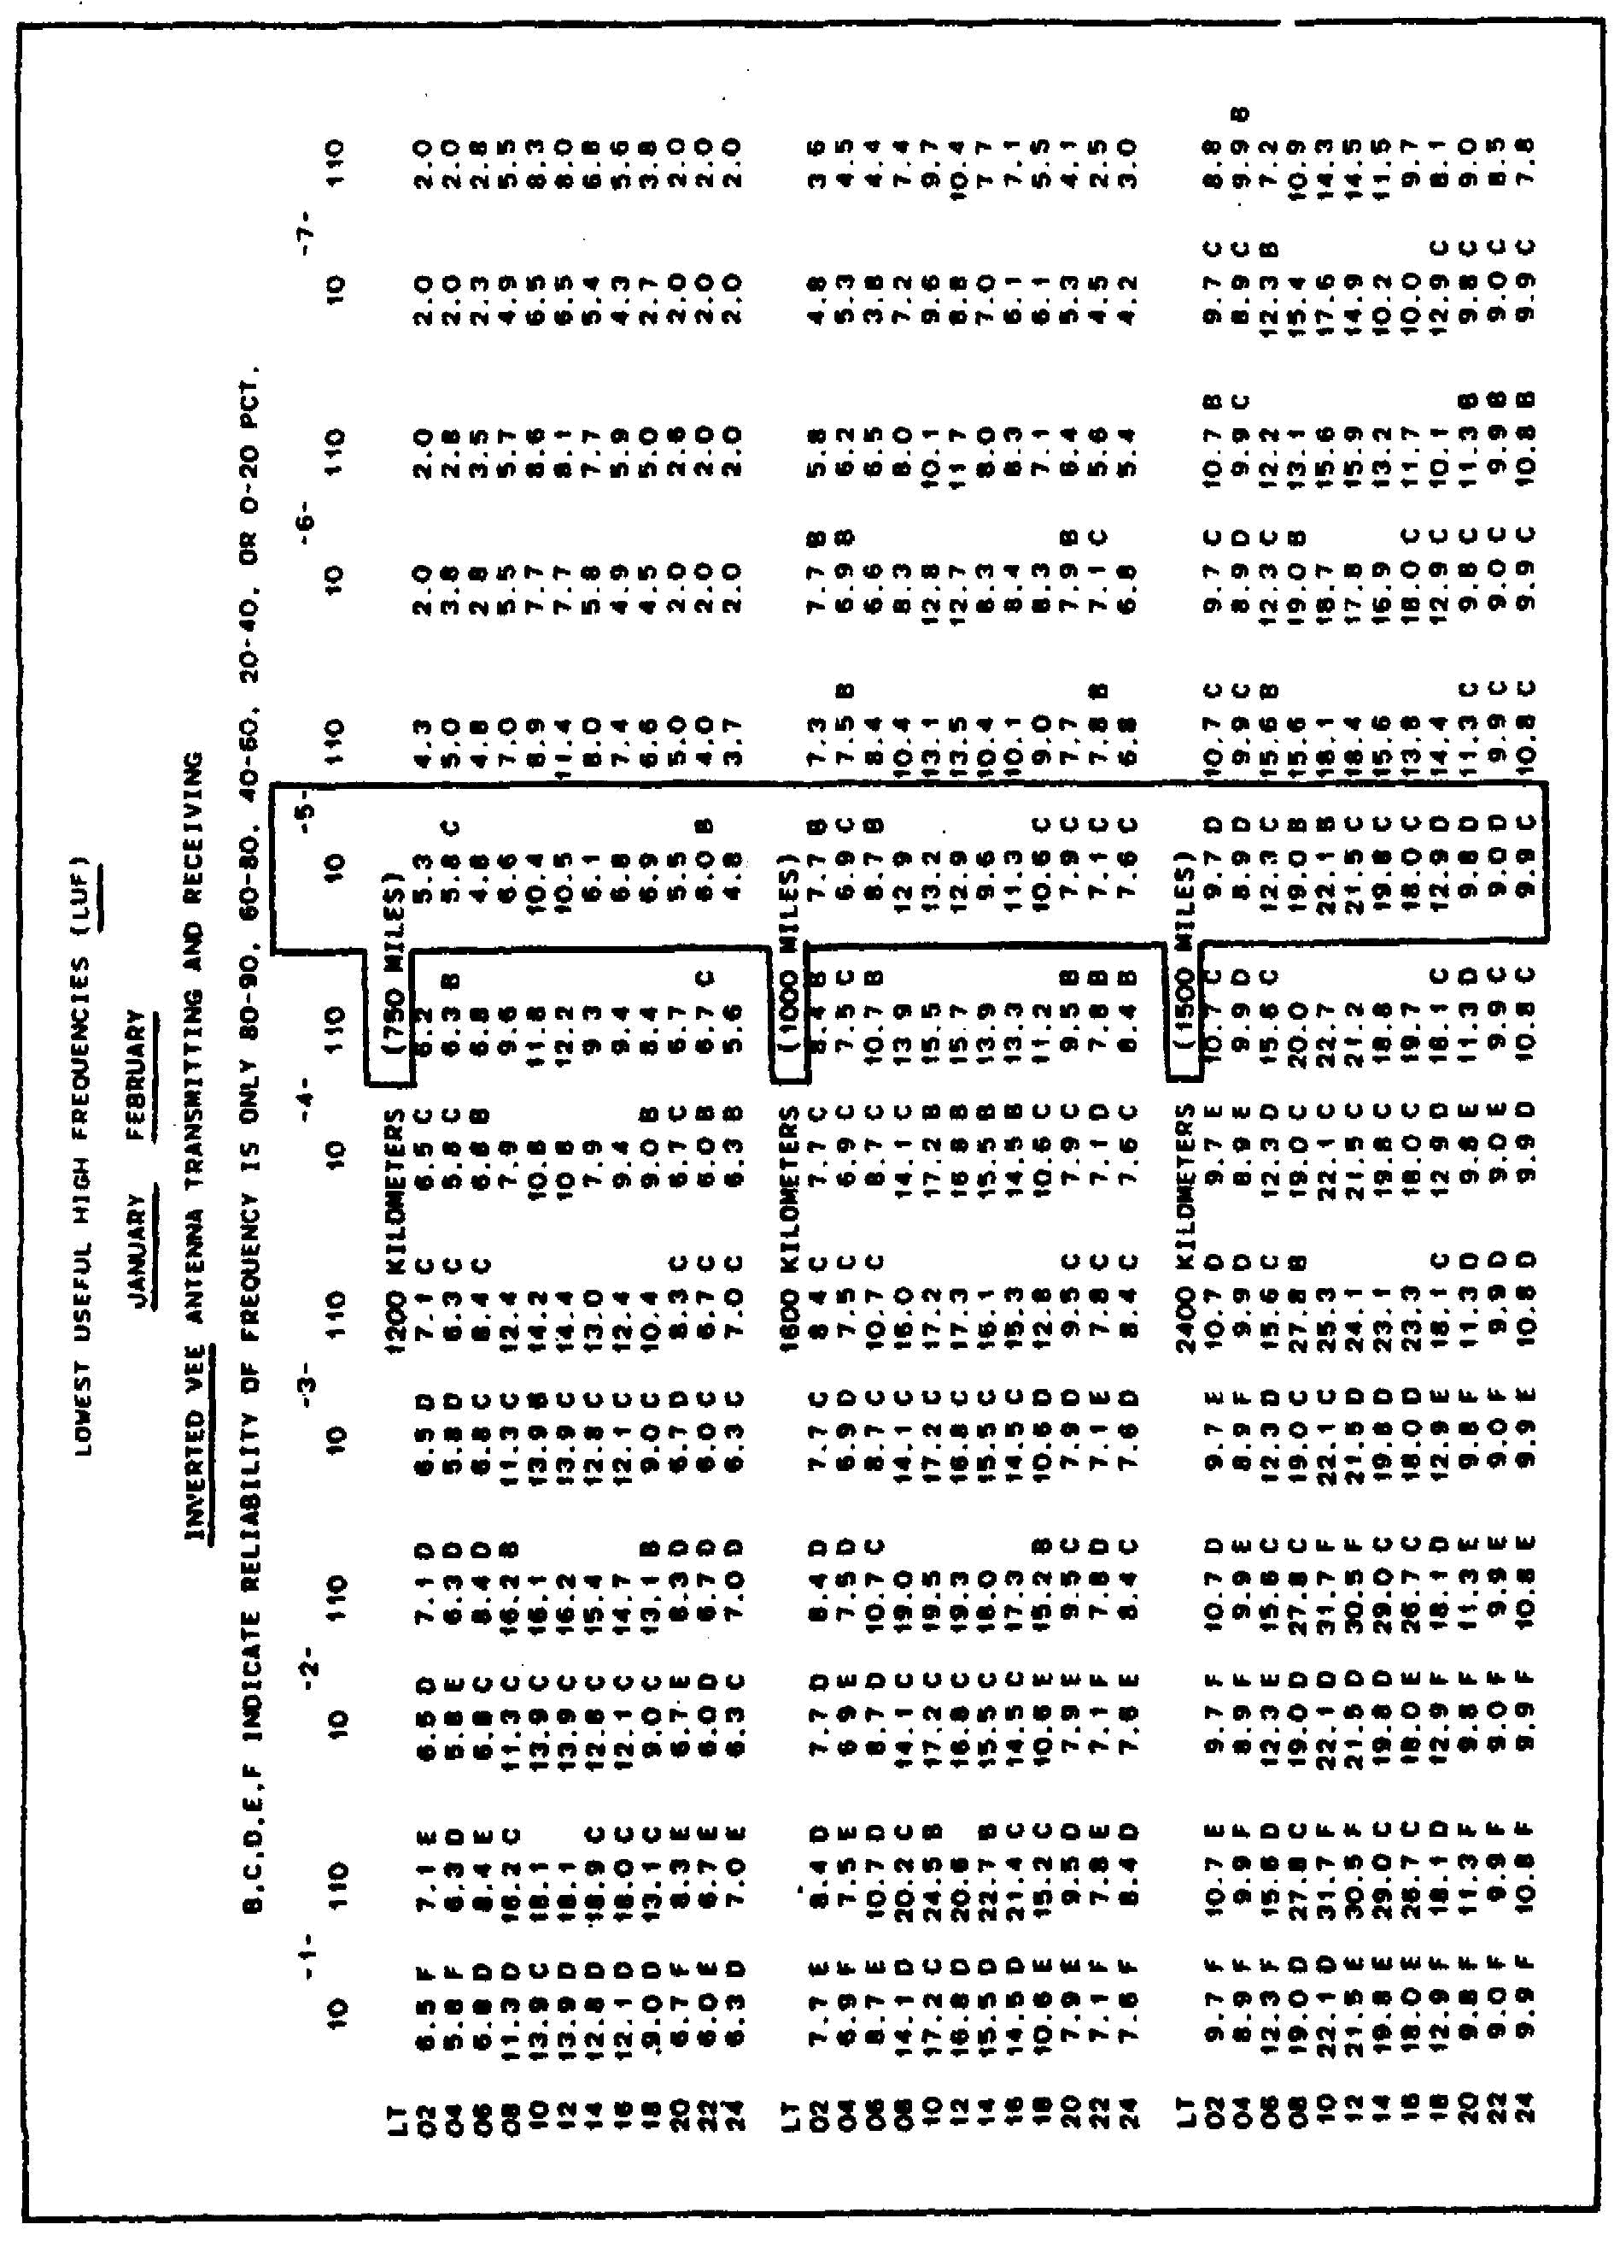

141

Conclusions: The closer to the equator you are the higher the frequency required because of atmospheric noise. The closer to the pole, the lower the noise level, the lower the frequency. Because the sun strikes the ionosphere at the pole obliquely not straight on, ionoization is thinner requiring lower frequencies. Notice that there is very little difference in frequency day or night at any location, except at the pole.

* Lt - Local time.

FOT - Optimum working frequency.

Depending on location, frequencies between 2-3 MHz can expect severe interference, especially at night, from ship-to-shore stations, therefore these frequencies should be avoided. Tactical transmitting equipment has little chance of maintaining communication. See page 121 for other frequency bands to avoid depending on location and time of day. Anytime interference is experienced submit a M1J1 report and request another frequency.

Comparisons (on following page) of MUF, FOT and LUF for various antennas during a low sunspot (SSN10) using the AN/GRC-142 (400 watts), RATT in Europe, for a range of 100 miles. Unlettered LUF is 90 percent, B 80-90 percent, C 60-80 percent, D 40-60 percent, E 20-40 percent, and F 0-20 percent reliability.

142

Transitional frequencies every 2 MHz between the night and day frequencies will be needed to maintain 24-hour communication.

For nets in which all stations are within 25 miles of one another, a frequency between 12-20 MHz will make the best use of the ground wave using a 15-foot whip.

Using a 15-foot whip you can expect only a 30 percent reliability for a 24-hour period. Using a 32-foot whip you can expect only a 50 percent reliability for a 24-hour period. Using a doublet, sloping wire (quarter wave long) for inverted vee you can expect a 90 percent reliability for a 24-hour period. Four frequencies should be available, anything less, reliability will decrease. A change in frequency at other than the times indicated will vary. There will be times when fewer frequencies are required. See page 121 for frequency bands to avoid.

MUF - Maximum Usable Frequency.

FOT - Optimum Working Frequency.

LUF - Lowest Usable Frequency.

SSN10 - Low Sunspot Number 10.

To make communication more difficult, most of our HF nets have frequencies assigned in the 2 and 3 MHz range. On closer examination those assignments are flawed. Even though the LUF is 2 and 3 MHz and should work for distances less than 100 miles, look closer, it is for a doublet antenna. We should use the whip's LUF not the doublet, because of power loss it's the worst antenna to use. Notice the whip's LUF in most cases is the MUF. A better frequency assignment for day and night is 6.7 and 3.4 MHz. Even so the reliability is 0-20 percent.

143

Comparison of MUF, FOT and LUF for various antennas during a low sunspot (SSN10) using the AN/GRC-142 (400 watts), RATT.

Unlettered frequency 90 percent, B 80-90 percent, C 60-80 percent, D 40-60 percent, E 20-40 percent, F 0-20 percent reliability.

Transitional frequencies every 2 MHz between the night and day frequencies will be needed to maintain 24-hour communication.

Using a 15-foot whip you can expect only a 50 percent reliability for a 24-hour period. Using a 32-foot whip you can expect only an 80 percent reliability for a 24-hour period. Using a doublet, sloping wire (quarter wave), or inverted vee you can expect 90 percent reliability for a 24-hour period. Four frequencies should be available, anything less, reliability will decrease. A change in frequency at other than the times indicated will vary. There will be times when fewer frequencies are required. See page 121 for frequency bands to avoid.

144

Comparison of MUF, FOT and LUF for various antennas during a low sunspot (SSN10) using the AN/GRC-142 (400 watts), RATT.

Unlettered frequency indicates 90 percent, B 80-90 percent, C 60-80 percent, D 40-60 percent, E 20-40 percent, F 0-20 percent reliability.

Transitional frequencies every 2 MHz between the night and day frequencies will be needed to maintain 24-hour communication.

Using a 15-foot whip you can expect 53 percent reliability for a 24-hour period. Using a 32-foot whip you can expect 87 percent reliability for a 24-hour period. Using a doublet, sloping (quarter wave), or inverted vee you can expect 90 percent reliability for a 24-hour period. Six frequencies should be available, anything less, reliability will decrease. A change in frequency at other than the time indicated will vary. There will be times when fewer frequencies are required. See page 121 for frequency bands to avoid.

145

Comparison of MUF, FOT and LUF for various antennas during a low sunspot (SSN10) using the AN/GRC-142 (400 watts), RATT.

Unlettered frequency indicates 90 percent, B 80-90 percent, C 60-80 percent, D 40-60 percent, E 20-40 percent, F 0-20 percent.

Transitional frequencies every 2 MHz between the night and day frequencies will be needed to maintain 24-hour communication.

Using a 15-foot whip you can expect 60 percent reliability for a 24-hour period. Using a 32-foot whip you can expect 80 percent reliability for a 24-hour period. Using a sloping wire (quarter wave) or inverted vee you can expect 85 percent reliability for a 24-hour period. Using a doublet, you can expect 90 percent reliability for a 24-hour period. Eight frequencies should be available, anything less, reliability will decrease. A change in frequency at other than the time indicated will vary. There will be times when fewer frequencies are required. See page 121 for frequency bands to avoid.

146

Comparison of MUF, FOT and LUF for various antennas during a low sunspot cycle (SSN10) using an AN/GRC-42 (400 watts).

Unlettered frequency 90 percent, B 80-90 percent, C 60-80 percent, D 40-60 percent, E 20-40 percent, F 0-20 percent reliability.

Transitional frequencies every 2 MHz will be needed between the night and day frequencies to maintain 24-hour communication.

Nine frequencies should be available, anything less, reliability will decrease. A change in frequency at other than the time indicated will vary. There will be times when fewer frequencies are required. See page 121 for frequency bands to avoid.

147

Comparison of MUF, FOT and LUF for various antennas during a low sunspot (SSN10) using an AN/GRC-42 (400 watts).

Transitional frequencies every 2 MHz will be needed to maintain 24-hour communication for 90 percent of the time.

Twelve frequencies should be available, anything less, reliability will decrease. A change in frequency at other than the time indicated will vary. There will be times when fewer frequencies are required. See page 121 for frequency bands to avoid.

148

Comparisons of frequencies for day and night, high and low sunspots, winter (Nov-Dec), and summer (Jul-Aug) in Europe for a distance of 100 miles. The letter F indicates 0-20 percent reliability.

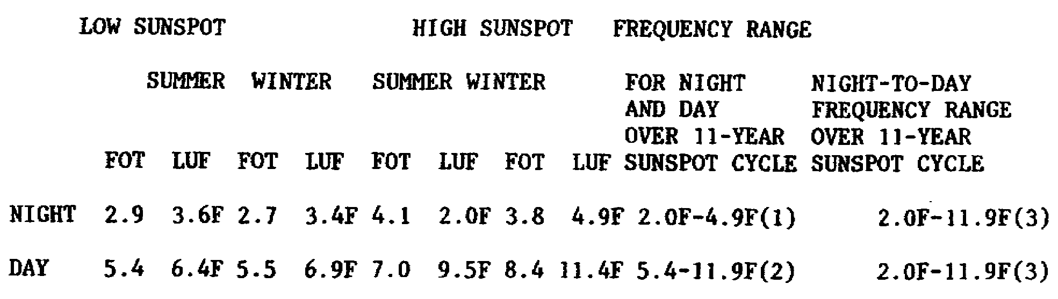

Conclusions: Frequency assignments should be the FOT, but hundreds of nets require the same FOT, therefore assignments will be from the FOT to the whip's LUF. The 15-foot whip's LUF is used because it's the worst antenna to use. We are forced to use it at times (mobile and mobile-at-a-halt). The whip should be bent at a 450 angle to make use of the sky wave. Frequencies on page 121 should be avoided, or expect severe interference resulting in no communication. Submit an interference report, and request another frequency. Ionization levels change from day to night, winter to summer, and from high to low sunspots causing frequency assignments to vary over the 11-year cycle.

(1) A nighttime low frequency would vary over 11 years from 2.0 to 4.9 MHz.

(2) A daytime high frequency would vary over 11 years from 5.4 to 11.9 MHz.

(3) To maintain day and night, 24-hour, 90% reliable communications over an 11-year period you would need frequencies from 2.0 to 11.9 MHz. For every 2 MHz increase in frequency, a frequency would be needed.

EXAMPLE: 2.0 MHz

4.0 MHz

6.0 MHz

8.0 MHz

10.0 MHz

11.9 MHz

149

A total of six frequencies would be needed to maintain 24-hour 90 percent reliable communication for a distance of 100 miles over an 11-year period.

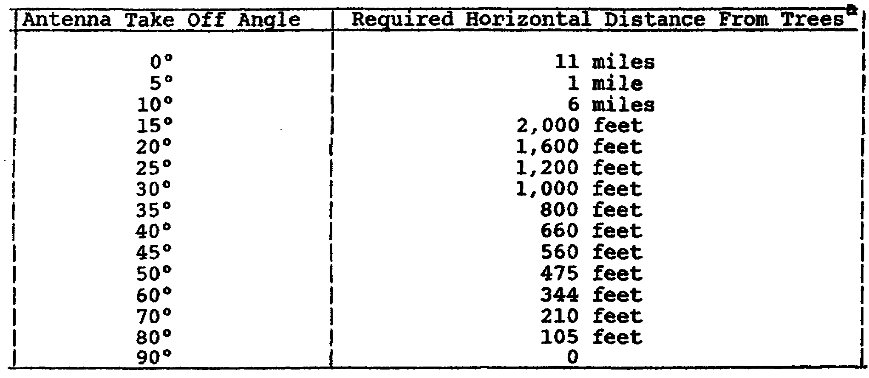

ª Assuming a 30-foot high antenna and 75-foot high trees, any vegetation (trees, bushes, grass, etc.) below or immediately in front of the transmitting antenna will absorb radio energy causing a weaker received signal by the distant station(s). The best transmitting site is a wet plowed field. The wet soil reflects the radio energy instead of having it enter the earth and being absorbed. Too much emphasis is placed by commanders on having all vehicles well into the tree line. A compromise must be made if satisfactory communication is to be maintained. A camouflaged HF set in a clearing with proper separation from trees that match the take-off angle/distance requirement is a must. Remember not enough coax is issued with the HF set to allow the vehicle to be in tree line and keep the antenna separated from the trees.

150

TAKE-OFF ANGLE VS DISTANCE

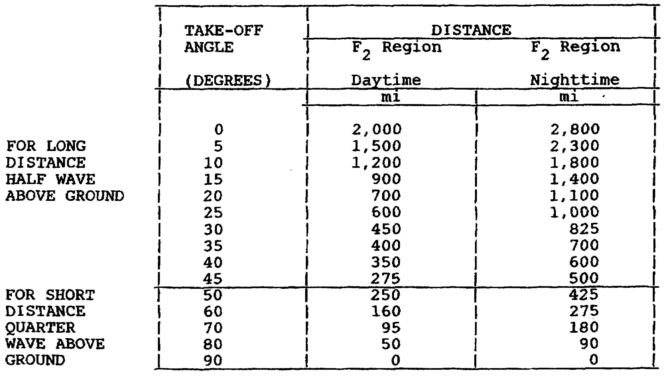

151

Comparisons take-off angles for various frequencies for the same antenna height. Notice that for short distance (250 miles) communication A 3 and 9 MHz will work fine, but that an 18 MHz will skip over the receiving station. A better antenna height would be 15 feet. For short distance communication we want our radiation pattern basically straight up (50 degrees either side of straight up).

TAKE-OFF ANGLE

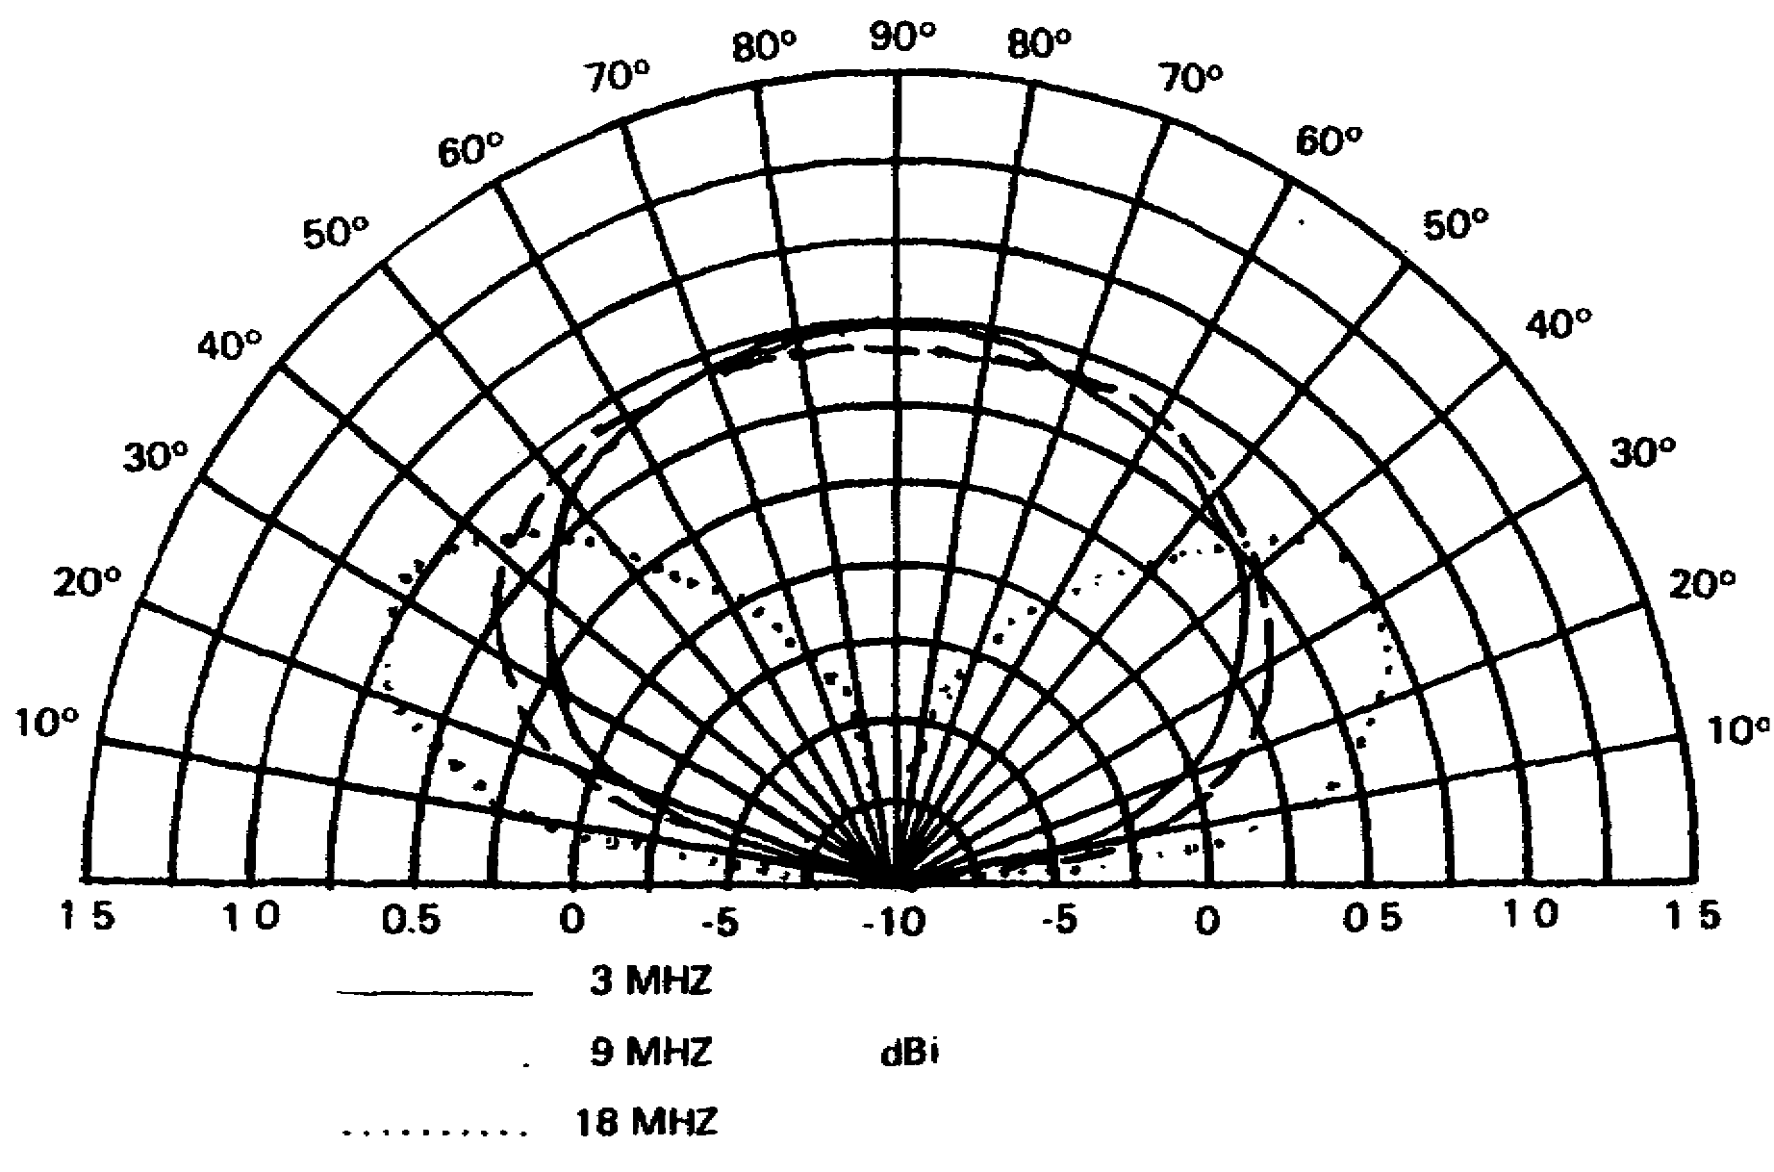

HALF-WAVE DOUBLET ANTENNA VERTICAL PATTERN, HEIGHT 25 FEET

152

Comparisons of take-off angles for various frequencies for the same antenna height. Notice that for short distance communication (0-250 miles) only the 3 MHz frequency has a radiation pattern virtually straight up. The 9 and 18 MHz frequency will skip over the receiving station.

TAKE-OFF ANGLE

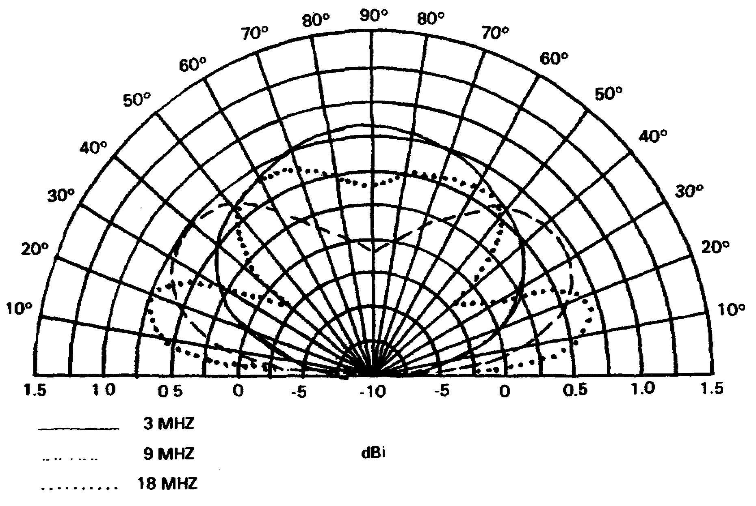

HALF-WAVE DOUBLET ANTENNA VERTICAL PATTERN, HEIGHT 40 FEET

153

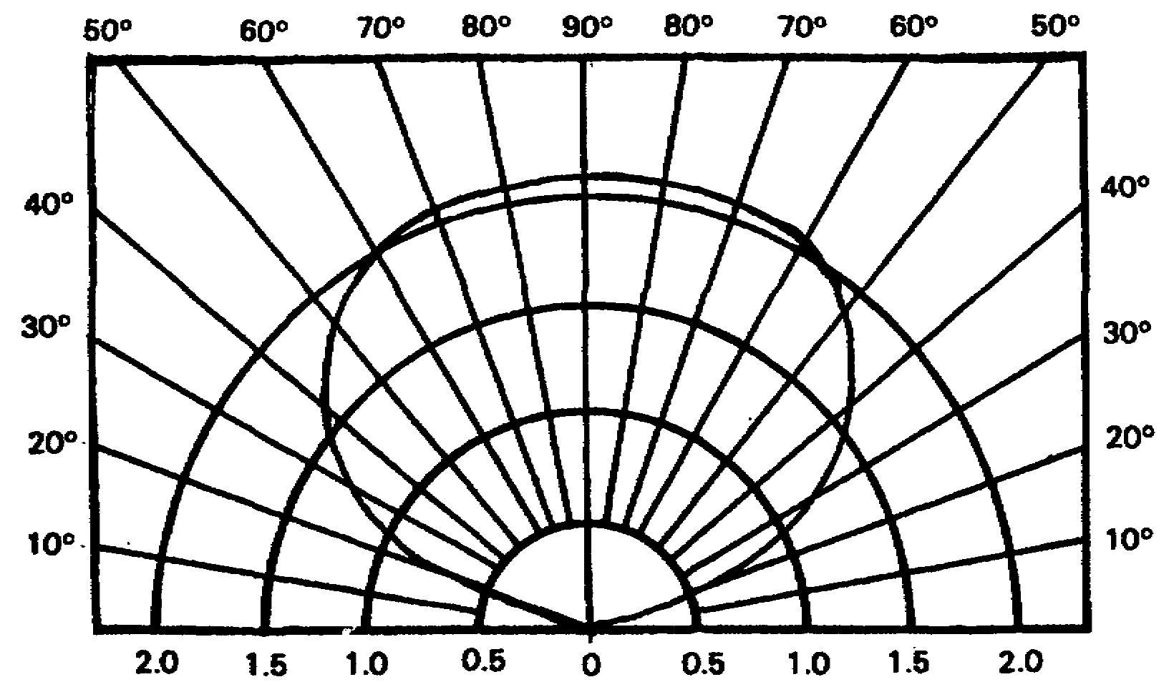

HALF-WAVE DOUBLET RADIATION PATTERN, QUARTER WAVE HIGH

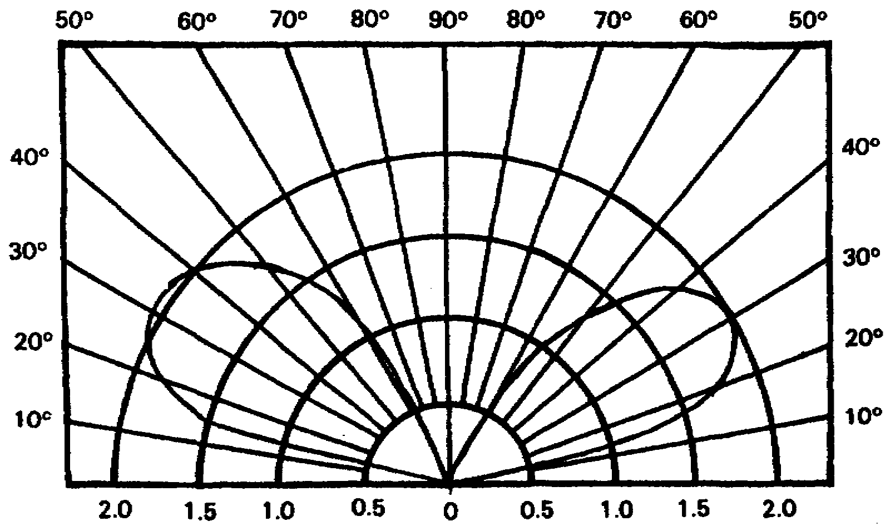

WHIP RADIATION PATTERN

154

Comparisons of doublet and whip antenna take-off angles. Conclusions: For short range communications (0-250 miles) the doublet is best for two reasons: Better take-off angle (straight-up) while the whip's lower take-off angle skips over the receiving station. Also a 15-foot whip has a power loss because it doesn't equal the correct length for frequencies below 15 MHz. The 32-foot whip also has a loss for frequencies below 7 MHz. Even for frequencies that a whip has no loss, a whip's low take-off angle eliminates its use for short distance communication.

CONCLUSIONS

The doublet is the best reliable (90 percent) antenna up to 1,000 miles; 1,000 to 1,500 miles it's 50 percent reliable.

The 15-foot whip is 20 percent reliable overall. Best hours 10-12 hours. Worst hours 22-06.

The 32-foot whip 50 percent reliable overall. Best hours 08-18. Worst hours 18-06.

15/32-foot whip best performance range is 250 to 500 miles.

155

GROUND-WAVE PROPAGATION CHARTS (GW BOOK) VOLUME 2 CENTRAL EUROPE

Ground-wave communications can be used in all areas of the world. Charts have been prepared covering a two-month period and for the following antennas: 15-foot whip, 32-foot whip, and sloping wire. Four types of earth conditions are considered: poor ground, good ground, fresh water, and sea water.

156

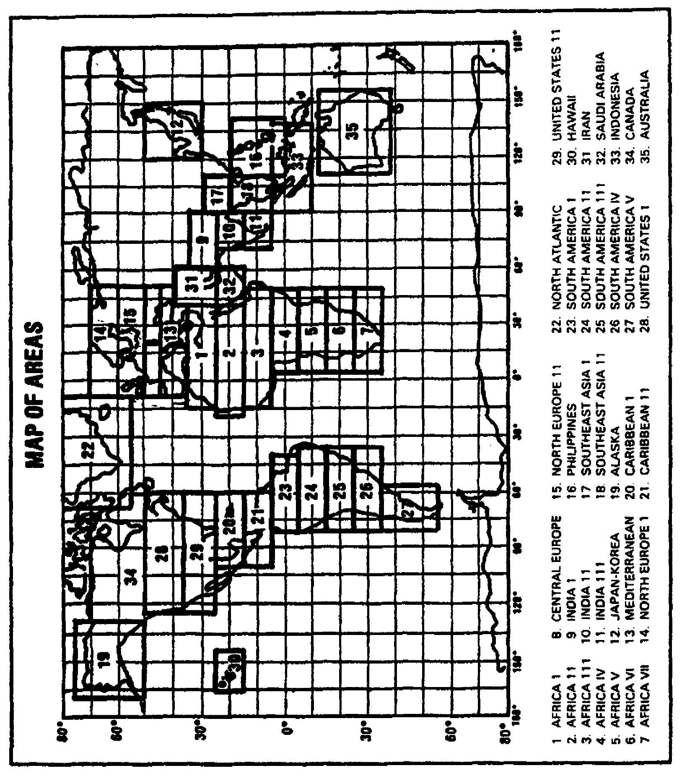

157

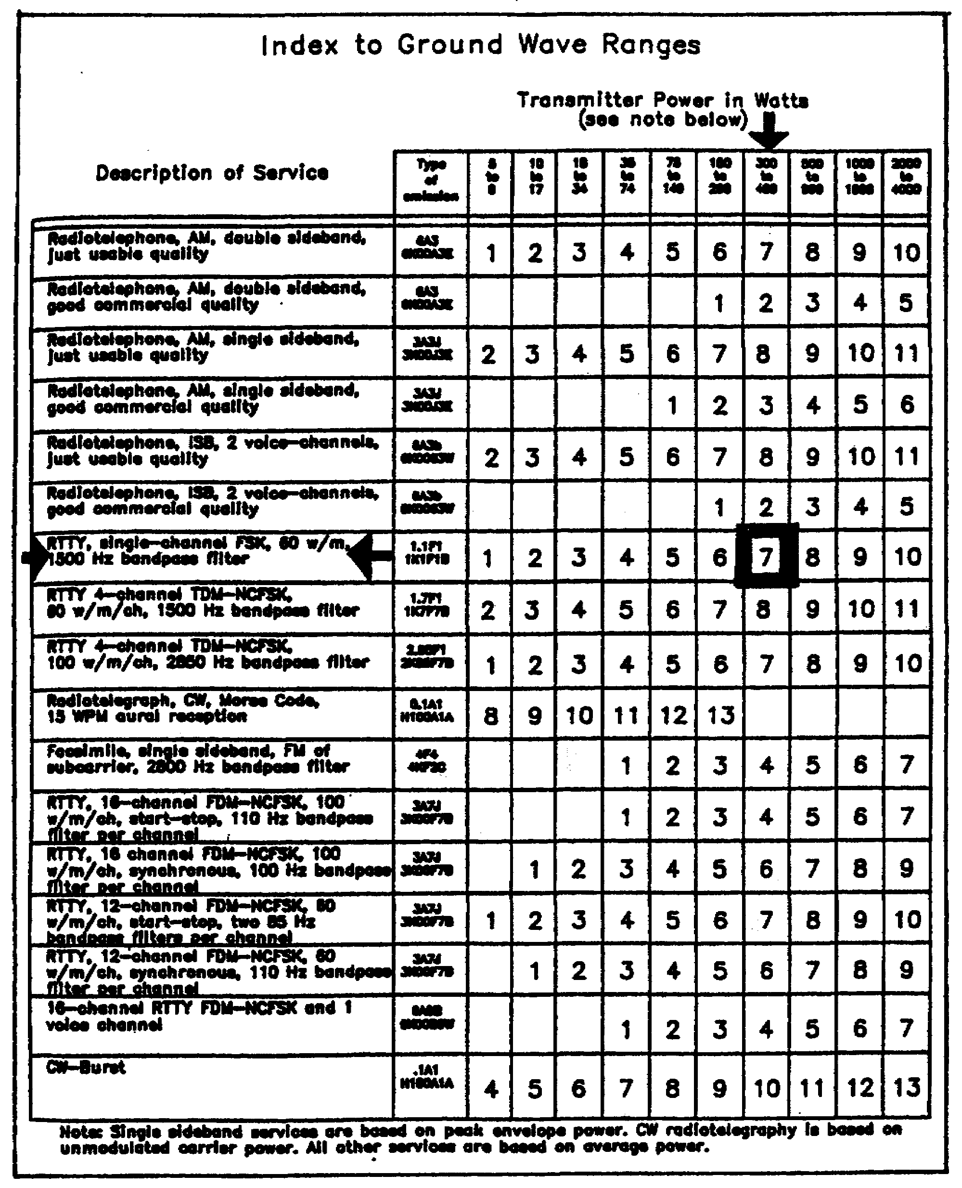

158

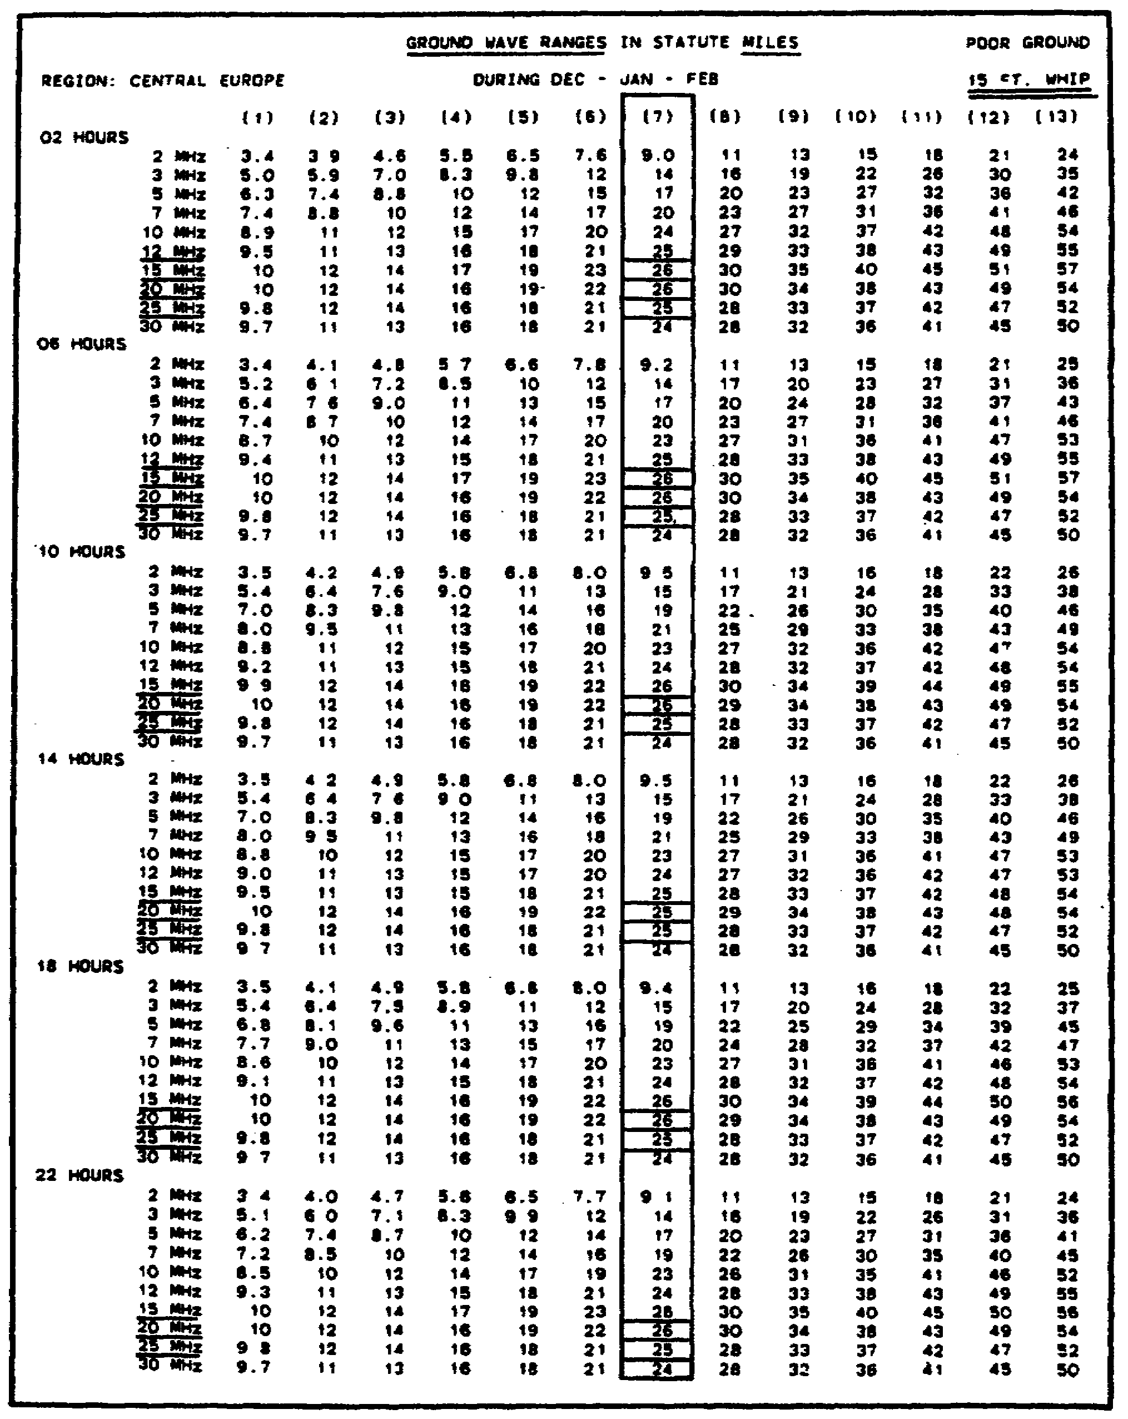

159

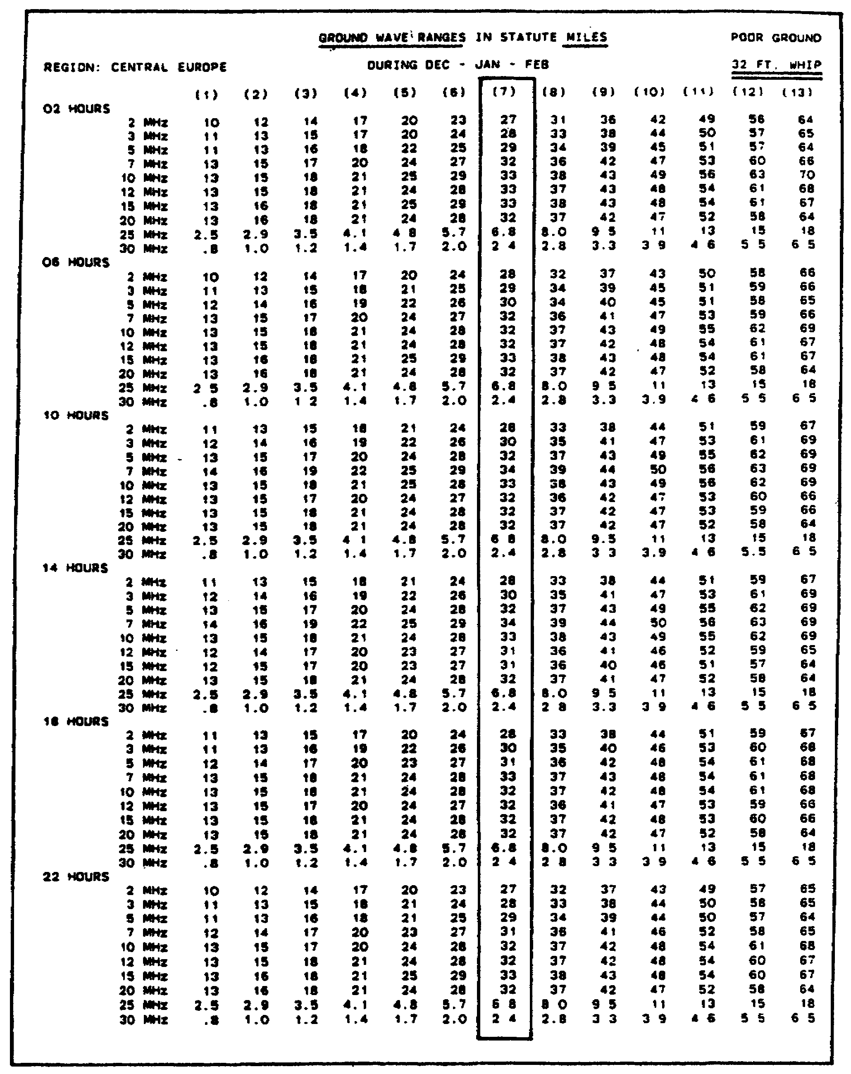

160

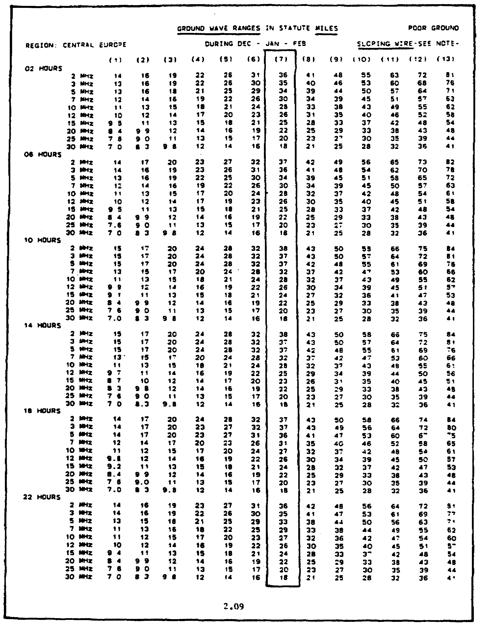

161

Comparison of ground wave ranges for various antennas using RATT in the AN/GRC-142 (400 watts).

Conclusions: As a 15-foot whip approaches a quarter wave in length (15 MHz) less power loss, longer range. As a 32-foot whip approaches a full wave in length at 30 MHz, range decreases because radiation pattern changes from low to straight up. Best frequency to get the longest ground wave is 12-25 MHz for a 15-foot whip; 7-20 MHz for a 32-foot whip.

162

LESSON 2/LEARNING EVENT 4

PRACTICAL EXERCISE

Instructions: Select the BEST response, and circle the correct answer.

1. Looking at page 129, the MUF/FOT chart, select the highest FOT for daytime use for a distance of 1,000 during a low sunspot cycle.

a. 14.1 MHz.

b. 12.0 MHz.

c. 17.1 MHz.

d. 14.6 MHz.

2. Looking at page 129, the MUF/FOT chart select the lowest FOT for nighttime use for a distance of 500 miles during a low sunspot cycle.

a. 3.5 MHz.

b. 4.5 MHz.

c. 5.2 MHz.

d. 4.2 MHz.

3. Looking at column 5 on page 130, the LUF chart for a doublet 33 feet high, select the highest LUF for daytime use for a distance of 250 miles during a low sunspot cycle.

a. 3.0 MHz.

b. 2.6 MHz.

c. 4.2 MHz.

d. 4.4 MHz.

163

4. Looking at column 5 on page 131, the LUF chart for a doublet 33 feet high, select the lowest LUF for nighttime use for a distance of 1,000 miles during a low sunspot cycle.

a. 2.9 MHz.

b. 3.2 MHz.

c. 2.0 MHz.

d. 3.3 MHz.

5. Looking at column 7 of the sloping wire antenna chart on page 161 of the ground wave book, select the frequency that provides the maximum range.

a. 2 MHz at 1000 hours.

b. 3 MHz at 1000 hours.

c. 30 MHz at 0200 hours.

d. 30 MHz at 2200 hours.

Turn to page 169 to check your answers.

164

LESSON 2

COMPREHENSIVE PRACTICE EXERCISE

1. The quarter-wave formula is--

a. 492/f.

b. 468/f.

c. 492(N-.05)/f.

d. 234/f.

2. Using the 15-foot ground wave chart on page 159, which frequency has the longer ground-wave range?

a. 2 MHz.

b. 3 MHz.

c. 15 MHz.

d. 30 MHz.

3. How can you make a whip more efficient?

a. Make it a full-wave long at the operating frequency.

b. Make it a quarter-wave at the operating frequency.

c. Make it shorter than 15 feet.

d. Ground the antenna.

4. A 30 MHz frequency's communication range can be increased the most by using a--

a. whip.

b. half rhombic.

c. doublet.

d. ground plane.

165

5. A 3 MHz sky-wave signal at night--

a. has a longer range.

b. has a shorter range.

c. has same range as the daytime signal.

d. uses the F2 layer.

Turn to page 170 to check your answers.

166

LESSON 2

CALCULATE ANTENNA LENGTH



167

ANSWERS TO PRACTICAL EXERCISES

LESSON 1

LESSON 1/LEARNING EVENT 1

Answers References

1. a, page 1, paragraph 1

2. b, page 4, paragraph 3

3. c, page 6, paragraph 4a

4. d, page 7, paragraph 4b

5. d, page 11, paragraph 8

LESSON 1/LEARNING EVENT 2

1. d, page 10, paragraph 6

2. a, page 18, paragraph 2c(2)

3. c, page 18, paragraph 2c(2)

4. d, page 26, paragraph 5e

5. b, page 21, paragraph 4

LESSON 1

(Comprehensive)

1. a, Table 2, page 5, paragraph 3

2. b, Table 2, page 5, paragraph 3

3. c, page 33, paragraph 8

4. d, page 15, paragraph 2

5. a, page 34, paragraph 8

168

LESSON 2/LEARNING EVENT 1

1. d, page 46 to 47, paragraph 1

2. c, page 47, paragraph 1

3. d, page 48, paragraph le

4. d, page 50, paragraph c

LESSON 2/LEARNING EVENT 2

1. a, page 46, paragraph 1

2. d, page 70, paragraph 4

3. b, page 86, paragraph 5c

4. a, page 90, paragraph 6

5. a, page 99, paragraph 9

LESSON 2/LEARNING EVENT 3

1. a, page 101, paragraph 3a

2. d, page 100, paragraph 2a

3. a, page 102, paragraph 3, single-hop table

4. a, page 102, paragraph 4

5. d, page 103, paragraph 5

LESSON 2/LEARNING EVENT 4

1. d, page 129

2. a, page 129

3. a, page 130

4. b, page 131

5. a, page 161

169

LESSON 2

(Comprehensive)

1. d, page 120, paragraph 5

2. c, GW chart page 159

3. b, page 120, paragraph 5

4. b, page 92, paragraph 9

5. a, page 120, paragraph 7

*U.S. Government Printing Office: 2000-628-075/40090

170

